|  |  |  |  |  |
| --- | --- | --- | --- | --- |
|  |  | | |  |
|  |  | | |  |
|  | Personal and Portable Profiles  <<Feature>>  (F002032/B;1) | | |  |
|  |  | | |  |
| Document Type | **Feature Document (FD)** | | |  |
| Template Version | **6.0b / FFSD 8.0** | | |  |
| SysML Report Template Version | **O (11/12/2019)** | | |  |
| Document ID | **VDOC075158** | | |  |
| Document Location | [**Link to Spec in VSEM**](https://www.vsemweb.ford.com/tc/launchapp?-attach=true&-s=226TCSession&-o=TjpBES7Lx3NrTDAAAAAAAAAAAAA&servername=Production_Server) | | |  |
| Document Owner | **Justin Bauer, Walter Stephens** | | |  |
| Document Revision | **FD0** | | |  |
| Document Status | **Draft** | | |  |
| Date Issued |  | | |  |
| Date Revised |  | | |  |
| Document Classification | GIS1 Item Number: | **27.60/35** | |  |
| GIS2 Classification: | **Confidential** | |
|  | | | | |
|  | | | | |
| Document Approval | | | | |
| Person | Role | | Email Confirmation | Date |
|  |  | |  |  |
|  |  | |  |  |

**Auto-Generated by MagicDraw**

Printed Copies Are Uncontrolled

# Disclaimer

**This document contains Ford Motor Company Confidential information. Disclosure of the information contained in any portion of this document is not permitted without the expressed, written consent of a duly authorized representative of Ford Motor Company, Dearborn, Michigan, U.S.A.**

**Copyright, Ó 2016 Ford Motor Company**

This document contains information developed and accumulated by and for FORD MOTOR COMPANY. As such, it is a proprietary document, which, if disseminated to unauthorized persons, would provide others with restricted information, data, or procedures not otherwise available, exposing the FORD MOTOR COMPANY to potential harm.

Employees and suppliers having custody of this specification or authorized to use it must be cognizant of its proprietary nature and ensure that the information herein is not made available to unauthorized persons.

FORD MOTOR COMPANY reserves the right to protect this work as an unpublished copyrighted work in the event of an inadvertent or deliberate unauthorized publication. FORD MOTOR COMPANY also reserves its rights under copyright laws to protect this work as a published work.

This document or portions thereof shall not be distributed outside FORD MOTOR COMPANY without prior written consent. Refer all questions concerning disclosure to the author(s) or to any duly authorized representative of Ford Motor Company.

# Contents

1.1.2 Decomposition of Functional Safety Requirement 13

Disclaimer 22

Contents 23

2 Introduction 26

2.1 Document Purpose 26

2.2 Document Scope 26

2.3 Document Audience 26

2.3.1 Stakeholder List 26

2.4 Document Organization 26

2.4.1 Document Context 26

2.4.2 Document Structure 27

2.5 Document Conventions 27

2.5.1 Requirements Templates 27

3 Feature Overview 28

3.1 Purpose and Description of Feature 28

3.2 Feature Variants 28

3.2.1 Regions & Markets 29

3.3 Input Requirements 29

3.3.1 Legal Requirements 30

3.3.2 Trustmark Requirements 30

3.3.3 Industry Standards 30

3.3.4 Attribute Requirements 30

3.4 Lessons Learned 30

3.5 Assumptions 31

3.6 References 31

3.6.1 Ford Documents 32

3.6.2 External Documents and Publications 32

3.7 Glossary 33

3.7.1 Parameters / Values 33

4 Feature Context 34

4.1 Feature Context Diagram 34

4.2 List of Influences 34

5 Feature Modeling 36

5.1 Operation Modes and States 36

5.2 Use Cases 38

5.2.1 Use Case Diagram 38

5.2.2 Actors 39

5.2.3 Use Case Descriptions 39

5.3 Driving and Operation Scenarios 43

5.4 Decision Tables 45

6 Feature Requirements 46

6.1 Functional Requirements 46

6.1.1 Error Handling 47

6.2 Non-Functional Requirements 47

6.2.1 Safety 47

6.2.2 Security 47

6.2.3 Reliability 47

6.3 HMI Requirements 47

6.4 Other Requirements 48

6.4.1 Design Requirements 48

6.4.2 Manufacturing Requirements 48

6.4.3 Service Requirements 48

6.4.4 After Sales Requirements 48

6.4.5 Process Requirements 48

6.4.6 Uncategorized Requirements 49

7 Functional Safety 50

7.1 System Behaviors for HARA 50

7.2 Safety Assumptions 50

7.3 Safety Goals 51

7.4 Functional Safety Requirements 53

7.4.1 Safety Goal: 53

7.4.2 Derivation of Functional Safety Requirements on Assumptions 55

7.5 ASIL Decomposition of Functional Safety Requirements 56

8 Architecture 57

8.1 Functional Architecture 57

8.1.1 List of Functions 57

8.2 Logical Architecture 58

8.2.1 Logical Interfaces 59

9 Open Concerns 61

10 Revision History 62

11 Appendix 63

11.1 Definitions 63

11.2 Abbreviations 63

**List of Figures**

Figure 1. 12

Figure 2: 28

Figure 3: - 28

Figure 4: 34

Figure 5: 36

Figure 6: 38

Figure 7:  55

Figure 8: 57

Figure 9: 58

**List of Tables**

Table 1: Features described in this FD 26

Table 2: Feature Variants 29

Table 3: Regions & Markets 29

Table 4: Ford internal Documents 32

Table 5: Ford internal Documents *(not specified in SysML model)* 32

Table 6: External documents and publications 32

Table 7: External documents and publications *(not specified in SysML model)* 33

Table 8: Parameters / Values used in this document *(Not supported by MagicDraw report generation)* 33

Table 9: List of Influences 35

Table 10: Operation Modes and States on 36

Table 11: Transitions between Operation Modes and States on 38

Table 12: List of Actors 39

Table 13: System Behaviors for HARA 50

Table 14: Functional Safety Assumptions 51

Table 15: Functional Safety Goals 53

Table 16: List of Functions 58

Table 17: List of Functions on 58

Table 18: Feature Interactions 59

Table 19: Feature Interactions on 59

Table 20: Open Concerns *(Not supported by MagicDraw report generation)* 61

Table 21: Definitions used in this document 63

Table 22: Abbreviations used in this document 64

# Introduction

## Document Purpose

A Feature Document (FD) document specifies **what** the feature shall do and how it shall behave from customer perspective. It should also provide reasoning and background **why** we have the feature in the vehicle.

The FD also serves as an Item Definition as defined by ISO26262 for those features, which follow the Ford Functional Safety process.

To get more information about the concept of feature, function and component level abstraction refer to the [Ford RE Wiki](http://wiki.ford.com/display/RequirementsEngineering/Requirements+Engineering+for+SW+Enabled+Features). For details on the Ford Functional Safety (ISO26262) process refer to the [Ford Functional Safety Sharepoint](https://pd3.spt.ford.com/sites/GlobalFunctionalSafety/Pages/default.aspx).

## Document Scope

This Feature Document (FD) specifies the following features:

|  |  |  |  |
| --- | --- | --- | --- |
| **Feature ID** | **Feature Name** | **Owner** | **Reference** |
| F002032/B;1 | Personal and Portable Profiles  (Program(s): Cross Carline) | Justin Bauer, Walter Stephens |  |

Table 1: Features described in this FD

## Document Audience

The FD is written by the feature owner of Justin Bauer, Walter Stephens. All Stakeholders, i.e., all people who have a valid interest in the feature should read and, if possible, review the FD. It needs to be guaranteed, that all stakeholders have access to the currently valid version of the FD.

**#Hint:** The FD template has the IP Classification “Proprietary” by default. IP Classification “Confidential” might be required in some cases, e.g. by Ford Functional Safety.

### Stakeholder List

For the latest list of stakeholder of the feature and their influence refer to <Put VSEM Link here>.

**#Hint:** Refer to [Ford RE Wiki – Stakeholder List](http://wiki.ford.com/display/RequirementsEngineering/Stakeholder+Analysis) on how to create a stakeholder list. The stakeholder list should be stored in VSEM in the pseudo folder “General Data Artifacts” of the corresponding feature.

## Document Organization

### Document Context

Refer to the [Specification Structure page](http://wiki.ford.com/display/RequirementsEngineering/Specification+templates) in the [Ford RE Wiki](http://wiki.ford.com/display/RequirementsEngineering/Requirements+Engineering+for+SW+Enabled+Features) to understand how the FD relates to other Ford Requirements Documents and Specifications.

### Document Structure

The structure of this document is explained below:

**Section 1** – Introduction how to use this document including responsibilities and requisite documents. Explains the terminology. Gives a clarification of the definitions, concepts and abbreviations used in the document.

**Section 2** – Feature Description. States briefly the background and the purpose of the feature, feature variants and corresponding regions and markets. Also includes input requirements, assumptions and constraints.

**Section 3** – Feature Context describes all external entities, which have an influence on the feature.

**Section 4** – Feature Modeling. Contains Use Case, Driving Scenarios, State Charts to describe the functional behavior of the feature.

**Section 5** – Safety. Lists System Behaviors and Safety Goals of the feature.

**Section 6** – Feature Requirements. Lists functional and non-functional requirements of the feature.

**Section 7** – Architecture. Shows the coarse architecture, which the feature requirements are deployed to. Describes the elements and the boundary of the feature as well as the decomposition and distribution of associated functions.

**Section 8** – List of Open Concerns

**Section 9** – Document Change History including a list of new or modified requirements. The requirements in this document are tagged, and this section contains different types of tables listing all, new, or changed requirements by their title and page no.

**Section 10** – Appendix

**#Hint:** All sections are mandatory, unless explicitly marked by the tag “#Classification” as “optional” or as applicable e.g. to certain domains like “Functional Safety”.

## Document Conventions

### Requirements Templates

Each requirement, use case or scenario in this specification shall follow the corresponding template given in the document template *Specification_Macros.dotm* at [RE Wiki - Specification Templates](http://wiki.ford.com/display/RequirementsEngineering/Specification+templates?src=contextnavpagetreemode).

#### Identification of requirements

#### Requirements Attributes

The templates provided by *Specification_Macros.dotm* define a list of attributes for each requirement. This helps to classify the requirement. The attributes are explained at [RE Wiki - Requirements Attributes](http://wiki.ford.com/display/RequirementsEngineering/Requirements+Attributes?src=contextnavpagetreemode).

## References

### Ford Documents

List here all Ford internal documents, which are directly related to the feature.

| **Reference** | **Title** | **Doc. ID** | **Document Location** | **Revision** |
| --- | --- | --- | --- | --- |
|  |  |  |  |  |

Table 5: Ford internal Documents *(not specified in SysML model)*

### External Documents and Publications

The list of external documents could include books, reports and online sources.

**#Hint:** You may refer to [IEEE Citation Reference](http://www.ieee.org/documents/ieeecitationref.pdf) on how to format a reference.

| **Reference** | **Document / Publication** | **Document Location** |
| --- | --- | --- |
|  |  |  |

Table 7: External documents and publications *(not specified in SysML model)*

## Glossary

**#Hint**: Terms, concepts and abbreviations used in the document shall be defined and illustrated here. Note that changes to terms and/or concepts described in this section tend to cause major updates to this document.

The tables below have feature specific definitions and abbreviations. For additional, non-feature specific terms please refer to the [RE Glossary](http://wiki.ford.com/display/RequirementsEngineering/Glossary?src=contextnavpagetreemode)

See Appendix for Definitions and Abbreviations.

### Parameters / Values

| **Name** | **Description** | **Range / Resolution** |
| --- | --- | --- |
|  |  |  |

Table 8: Parameters / Values used in this document *(Not supported by MagicDraw report generation)*

# Feature Overview

## Purpose and Description of Feature

**#Hint:** Some descriptive text to explain the purpose and functionality of the feature.

Develop a cloud-based platform / ecosystem to deliver a personalized in-vehicle experience that is seamlessly transferrable between Ford/Lincoln vehicles. This would reduce the time and effort a customer needs to setup / customize a vehicle (known pain point for subscription based ownership). Creating a personalized experience will increase customer loyalty and provide a data platform for vehicle and cloud based predictions, Digital Assistant, in-vehicle purchases and other monetization strategies. This in-vehicle profile will link with the centralized member profile for a common profile across all channels of the ecosystem.

## Feature Variants

**#Hint:** Definitions for different variants of the feature (if applicable). Give each variant a descriptive name by which it can be referenced further on in the document. If no variant exists, state “No Feature Variants”.

The Variant Description should give a short informative text which describes the variants of the feature.

|  |  |  |
| --- | --- | --- |
| **Variant Name** | **Variant Description** | **Remarks** |
| **No Feature Variants** | No Feature Variants |  |

Table 2: Feature Variants

### Regions & Markets

**#Hint:** Description of purpose and functionality of the feature. If there is no variant, give feature name in first column.

|  |  |  |  |  |  |  |
| --- | --- | --- | --- | --- | --- | --- |
| **Market /**  **Region**  Variant Name | **North America** | **South America** | **Europe** | **Middle East/Africa** | **Asia / Pacific** | **China** |
| **No Feature Variants** | Optional | Optional | Optional | Optional | Optional | Optional |

Table 3: Regions & Markets

## Input Requirements

**#Hint:** List all input requirements, which are relevant for the feature. Typically, attribute requirements, legal requirements as well as national and international standards have to be considered.

### Legal Requirements

* 654386/A : Compliance with FMVSS101
  + The Feature shall comply with FMVSS101.

### Trustmark Requirements

No Trustmark Requirements specified.

### Industry Standards

* 654387/A : ISO 26262
  + The system should be developed according to Ford's implementation of Functional Safety.

## Lessons Learned

**#Hint:** Additional information and lessons learned from previous development or related features. A typical source for Lessons Learned is the FMA Quality History.

**#Functional Safety:** In context of Functional Safety Lessons Learned and similar information will be used to check the completeness of the Functional Safety Goals and assumptions in the Hazard Analysis and Risk Assessment (HARA).

**#Link:** [Ford Functional Safety Sharepoint](https://pd3.spt.ford.com/sites/GlobalFunctionalSafety/Pages/default.aspx)

1. There needs to be a clear way to wipe customer data from a vehicle.
2. Selecting a driver profile should set priority on Bluetooth connection. The owner of the active profile should have their phone connected via Bluetooth.
3. Positional settings (seats, mirrors, steering wheel, AHUD) should be part of the Portable Profile. Not having these settings is seen as a big miss with the competition.
4. Customers want the ability to access their Driver Profile from a mobile application.
5. Profile displays should be simple and easy to use so there are no added distractions or complications for the driver.
6. Key Fobs are not a completely reliable way to apply a driver profile to a vehicle. Families with 3 or more users of a vehicle cannot all have a key fob to associate to their profile.
7. After servicing a vehicle, the driver's profile should still be available or easily accessible. A customer does not want to have to reset or restore settings after servicing their vehicle.

## Assumptions

**#Classification**: Optional

**#Hint:** A list of known assumptions concerning the effects of the feature’s behavior on other features or elements (i.e., dependencies) as well as assumptions on the behavior expected by the feature (e.g. known limitations). During the course of the feature development most of those assumptions are typically either converted into actual requirements or discarded at some point – such that this chapter remains mostly empty. For assumptions, which are relevant for the Functional Safety process refer to chapter 7.2 “Safety Assumptions”

No Assumptions specified.

# Feature Context

## Feature Context Diagram

**#Hint:** High level diagram of feature interactions with the environment, people or other feature or other external entities.

**#Link:** [RE Wiki - Context Diagram](http://wiki.ford.com/pages/viewpage.action?pageId=107676234&src=contextnavpagetreemode)

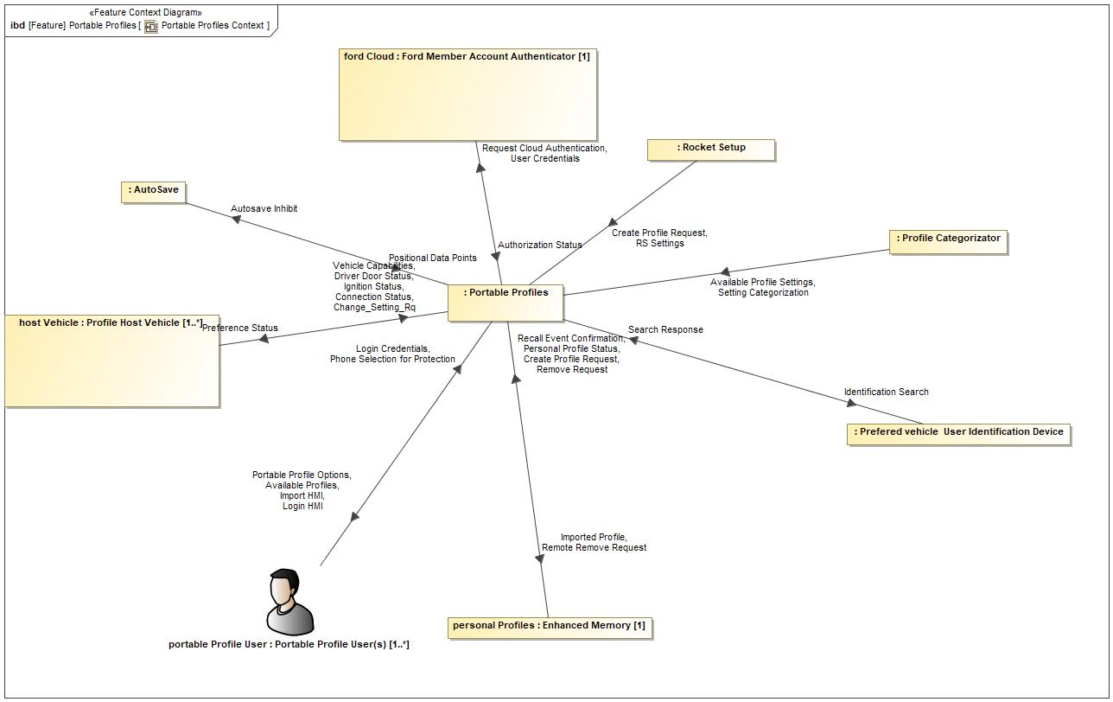

Figure 4: Portable Profiles Context

## List of Influences

|  |  |  |
| --- | --- | --- |
| **ID** | **External Entity** | **Influence Description** |
| Authorization Status |  | User is authenticated by the cloud account manager. |
| Autosave Inhibit | Portable Profiles To AutoSave | Portable Profiles inhibiting the auto save functionality due to profile protection status. |
| Available Profile Settings |  | Defined list of profile parameters defined by the Profile Attribute. |
| Available Profiles | Portable Profiles To | Available profiles as a result of an identification search |
| Change_Setting_Rq |  | User's input to changes to their Portable Profile settings. |
| Connection Status |  | Sync Bluetooth tells PPP which mobile device is actively paired to the vehicle. |
| Create Profile Request | Rocket Setup To Portable Profiles | Request to create a profile that is send from Enhanced Memory to the Profile Management Server of PPP. |
| personal Profiles (Enhanced Memory) To Portable Profiles | Request to create a profile that is send from Enhanced Memory to the Profile Management Server of PPP. |
| Driver Door Status |  | Vehicle tells PPP when the driver door goes from closed to ajar. |
| Identification Search | Portable Profiles To | Portable Profiles searching for available profiles. |
| Ignition Status |  | Vehicle tells PPP what the ignition status of the vehicle is. |
| Import HMI | Portable Profiles To | HMI to allow the user to import a profile. |
| Imported Profile | Portable Profiles To personal Profiles (Enhanced Memory) | Notify Enhanced Memory that there is a new imported profile in the vehicle. |
| Login Credentials |  | User providing login credentials to the system. |
| Login HMI | Portable Profiles To | HMI to allow the user to input their user credentials. |
| Personal Profile Status | personal Profiles (Enhanced Memory) To Portable Profiles | Profile active/inactive status. |
| Phone Selection for Protection |  | User deciding which phone to user for profile protection. |
| Portable Profile Options | Portable Profiles To | The feature providing the user with profile options for their settings. |
| Positional Data Points | AutoSave To Portable Profiles | Autosave notifying PPP which positional data point should be part of the profile. |
| Preference Status | Portable Profiles To |  |
| Recall Event Confirmation | personal Profiles (Enhanced Memory) To Portable Profiles | Enhanced Memory telling PPP that there has been a Profile Recall Event. |
| Remote Remove Request | Portable Profiles To personal Profiles (Enhanced Memory) | Remove profile request coming from outside of the vehicle will be sent from the Profile Management Server to Enhanced Memory so that Enhanced Memory can perform a delete profile operation. |
| Remove Request | personal Profiles (Enhanced Memory) To Portable Profiles | Remove request coming from Enhanced Memory. |
| Request Cloud Authentication | Portable Profiles To | PPP requesting the cloud to authenticate a user's credentials. |
| RS Settings | Rocket Setup To Portable Profiles | Pre-determined group of settings that Rocket Setup will use to populate a newly created Portable Profile. |
| Search Response |  | Mobile devices in vicinity of host vehicle responding to a search request. |
| Setting Categorization |  | Profile Attribute deciding how to categorize profile data. |
| User Credentials | Portable Profiles To | User credentials being sent from PPP to cloud to be verified. |
| Vehicle Capabilities |  | Vehicle providing information to PPP about what personalized features it has. |

Table 9: List of Influences

# Feature Modeling

## Operation Modes and States

**#Classification:** Optional (Mandatory for Functional Safety)

**#Link:** [RE Wiki – State Charts](http://wiki.ford.com/display/RequirementsEngineering/State+Charts?src=contextnavpagetreemode)

**#Hint:** State Charts are a popular means to express feature behavior in terms of states and modes. An advantage of this state machine like approach is that consistency can be easily verified.

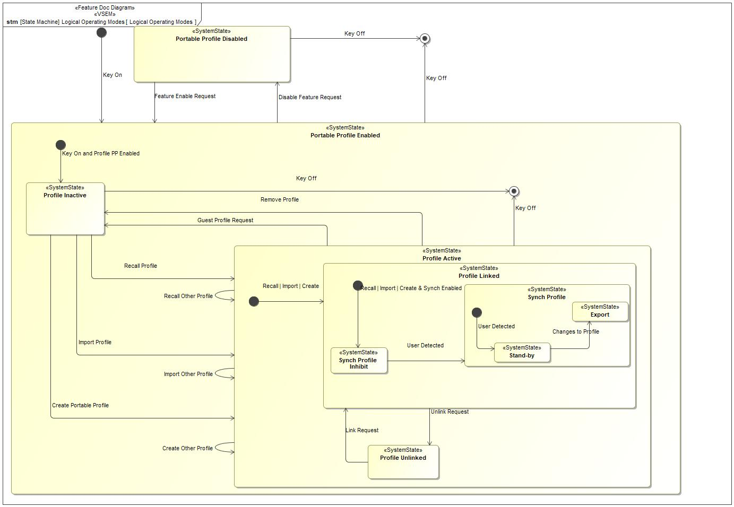

Figure 5: Logical Operating Modes

|  |  |  |
| --- | --- | --- |
| **State** | **Description** | **Requirements Reference** (optional) |
| Export | Changes are made to an active profile and the settings are synchronized with the master profile in the cloud. |  |
| Portable Profile Disabled | Feature is disabled in the host vehicle. |  |
| Portable Profile Enabled | Feature is Enabled in the host vehicle. |  |
| Profile Active | There is an active Profile in the host vehicle. |  |
| Profile Inactive | There is no active Profile in the host vehicle. |  |
| Profile Linked | The active profile is linked to a FordPass account. |  |
| Profile Unlinked | The active Profile is not linked to a FordPass account. |  |
| Stand-by | Portable Profile is able to accept preference changes. |  |
| Synch Profile | Autosave is enabled, owner of the active Profile is identified by the feature. |  |
| Synch Profile Inhibit | Autosave is inhibited for the active Profile because the owner of the active Profile has not been identified. |  |

Table 10: Operation Modes and States on Logical Operating Modes

|  |  |  |
| --- | --- | --- |
| **Transition ID** | **Description** | **Requirements Reference**  (optional) |
| T1 | Trigger signal: Key Off |  |
| T2 | Trigger signal: Key On |  |
| T3 | Trigger signal: Create Other Profile |  |
| T4 | Trigger signal: Key Off |  |
| T5 | Trigger signal: Changes to Profile |  |
| T6 | Trigger signal: Link Request |  |
| T7 | Trigger signal: Unlink Request |  |
| T8 | Trigger signal: Key Off |  |
| T9 | Trigger signal: Feature Enable Request |  |
| T10 | Trigger signal: Recall | Import | Create & Synch Enabled |  |
| T11 | Trigger signal: Import Profile |  |
| T12 | Trigger signal: User Detected |  |
| T13 | Trigger signal: Create Portable Profile |  |
| T14 | Trigger signal: User Detected |  |
| T15 | Trigger signal: Recall Profile |  |
| T16 | Trigger signal: Disable Feature Request |  |
| T17 | Trigger signal: Recall | Import | Create |  |
| T18 | Trigger signal: Key Off |  |
| T19 | Trigger signal: Key On and Profile PP Enabled |  |
| T20 | Trigger signal: Import Other Profile |  |
| T21 | Trigger signal: Guest Profile Request |  |
| T22 | Trigger signal: Remove Profile |  |
| T23 | Trigger signal: Recall Other Profile |  |

Table 11: Transitions between Operation Modes and States on Logical Operating Modes

## Use Cases

**#Classification:** Optional

**#Link:** [RE Wiki – Use Cases](http://wiki.ford.com/display/RequirementsEngineering/Use+Cases+Overview?src=contextnavpagetreemodehttp://wiki.ford.com/display/RequirementsEngineering/Use+Cases?src=contextnavpagetreemode)

### Use Case Diagram

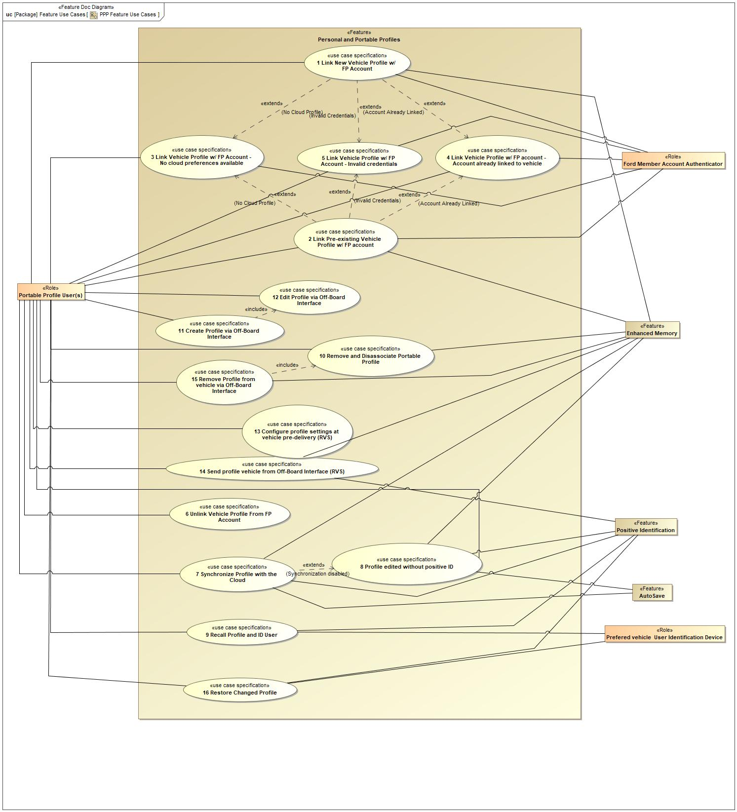

Figure 6: PPP Feature Use Cases

### Actors

| **Actor** | **Description** |
| --- | --- |
| AutoSave | Feature that automatically saves the positional preferences to an active profile. |
| Enhanced Memory | Memory system that associates several personalized settings to a memory seat button and key fob. |
| Ford Member Account Authenticator | System used to authenticate users of the Ford ecosystem. |
| Portable Profile User(s) | User of the PPP feature. This person initiates the use cases. |
| Positive Identification | Vehicle function that identifies who is inside of a Ford/Lincoln vehicle. |
| Prefered vehicle User Identification Device | A device (Bluetooth, NFC, etc.) used by the user of the PPP feature to identify themselves in the vehicle. |

Table 12: List of Actors

### Use Case Descriptions

**#Classification:** Optional

REQ-387142/A 1 Link New Vehicle Profile w/ FP Account

|  |  |  |
| --- | --- | --- |
| **Actors** |  | Enhanced Memory |
|  | Ford Member Account Authenticator |
|  | Portable Profile User(s) |
| **Subject** |  | Personal and Portable Profiles |
| **Description** |  | User adds/creates a new vehicle profile and links it to their FordPass Account. Any cloud profile preferences will be downloaded and applied to new vehicle profile. |
| **Preconditions** | PreC1 | Account has pre-existing profile preferences |
| PreC2 | User has a valid FordPass account |
| PreC3 | Vehicle has cloud connectivity |
| **Triggers** | T1 | User navigates to profile screen and selects to add a new profile. |
| **Main Flow Description** |  | User navigates to vehicle profile menu and add/creates a profile. User enters FordPass account credentials in vehicle and is authenticated. Vehicle imports pre-existing profile preferences while user finishes in vehicle profile creation. Profile preferences are applied to the newly created vehicle profile. |
| **Main Flow** | M1 | User selects to add a new vehicle profile. |
| M2 | In Vehicle Login provides HMI that allows the user to input their FordPass login credentials. Screen may also provide alternative method to provide FordPass Login, such as QR code. |
| M3 | User inputs FordPass credentials via method provided. |
| M4 | In Vehicle Login authenticates user credentials. |
| M5 | Cloud profile that is associated to linked FordPass account is downloaded to the host vehicle. |
| M6 | Vehicle HMI prompts user to enable or disable positive ID. |
| M7 | User selects to enable positive ID. |
| M8 | Vehicle HMI prompts user to setup primary authentication method. |
| M9 | Vehicle HMI prompts user to create a secondary authentication passcode. |
| M10 | Cloud profile preferences are applied to the newly created vehicle profile. |
| M11 | New Profile is made active. |
| **Alternative Flow Description** |  | See "Link Vehicle Profile w/ FP Account - Invalid credentials" use case. |
| **Exceptional Flow Description** |  | See "Link Vehicle Profile w/ FP Account - No cloud preferences available" use case. |
| **Exceptional Flow Description** |  | See "Link Vehicle Profile w/ FP Account - Account already linked to vehicle" use case. |
| **Postconditions** | PostC1 | Cloud profile preferences applied to vehicle profile. |
| PostC2 | FordPass account associated to vehicle and vehicle profile. |
| PostC3 | Positive ID methods configured for profile. |

REQ-387150/A 2 Link Pre-existing Vehicle Profile w/ FP account

|  |  |  |
| --- | --- | --- |
| **Actors** |  | Enhanced Memory |
|  | Ford Member Account Authenticator |
|  | Portable Profile User(s) |
| **Subject** |  | Personal and Portable Profiles |
| **Description** |  | User links their FordPass account to a pre-existing vehicle profile. Any cloud profile preferences will be downloaded and applied to the vehicle profile. |
| **Preconditions** | PreC1 | Enhanced Memory (Personal Profile) created in vehicle |
| PreC2 | User has valid FordPass account |
| PreC3 | Vehicle has cloud connectivity |
| **Triggers** | T1 | Portable Profile User navigates to pre-exisiting vehicle profile. |
| **Main Flow Description** |  | User enters vehicle profile menu and selects target profile. Option to link profile is provided and user selects. User enters login credentials and links their profile to their account. If there is a cloud profile associated with the linked FordPass account, the cloud profile preferences will be imported and applied to the vehicle profile. |
| **Main Flow** | M1 | Vehicle HMI displays selected profile with the option to link their FordPass account. |
| M2 | User selects option to link their FordPass account. |
| M3 | In-Vehicle Login provides HMI screen that asks the user to input their FordPass Login credentials. Screen may also provide alternative method to provide FordPass Login, such as QR code. |
| M4 | User inputs FordPass Login credentials via method provided. |
| M5 | In-Vehicle Login authenticates user credentials. |
| M6 | Check if there is an associated cloud profile |
| M7 | If there is, the cloud profile is downloaded and applied to the vehicle profile. |
| **Alternative Flow Description** |  | See "Link Vehicle Profile w/ FP Account - Invalid Credentials" use case. |
| **Exceptional Flow Description** |  | See "Link Vehicle Profile w/ FP Account - no cloud preferences" use case. |
| **Exceptional Flow Description** |  | See "Link Vehicle Profile w/ FP Account - Account already linked to vehicle" use case. |
| **Postconditions** | PostC1 | Cloud Profile preferences are downloaded and applied to the pre-exisiting vehicle profile. |
| PostC2 | Pre-existing vehicle profile is linked to the users FordPass account. |

REQ-387143/A 3 Link Vehicle Profile w/ FP Account - No cloud preferences available

|  |  |  |
| --- | --- | --- |
| **Actors** |  | Enhanced Memory |
|  | Ford Member Account Authenticator |
|  | Portable Profile User(s) |
| **Subject** |  | Personal and Portable Profiles |
| **Description** |  | User links their FordPass account to a vehicle profile, but there are no cloud profile preferences to download. Vehicle profile preferences are exported to create the cloud profile. |
| **Preconditions** | PreC1 | FordPass account does not have an associated cloud profile |
| PreC2 | User has a valid FordPass Account |
| PreC3 | Vehicle has cloud connectivity |
| **Triggers** | T1 | User linked their FordPass account to a vehicle profile. |
| **Main Flow Description** |  | Vehicle profile settings are collected and exported as soon as the vehicle profile is created and linked to a FordPass account. The exported profile settings create a cloud profile associated to the linked FordPass account. |
| **Main Flow** | M1 | Vehicle collects portable vehicle profile settings. |
| M2 | Vehicle sends profile settings to the cloud. |
| M3 | Cloud creates a cloud profile for the linked FordPass account and populates the profile with the exported portable vehicle profile settings. |
| **Postconditions** | PostC1 | Cloud profile contains portable vehicle settings exported from the vehicle profile. |
| PostC2 | Cloud profile created for linked FordPass account. |

REQ-387145/A 4 Link Vehicle Profile w/ FP account - Account already linked to vehicle

|  |  |  |
| --- | --- | --- |
| **Actors** |  | Enhanced Memory |
|  | Ford Member Account Authenticator |
|  | Portable Profile User(s) |
| **Subject** |  | Personal and Portable Profiles |
| **Description** |  | User attempts to link a vehicle profile to a FordPass account that is already linked to a different vehicle profile in the same vehicle. |
| **Preconditions** | PreC1 | User has a valid FordPass account |
| PreC2 | User's FordPass account is already linked to another profile on host vehicle. |
| PreC3 | Vehicle has cloud connectivity. |
| **Triggers** | T1 | User attempts to link a vehicle profile to a FordPass account. |
| **Main Flow Description** |  | User attempts to link a FordPass account to a vehicle profile that the account is already associated to it. HMI displays notification that account already linked to another vehicle profile. HMI provides option for user to recall the linked profile or to cancel the operation. |
| **Main Flow** | M1 | Vehicle compares FordPass account authentication to other vehicle profiles. |
| M2 | ForPass account is found to be linked to another vehicle profile. |
| M3 | Vehicle HMI displays option for user to recall the linked vehicle profile or to cancel the operation. |
| **Postconditions** | PostC1 | User notified that account is already linked |
| PostC2 | Vehicle HMI displays option to recall linked account or cancel operation. |

REQ-387144/A 5 Link Vehicle Profile w/ FP Account - Invalid credentials

|  |  |  |
| --- | --- | --- |
| **Actors** |  | Enhanced Memory |
|  | Ford Member Account Authenticator |
|  | Portable Profile User(s) |
| **Subject** |  | Personal and Portable Profiles |
| **Description** |  | User enters invalid FordPass credentials when attempting to link their FordPass account to a vehicle profile. |
| **Preconditions** | PreC1 | User has attempted to enter credentials less than 5 times. |
| PreC2 | Vehicle has cloud connectivity |
| **Triggers** | T1 | User attempts to link FordPass account to vehicle profile. |
| **Main Flow Description** |  | User enters invalid FordPass account credentials when attempting to associate account with vehicle and vehicle profile. FordPass account is found to be invalid and the vehicle HMI allows the user to re-submit their account credentials. |
| **Main Flow** | M1 | In Vehicle Login attempts to authenticate FordPass credentials. |
| M2 | In Vehicle Login finds credentials to be invalid. |
| M3 | Vehicle HMI prompts user to re-submit FordPass credentials until the user cancels the operation, credentials are authenticated or the maximum ammount of attempts has been reached (maximum is 5). |
| **Postconditions** | PostC1 | Vehicle HMI prompts user to re-submit account credentials |

REQ-352312/A 6 Unlink Vehicle Profile From FP Account

|  |  |  |
| --- | --- | --- |
| **Actors** |  | Portable Profile User(s) |
| **Subject** |  | Feature |
| **Subject** |  | Personal and Portable Profiles |
| **Description** |  | User unlinks their profile from their FordPass account. |
| **Preconditions** | PreC1 | Owner of the profile is positively identified or positive ID is disabled. |
| PreC2 | Profile is linked to a FordPass account |
| **Triggers** | T1 | User navigates to their vehicle profile menu. |
| **Main Flow Description** |  | User navigates to their linked vehicle profile and selects to unlink their profile from their FordPass account. |
| **Main Flow** | M1 | User selects to unlink their profile. |
| M2 | Profile is unlinked from the FordPass account. |
| **Alternative Flow Description** |  | Owner of the vehicle profile is not positively identified.User attempts to unlink their profile from their FordPass account. Vehicle HMI prompts the user to input their secondary authentication passcode to make the change. |
| **Postconditions** | PostC1 | Profile is not linked to a FordPass account. |

REQ-387147/A 7 Synchronize Profile with the Cloud

|  |  |  |
| --- | --- | --- |
| **Actors** |  | AutoSave |
|  | Enhanced Memory |
|  | Portable Profile User(s) |
|  | Positive Identification |
| **Subject** |  | Feature |
| **Subject** |  | Personal and Portable Profiles |
| **Description** |  | User makes a change to their profile settings and the settings are exported and synchronized with the master copy. |
| **Preconditions** | PreC1 | Change was made to at least one vehicle profile setting |
| PreC2 | Owner of active profile is positively identified by the vehicle or positive ID is disabled |
| PreC3 | Vehicle has cloud connectivity |
| PreC4 | Vehicle profile is linked to FordPass account |
| **Triggers** | T1 | User switches vehicle profiles |
| T2 | User turns off vehicle |
| **Main Flow Description** |  | Changes made to portable vehicle profile settings are collected and ready to be sent to the cloud. Upon the export trigger (profile change or vehicle off), only the changed setting is exported to the linked FordPass cloud profile. |
| **Main Flow** | M1 | Vehicle exports any portable vehicle profile settings that have changed. |
| M2 | Cloud receives changed settings and updates the linked cloud profile with the altered settings. |
| **Postconditions** | PostC1 | All changed portable vehicle preference settings are sent to the cloud and updated in linked cloud profile. |

REQ-387148/A 8 Profile edited without positive ID

|  |  |  |
| --- | --- | --- |
| **Actors** |  | AutoSave |
|  | Enhanced Memory |
|  | Portable Profile User(s) |
|  | Positive Identification |
| **Subject** |  | Personal and Portable Profiles |
| **Description** |  | A change is made to a vehicle profile setting, but the owner of that profile is not identified or Synchronization is disabled for that profile. |
| **Preconditions** | PreC1 | Positive ID is enabled for the active profile. |
| PreC2 | Profile owner is not positively identified. |
| **Triggers** | T1 | Change is made to profile setting/preference. |
| **Main Flow Description** |  | A change is made to a profile setting/preference. The preference will be active in the vehicle but will not be saved to the vehicle profile or exported to the cloud profile |
| **Main Flow** | M1 | Vehicle HMI prompts user to enter secondary authentication passcode. |
| M2 | User does not input passcode and selects to cancel. |
| M3 | Vehicle profile does not save changed setting. |
| **Alternative Flow Description** |  | User does input secondary authentication passcode. User is positively identified and that changed setting is saved to the vehicle profile and synchronized with the cloud. |
| **Postconditions** | PostC1 | Changed setting is not saved or synchronized withthe cloud profile. |

9 Recall Profile and ID User

|  |  |  |
| --- | --- | --- |
| **Actors** |  | Portable Profile User(s) |
|  | Positive Identification |
|  | Prefered vehicle User Identification Device |
| **Subject** |  | Personal and Portable Profiles |
| **Description** |  | A user profile is recalled in a vehicle and the feature attempts to positively identify the owner of the profile, if enabled by the user. |
| **Preconditions** | PreC1 | Profile saved to host vehicle |
| **Triggers** | T1 | Profile recalled in Host Vehicle |
| **Main Flow Description** |  | A Portable Profile User recalls their profile in the vehicle. Upon recall the feature attempts to positively identify the user using their primary authentication method (if enabled). Upon profile authentication the vehicle downloads a newer profile version from the cloud. |
| **Main Flow** | M1 | User enters host vehicle and profile is recalled. |
| M2 | Recalled profile settings are made active. |
| M3 | Positive Identification system attempts to identify the User through their primary authentication method. |
| M4 | User is positively identified and their profile is fully activated. |
| M5 | Profile authentication status is displayed to the user. |
| M6 | The feature checks the cloud profile storage for an updated profile. |
| M7 | Updated profile is downloaded and applied to the active vehicle profile. |
| **Alternative Flow Description** |  | Positive ID is disabled for the profile. Profile settings are recalled and activated and the feature checks for a newer profile version in the cloud. |
| **Alternative Flow Description** |  | Primary authentication fails and the vehicle prompts the user to enter their secondary authentication method (passcode). |
| **Exceptional Flow Description** |  | Neither primary nor secondary authentication methods are successful in positively identifying the user. Profile is not authenticated and is inhibited from updates. |
| **Postconditions** | PostC1 | Portable Profile User is positively identified as the owner of the active profile. |
| PostC2 | Updated profile version (if available) is downloaded and applied to the vehicle profile |

REQ-352329/A 10 Remove and Disassociate Portable Profile

|  |  |  |
| --- | --- | --- |
| **Actors** |  | Enhanced Memory |
|  | Portable Profile User(s) |
| **Subject** |  | Feature |
| **Subject** |  | Personal and Portable Profiles |
| **Description** |  | Removing a Portable Profile while inside a host vehicle. |
| **Preconditions** | PreC1 | Vehicle has cloud connectivity. |
| PreC2 | Vehicle profile linked to FordPass account. |
| **Triggers** | T1 | User navigates to profile menu. |
| **Main Flow Description** |  | User removes their linked vehicle profile from the vehicle. A request is sent to the cloud to disassociate the cloud profile from the specified vehicle. |
| **Main Flow** | M1 | User removes vehicle profile from the vehicle. |
| M2 | Request sent from vehicle to cloud to disassociate cloud profile from specified vehicle. |
| M3 | Cloud profile disassociates from the vehicle. |
| **Postconditions** | PostC1 | Cloud profile disassociated from specified vehicle. |
| PostC2 | Vehicle profile removed from vehicle. |

REQ-352316/A 11 Create Profile via Off-Board Interface

|  |  |  |
| --- | --- | --- |
| **Actors** |  | Ford Member Account Authenticator |
|  | Portable Profile User(s) |
| **Subject** |  | Feature |
| **Subject** |  | Personal and Portable Profiles |
| **Description** |  | User creates a Cloud profile that is associated with their FordPass account using an off-board (not in vehicle) interface. |
| **Preconditions** | PreC1 | User does not have a cloud profile associated with their FordPass account |
| PreC2 | User has a FordPass account |
| PreC3 | User has a means to access the FordPass account (FordPass App or Owners site) |
| **Triggers** | T1 | User opens off-board profile user interface and navigates to the cloud profile interface. |
| **Main Flow Description** |  | User opens cloud profile interface and selects to create a cloud profile. The cloud profile interface will display profile settings and preferences for the user to configure. Once completed, the profile settings/preferences are sent to the cloud profile storage. Cloud profile is created and associated with FordPass account. |
| **Main Flow** | M1 | User enters cloud profile interface. |
| M2 | User selects to create a cloud profile. |
| M3 | Cloud profile interface displays profile settings and preferences for the user to configure. |
| M4 | User configures profile settings and preferences. |
| M5 | User saves settings/preferences and completes profile creation. |
| M6 | Settings/preferences are sent to the cloud profile storage and are associated with the FordPass account. |
| **Postconditions** | PostC1 | Cloud profile is associated with the user's FordPass account. |
| PostC2 | Cloud profile is created and stored in cloud profile storage. |

REQ-387149/A 12 Edit Profile via Off-Board Interface

|  |  |  |
| --- | --- | --- |
| **Actors** |  | Portable Profile User(s) |
| **Subject** |  | Personal and Portable Profiles |
| **Description** |  |  |
| **Preconditions** | PreC1 | Cloud profile previously created for FordPass account. |
| PreC2 | User logged into FordPass account. |
| **Triggers** | T1 | User enters cloud profile interface, via FordPass app or Owner's site, and selects to edit their profile. |
| **Main Flow Description** |  | User selects to edit their cloud profile. Cloud profile interface displays profile settings/preferences that are able to be editted via off-board interface. User makes changes and saves to the cloud profile storage. |
| **Main Flow** | M1 | User selects to edit their cloud profile. |
| M2 | Cloud profile interface displays profile settings and preferences that are able to be editted. |
| M3 | User makes desired changes to the cloud profile. |
| M4 | Changes are saved and sent to the cloud profile storage. |
| **Postconditions** | PostC1 | All cloud profile changes are saved and stored in the cloud profile storage. |

REQ-387151/A 13 Configure profile settings at vehicle pre-delivery (RVS)

|  |  |  |
| --- | --- | --- |
| **Actors** |  | Portable Profile User(s) |
| **Subject** |  | Personal and Portable Profiles |
| **Description** |  | User orders a vehicle and is able to pre-configure specific vehicle preferences before receiving the vehicle. |
| **Preconditions** | PreC1 | User has a FordPass account. |
| PreC2 | User has a cloud profile associated to their FordPass account. |
| **Triggers** | T1 | Initial purchase/order status to enable Remote Vehicle Setup |
| T2 | VIN of desired vehicle added to FordPass garage |
| **Main Flow Description** |  | After receiving the initial purchase/order status the Remote Vehicle Setup option is enabled in FordPass. The user selects this option and is prompted with vehicle specific settings/preferences that they can configure. Some settings will be pre-populated with cloud profile preferences. The user will configure any desired settings and save to their cloud profile. |
| **Main Flow** | M1 | Remote Vehicle Setup option is enabled on FordPass and Owner's site. |
| M2 | User selects option and opens Remote Vehicle Setup. |
| M3 | Remote Vehicle Setup displays vehicle specific settings/preferences to the user. |
| M4 | The user configures any desired settings. |
| M5 | Configured settings are saved and sent to the cloud profile storage. |
| **Alternative Flow Description** |  | User does not have a cloud profile created yet. Remote Vehicle Setup will prompt user to create a cloud profile first before configuring their Remote Vehicle Setup preferences. |
| **Postconditions** | PostC1 | All pre-configured settings are stored in the cloud profile. |

REQ-387146/A 14 Send profile vehicle from Off-Board Interface (RVS)

|  |  |  |
| --- | --- | --- |
| **Actors** |  | Enhanced Memory |
|  | Portable Profile User(s) |
|  | Positive Identification |
| **Subject** |  | Personal and Portable Profiles |
| **Description** |  | User remotely sends their cloud profile to a specific vehicle using the FordPass App. |
| **Preconditions** | PreC1 | User has a FordPass account |
| PreC2 | User has a cloud profile associated to their FordPass account |
| **Triggers** | T1 | VIN of desired vehicle is added to the FordPass garage. |
| **Main Flow Description** |  | User navigates to desired vehicle in FordPass garage. FordPass displays the option to send the user's cloud profile to the vehicle. The user selects the option and the cloud profile is sent to the vehicle. In the vehicle, the user is positively identified and then welcomed to the vehicle (using name in cloud profile). The user is prompted to create a vehicle profile. Cloud profile settings are applied to the newly created vehicle profile. |
| **Main Flow** | M1 | User navigates to desired vehicle in FordPass garage. |
| M2 | FordPass displays option to send cloud profile to the vehicle. |
| M3 | User selects the option to send profile to the vehicle. |
| M4 | FordPass prompts the user to confirm settings selection and send profile to vehicle. |
| M5 | User confirms and sends profile to the vehicle. |
| M6 | Vehicle downloads and stores the cloud profile settings. |
| M7 | User turns on vehicle and provides positive ID (BLE Auto Pair, In-Vehicle Login) |
| M8 | Vehicle HMI welcomes the user (using NAME in cloud profile) |
| M9 | User accepts welcome and is prompted to created a vehicle profile. |
| M10 | Once the vehicle profile is created, the downloaded settings are applied to the newly created profile. |
| **Alternative Flow Description** |  | User postpones the welcome screen. The user will be able to access this welcome screen later (next key cycle or in the Vehicle Profiles menu) |
| **Exceptional Flow Description** |  | User decides to reject welcome screen. Downloaded profile settings are deleted from the vehicle and no vehicle profile is created. |
| **Postconditions** | PostC1 | Cloud profile settings are imported and applied to a newly created vehicle profile. |
| PostC2 | Vehcile profile is linked with the user's FordPass account. |

REQ-352308/A 15 Remove Profile from vehicle via Off-Board Interface

|  |  |  |
| --- | --- | --- |
| **Actors** |  | Enhanced Memory |
|  | Portable Profile User(s) |
| **Subject** |  | Feature |
| **Subject** |  | Personal and Portable Profiles |
| **Description** |  | Vehicle profile is removed from a specific vehicle. The cloud profile is also disassociated from the vehicle. |
| **Preconditions** | PreC1 | Receiving vehicle has cellular connection to cloud |
| PreC2 | User has FordPass Account |
| PreC3 | User has a cloud profile associated to their FordPass account |
| PreC4 | Vehicle profile linked to FordPass account is saved to specified vehicle |
| **Triggers** | T1 | User navigates to their profile in Cloud Profile Interface (FordPass app or owner's site). |
| **Main Flow Description** |  | User navigates to cloud profile menu in FordPass or Owners Site. User selects to remove their vehicle profile from a specific vehicle. Request is sent from the cloud to the specified vehicle. Vehicle executes the remove operation and alerts the cloud. Cloud profile disassociates form the specified vehicle. |
| **Main Flow** | M1 | Option to remove profile from specific vehicles is displayed to the user. |
| M2 | User selects which vehicle to remove their profile from. |
| M3 | Request is sent from the cloud to the specified vehicle to remove the profile. |
| M4 | When available, the vehicle receives the request and executes the remove operation. |
| M5 | Vehicle alerts cloud of successful vehicle profile removal. |
| M6 | Cloud profile disassociates from the specified vehicle. |
| **Postconditions** | PostC1 | Cloud profile is disassociated from specified vehicle. |
| PostC2 | Linked vehicle profile removed from specified vehicle. |

16 Restore Changed Profile

|  |  |  |
| --- | --- | --- |
| **Actors** |  | Portable Profile User(s) |
|  | Positive Identification |
|  | Prefered vehicle User Identification Device |
| **Subject** |  | Personal and Portable Profiles |
| **Description** |  | Correcting un-wanted changes made to a user's portable profile in a vehicle. |
| **Preconditions** | PreC1 | Changes made to user profile when profile was not authenticated. |
| PreC2 | User is authenticated |
| **Triggers** | T1 | User's profile is recalled and the user is authenticated |
| **Main Flow Description** |  | Changes were made to a user's profile when the user was not positively identified and authenticated in the vehicle. The changed settings are automatically corrected for the user. |
| **Main Flow** | M1 | User's profile is recalled and user is authenticated. |
| M2 | PPP feature recognizes that un-accepted changes were made to some profile settings. |
| M3 | PPP feature applies correct profile settings to the user's active profile. |
| **Postconditions** | PostC1 | Correct profile settings are applied to the user's active profile. |

## Driving and Operation Scenarios

**#Classification:** Optional (Mandatory for Functional Safety)

**#Functional Safety:** Driving and operating scenarios which impact the functionality of the feature can be used to check, if the situation analysis in the HARA is complete

**#Link:** [RE Wiki – Driving Scenarios](http://wiki.ford.com/display/RequirementsEngineering/Driving+Scenarios?src=contextnavpagetreemode)

## Decision Tables

**#Classification:** Optional

**#Link:** [RE Wiki – Decision Tables](http://wiki.ford.com/display/RequirementsEngineering/Decision+Table).

**#Hint:** Use decision table, if behavior is not state based (in that case prefer state chart from ch. 5.1) and based purely on current inputs.

*Not supported by MagicDraw report generation.*

# Feature Requirements

**#Functional Safety:** In general, safety requirements are not listed here. However, it is possible that later in the development process, a non-safety requirement becomes a safety requirement. In such a case it may remain on this list.

**#Link:** [RE Wiki – How to write good requirements](http://wiki.ford.com/display/RequirementsEngineering/How+to+write+better+requirements?src=contextnavpagetreemode).

## Functional Requirements

Profile Protection Mode

The PPP feature shall contain a profile protection mode for profiles that have positive ID enabled for their profile. Profile protection mode shall include the following functions:

- Inhibit saving of profile settings to the central profile storage

- Inhibit the AutoSave feature

- Prohibit access to PII data

|  |  |  |  |  |  |  |  |
| --- | --- | --- | --- | --- | --- | --- | --- |
| Requirement ID: | | | | | | | |
| **Rationale** |  | | | | | | |
| **Acceptance Criteria** |  | | | | | | |
| **Notes** |  | | | | | | |
| **Source** |  | | | | | **Owner** |  |
| **Source Req.** |  | | | | | **V&V Method** |  |
| **Type** |  | | | **Priority** |  | **Status** | In-Progress |
| [Req. Template](http://wiki.ford.com/display/RequirementsEngineering/Requirements+Attributes) Version | | 6.0 | End of Requirement | | | | |

Normalize seat position on export

When profile seat settings are exported to the cloud, the seat positions shall be normalized via the export calculation. (See definition for normalized seat position)

|  |  |  |  |  |  |  |  |
| --- | --- | --- | --- | --- | --- | --- | --- |
| Requirement ID: | | | | | | | |
| **Rationale** |  | | | | | | |
| **Acceptance Criteria** |  | | | | | | |
| **Notes** |  | | | | | | |
| **Source** |  | | | | | **Owner** |  |
| **Source Req.** |  | | | | | **V&V Method** |  |
| **Type** |  | | | **Priority** |  | **Status** | In-Progress |
| [Req. Template](http://wiki.ford.com/display/RequirementsEngineering/Requirements+Attributes) Version | | 6.0 | End of Requirement | | | | |

X seat position delta calculation

The visor point, hood top point, front hinge pillar point and steering wheel point shall be used to calculate the X seat position delta from hood top point.

|  |  |  |  |  |  |  |  |
| --- | --- | --- | --- | --- | --- | --- | --- |
| Requirement ID: | | | | | | | |
| **Rationale** |  | | | | | | |
| **Acceptance Criteria** |  | | | | | | |
| **Notes** |  | | | | | | |
| **Source** |  | | | | | **Owner** |  |
| **Source Req.** |  | | | | | **V&V Method** |  |
| **Type** |  | | | **Priority** |  | **Status** | In-Progress |
| [Req. Template](http://wiki.ford.com/display/RequirementsEngineering/Requirements+Attributes) Version | | 6.0 | End of Requirement | | | | |

Anthropometric Translation Data Points

Anthropometric Translation shall require the following data elements in order to perform an import or export calculation:

- Host vehicle SgRP (seating reference point)

- Host vehicle Absolute Positioning points

- Seat motor conversion factor for each seat axis

- Host vehicle visor point

- Host vehicle hood top point

- Host vehicle front hinge pillar point

- Host vehicle steering wheel point

|  |  |  |  |  |  |  |  |
| --- | --- | --- | --- | --- | --- | --- | --- |
| Requirement ID: | | | | | | | |
| **Rationale** |  | | | | | | |
| **Acceptance Criteria** |  | | | | | | |
| **Notes** |  | | | | | | |
| **Source** |  | | | | | **Owner** |  |
| **Source Req.** |  | | | | | **V&V Method** |  |
| **Type** |  | | | **Priority** |  | **Status** | In-Progress |
| [Req. Template](http://wiki.ford.com/display/RequirementsEngineering/Requirements+Attributes) Version | | 6.0 | End of Requirement | | | | |

Absolute Positioning Requirement for Anthropometric Translation

Absolute Positioning shall be present on all vehicles that require Anthropometric Translation.

|  |  |  |  |  |  |  |  |
| --- | --- | --- | --- | --- | --- | --- | --- |
| Requirement ID: | | | | | | | |
| **Rationale** |  | | | | | | |
| **Acceptance Criteria** |  | | | | | | |
| **Notes** |  | | | | | | |
| **Source** |  | | | | | **Owner** |  |
| **Source Req.** |  | | | | | **V&V Method** |  |
| **Type** |  | | | **Priority** |  | **Status** | In-Progress |
| [Req. Template](http://wiki.ford.com/display/RequirementsEngineering/Requirements+Attributes) Version | | 6.0 | End of Requirement | | | | |

Calculation to relate vehicle seat position delta from SgRP to Absolute Position

A secondary calculation shall relate the new vehicle seat position delta from SgRP to the vehicle absolute position.

|  |  |  |  |  |  |  |  |
| --- | --- | --- | --- | --- | --- | --- | --- |
| Requirement ID: | | | | | | | |
| **Rationale** |  | | | | | | |
| **Acceptance Criteria** |  | | | | | | |
| **Notes** |  | | | | | | |
| **Source** |  | | | | | **Owner** |  |
| **Source Req.** |  | | | | | **V&V Method** |  |
| **Type** |  | | | **Priority** |  | **Status** | In-Progress |
| [Req. Template](http://wiki.ford.com/display/RequirementsEngineering/Requirements+Attributes) Version | | 6.0 | End of Requirement | | | | |

When to use Anthropometric Translation Import Calculation

The Anthropometric Translation import calculation shall only happen on initial import to a new vehicle. Subsequent profile updates shall not incur the import calculation.

|  |  |  |  |  |  |  |  |
| --- | --- | --- | --- | --- | --- | --- | --- |
| Requirement ID: | | | | | | | |
| **Rationale** |  | | | | | | |
| **Acceptance Criteria** |  | | | | | | |
| **Notes** |  | | | | | | |
| **Source** |  | | | | | **Owner** |  |
| **Source Req.** |  | | | | | **V&V Method** |  |
| **Type** |  | | | **Priority** |  | **Status** | In-Progress |
| [Req. Template](http://wiki.ford.com/display/RequirementsEngineering/Requirements+Attributes) Version | | 6.0 | End of Requirement | | | | |

The Anthropometric Translation Algorithm Process

The Anthropometric Translation shall follow the following process:

1. Calculate vision angle from vehicle 1 with the hood top point Z and seat position Z

2. Maintain the same vision angle in vehicle 2 using the hoop top point and new seat position

3. Back calculate to find that point from SgRP (This is the new up/down Z seat position)

4. The seat shall position the driver so there is a simliar vision angle in vehicle 2 as vehicle 1

|  |  |  |  |  |  |  |  |
| --- | --- | --- | --- | --- | --- | --- | --- |
| Requirement ID: | | | | | | | |
| **Rationale** |  | | | | | | |
| **Acceptance Criteria** |  | | | | | | |
| **Notes** |  | | | | | | |
| **Source** |  | | | | | **Owner** |  |
| **Source Req.** |  | | | | | **V&V Method** |  |
| **Type** |  | | | **Priority** |  | **Status** | In-Progress |
| [Req. Template](http://wiki.ford.com/display/RequirementsEngineering/Requirements+Attributes) Version | | 6.0 | End of Requirement | | | | |

REQ-344341/A Active Portable Profile

A portable profile shall be considered active when the profile is recalled by Enhanced Memory and the profile owner is authenticated or has authentication disabled for the profile.

|  |  |  |  |  |  |  |  |
| --- | --- | --- | --- | --- | --- | --- | --- |
| Requirement ID: REQ-344341/A | | | | | | | |
| **Rationale** |  | | | | | | |
| **Acceptance Criteria** |  | | | | | | |
| **Notes** |  | | | | | | |
| **Source** | Enhanced Memory | | | | | **Owner** |  |
| **Source Req.** |  | | | | | **V&V Method** |  |
| **Type** |  | | | **Priority** |  | **Status** |  |
| [Req. Template](http://wiki.ford.com/display/RequirementsEngineering/Requirements+Attributes) Version | | 6.0 | End of Requirement | | | | |

REQ-352250/A Profile Attribute Settings

All settings that can be part of the Portable Profile shall be defined by the Profile Attribute Specification.

|  |  |  |  |  |  |  |  |
| --- | --- | --- | --- | --- | --- | --- | --- |
| Requirement ID: REQ-352250/A | | | | | | | |
| **Rationale** |  | | | | | | |
| **Acceptance Criteria** |  | | | | | | |
| **Notes** |  | | | | | | |
| **Source** |  | | | | | **Owner** |  |
| **Source Req.** |  | | | | | **V&V Method** |  |
| **Type** |  | | | **Priority** |  | **Status** |  |
| [Req. Template](http://wiki.ford.com/display/RequirementsEngineering/Requirements+Attributes) Version | | 6.0 | End of Requirement | | | | |

REQ-352253/A Positively Identify owner of an active vehicle profile using primary authentication method.

When a user's vehicle profile is active in a vehicle and positive ID is enabled for the profile, the PPP feature shall attempt to positively identify the owner of an active portable profile using one of the following primary authentication methods.

- Associated Bluetooth Device

- Facial Recognition (if available)

- Biometrics (if available)

- other methods accepted by Cyber Security to provide positive identification

|  |  |  |  |  |  |  |  |
| --- | --- | --- | --- | --- | --- | --- | --- |
| Requirement ID: REQ-352253/A | | | | | | | |
| **Rationale** |  | | | | | | |
| **Acceptance Criteria** |  | | | | | | |
| **Notes** |  | | | | | | |
| **Source** |  | | | | | **Owner** |  |
| **Source Req.** |  | | | | | **V&V Method** |  |
| **Type** |  | | | **Priority** |  | **Status** |  |
| [Req. Template](http://wiki.ford.com/display/RequirementsEngineering/Requirements+Attributes) Version | | 6.0 | End of Requirement | | | | |

REQ-352255/A Process remove request upon vehicle connection to the cloud

When a user sends a remote remove request to a specific vehicle, the PPP feature shall receive and handle the remove request when the vehicle gains connection to the cloud.

|  |  |  |  |  |  |  |  |
| --- | --- | --- | --- | --- | --- | --- | --- |
| Requirement ID: REQ-352255/A | | | | | | | |
| **Rationale** |  | | | | | | |
| **Acceptance Criteria** |  | | | | | | |
| **Notes** |  | | | | | | |
| **Source** |  | | | | | **Owner** |  |
| **Source Req.** |  | | | | | **V&V Method** |  |
| **Type** |  | | | **Priority** |  | **Status** |  |
| [Req. Template](http://wiki.ford.com/display/RequirementsEngineering/Requirements+Attributes) Version | | 6.0 | End of Requirement | | | | |

REQ-352258/A Profile Storage Out of Vehicle

The PPP feature shall maintain a profile storage in the cloud that contains all portable profile settings and is associated with a user's FordPass account.

|  |  |  |  |  |  |  |  |
| --- | --- | --- | --- | --- | --- | --- | --- |
| Requirement ID: REQ-352258/A | | | | | | | |
| **Rationale** |  | | | | | | |
| **Acceptance Criteria** |  | | | | | | |
| **Notes** |  | | | | | | |
| **Source** |  | | | | | **Owner** |  |
| **Source Req.** |  | | | | | **V&V Method** |  |
| **Type** |  | | | **Priority** |  | **Status** |  |
| [Req. Template](http://wiki.ford.com/display/RequirementsEngineering/Requirements+Attributes) Version | | 6.0 | End of Requirement | | | | |

REQ-352259/A Higher Content Vehicle

When a user's portable profile is imported into a vehicle with more content that can be personalized, the PPP feature shall add the incremental personalized content to the profile and export to the cloud when available.

|  |  |  |  |  |  |  |  |
| --- | --- | --- | --- | --- | --- | --- | --- |
| Requirement ID: REQ-352259/A | | | | | | | |
| **Rationale** |  | | | | | | |
| **Acceptance Criteria** |  | | | | | | |
| **Notes** |  | | | | | | |
| **Source** |  | | | | | **Owner** |  |
| **Source Req.** |  | | | | | **V&V Method** |  |
| **Type** |  | | | **Priority** |  | **Status** |  |
| [Req. Template](http://wiki.ford.com/display/RequirementsEngineering/Requirements+Attributes) Version | | 6.0 | End of Requirement | | | | |

REQ-352261/A Export Profile when changes are made to profile settings

When settings/preferences in an activated and FordPass linked portable profile are changed, the PPP feature shall export and synchronize only the updated settings to the linked cloud profile when either of the following occur:

- Vehicle is turned off

- A different profile is made active

|  |  |  |  |  |  |  |  |
| --- | --- | --- | --- | --- | --- | --- | --- |
| Requirement ID: REQ-352261/A | | | | | | | |
| **Rationale** |  | | | | | | |
| **Acceptance Criteria** |  | | | | | | |
| **Notes** |  | | | | | | |
| **Source** |  | | | | | **Owner** |  |
| **Source Req.** |  | | | | | **V&V Method** |  |
| **Type** |  | | | **Priority** |  | **Status** |  |
| [Req. Template](http://wiki.ford.com/display/RequirementsEngineering/Requirements+Attributes) Version | | 6.0 | End of Requirement | | | | |

REQ-352262/A Translate Profile Settings

When portable profile settings are imported into a vehicle from the cloud storage, the feature shall translate the settings so that the receiving vehicle will be able to properly apply the User's profile settings.

The settings that require translation shall be determined by the Profile Attribute Specification.

|  |  |  |  |  |  |  |  |
| --- | --- | --- | --- | --- | --- | --- | --- |
| Requirement ID: REQ-352262/A | | | | | | | |
| **Rationale** |  | | | | | | |
| **Acceptance Criteria** |  | | | | | | |
| **Notes** |  | | | | | | |
| **Source** |  | | | | | **Owner** |  |
| **Source Req.** |  | | | | | **V&V Method** |  |
| **Type** |  | | | **Priority** |  | **Status** |  |
| [Req. Template](http://wiki.ford.com/display/RequirementsEngineering/Requirements+Attributes) Version | | 6.0 | End of Requirement | | | | |

REQ-352263/A Enter Profile Protection

When a portable profile with positive ID enabled is recalled and positive ID is not established, the PPP feature shall enter a profile protection mode.

|  |  |  |  |  |  |  |  |
| --- | --- | --- | --- | --- | --- | --- | --- |
| Requirement ID: REQ-352263/A | | | | | | | |
| **Rationale** |  | | | | | | |
| **Acceptance Criteria** |  | | | | | | |
| **Notes** |  | | | | | | |
| **Source** |  | | | | | **Owner** |  |
| **Source Req.** |  | | | | | **V&V Method** |  |
| **Type** |  | | | **Priority** |  | **Status** |  |
| [Req. Template](http://wiki.ford.com/display/RequirementsEngineering/Requirements+Attributes) Version | | 6.0 | End of Requirement | | | | |

REQ-352264/A Update profile - user positively identified

When a FordPass linked vehicle profile is recalled and the user is positively identified or positive ID is disabled for the profile, the PPP feature shall compare the profile version of the current vehicle profile with the version of the most recent cloud profile. If the cloud version is newer than the vehicle version, the PPP feature shall import the updated profile settings and apply them to the vehicle profile.

* Note: Not all settings will be updated. Settings eligible to be updated shall be defined by the Profile Attribute Specification.

|  |  |  |  |  |  |  |  |
| --- | --- | --- | --- | --- | --- | --- | --- |
| Requirement ID: REQ-352264/A | | | | | | | |
| **Rationale** |  | | | | | | |
| **Acceptance Criteria** |  | | | | | | |
| **Notes** |  | | | | | | |
| **Source** |  | | | | | **Owner** |  |
| **Source Req.** |  | | | | | **V&V Method** |  |
| **Type** |  | | | **Priority** |  | **Status** |  |
| [Req. Template](http://wiki.ford.com/display/RequirementsEngineering/Requirements+Attributes) Version | | 6.0 | End of Requirement | | | | |

REQ-352272/A Unlinked Portable Profile and Synchronization

When a portable profile is no longer linked to a FordPass account, the PPP feature shall continue to save changes to the profile locally, but shall not send any changes to the cloud profile.

|  |  |  |  |  |  |  |  |
| --- | --- | --- | --- | --- | --- | --- | --- |
| Requirement ID: REQ-352272/A | | | | | | | |
| **Rationale** |  | | | | | | |
| **Acceptance Criteria** |  | | | | | | |
| **Notes** |  | | | | | | |
| **Source** | Synchronization Use Case | | | | | **Owner** |  |
| **Source Req.** |  | | | | | **V&V Method** |  |
| **Type** |  | | | **Priority** |  | **Status** |  |
| [Req. Template](http://wiki.ford.com/display/RequirementsEngineering/Requirements+Attributes) Version | | 6.0 | End of Requirement | | | | |

REQ-352273/A Unlink Profile from FP Account

The PPP feature shall allow the user to unlink their portable profile from their FordPass account in the host vehicle.

|  |  |  |  |  |  |  |  |
| --- | --- | --- | --- | --- | --- | --- | --- |
| Requirement ID: REQ-352273/A | | | | | | | |
| **Rationale** |  | | | | | | |
| **Acceptance Criteria** |  | | | | | | |
| **Notes** |  | | | | | | |
| **Source** | Synchronization Use Case | | | | | **Owner** |  |
| **Source Req.** |  | | | | | **V&V Method** |  |
| **Type** |  | | | **Priority** |  | **Status** |  |
| [Req. Template](http://wiki.ford.com/display/RequirementsEngineering/Requirements+Attributes) Version | | 6.0 | End of Requirement | | | | |

REQ-352274/A Authenticate User Credentials

When a user enters their FordPass credentials into the vehicle HMI in order to link their vehicle profile with their FordPass account, the feature shall authenticate the credentials and provide a status to the User.

|  |  |  |  |  |  |  |  |
| --- | --- | --- | --- | --- | --- | --- | --- |
| Requirement ID: REQ-352274/A | | | | | | | |
| **Rationale** |  | | | | | | |
| **Acceptance Criteria** |  | | | | | | |
| **Notes** |  | | | | | | |
| **Source** |  | | | | | **Owner** |  |
| **Source Req.** |  | | | | | **V&V Method** |  |
| **Type** |  | | | **Priority** |  | **Status** |  |
| [Req. Template](http://wiki.ford.com/display/RequirementsEngineering/Requirements+Attributes) Version | | 6.0 | End of Requirement | | | | |

REQ-352275/A Enhanced Memory Disabled

When Enhanced Memory is disabled in a vehicle, Portable Profiles shall also be disabled. Portable Profile can only be enabled when Enhanced Memory is enabled.

|  |  |  |  |  |  |  |  |
| --- | --- | --- | --- | --- | --- | --- | --- |
| Requirement ID: REQ-352275/A | | | | | | | |
| **Rationale** |  | | | | | | |
| **Acceptance Criteria** |  | | | | | | |
| **Notes** |  | | | | | | |
| **Source** |  | | | | | **Owner** |  |
| **Source Req.** |  | | | | | **V&V Method** |  |
| **Type** |  | | | **Priority** |  | **Status** |  |
| [Req. Template](http://wiki.ford.com/display/RequirementsEngineering/Requirements+Attributes) Version | | 6.0 | End of Requirement | | | | |

REQ-352276/A Remove Portable Profile while in Vehicle

When a user removes their portable profile from a host vehicle, the feature shall disassociate the host vehicle VIN from the user's portable profile VIN record. The portable profile will no longer be associated with that VIN.

|  |  |  |  |  |  |  |  |
| --- | --- | --- | --- | --- | --- | --- | --- |
| Requirement ID: REQ-352276/A | | | | | | | |
| **Rationale** |  | | | | | | |
| **Acceptance Criteria** |  | | | | | | |
| **Notes** |  | | | | | | |
| **Source** |  | | | | | **Owner** |  |
| **Source Req.** |  | | | | | **V&V Method** |  |
| **Type** |  | | | **Priority** |  | **Status** |  |
| [Req. Template](http://wiki.ford.com/display/RequirementsEngineering/Requirements+Attributes) Version | | 6.0 | End of Requirement | | | | |

REQ-352277/A Vehicle Profile Version Number

The PPP feature shall require each FordPass linked vehicle profile to maintain a profile version number. Each time a profile is updated/changed in vehicle by the user, the version number shall be incremented to reflect an updated profile

|  |  |  |  |  |  |  |  |
| --- | --- | --- | --- | --- | --- | --- | --- |
| Requirement ID: REQ-352277/A | | | | | | | |
| **Rationale** |  | | | | | | |
| **Acceptance Criteria** |  | | | | | | |
| **Notes** |  | | | | | | |
| **Source** |  | | | | | **Owner** |  |
| **Source Req.** |  | | | | | **V&V Method** |  |
| **Type** |  | | | **Priority** |  | **Status** |  |
| [Req. Template](http://wiki.ford.com/display/RequirementsEngineering/Requirements+Attributes) Version | | 6.0 | End of Requirement | | | | |

REQ-352278/A Cloud Profile Version Number

The PPP feature shall maintain a cloud profile version number in the cloud that will always be the most up to date version of the profile. The version number shall increment when receiving any profile updates.

* The version number will be used to compare the user's cloud profile with vehicle profiles.

|  |  |  |  |  |  |  |  |
| --- | --- | --- | --- | --- | --- | --- | --- |
| Requirement ID: REQ-352278/A | | | | | | | |
| **Rationale** |  | | | | | | |
| **Acceptance Criteria** |  | | | | | | |
| **Notes** |  | | | | | | |
| **Source** |  | | | | | **Owner** |  |
| **Source Req.** |  | | | | | **V&V Method** |  |
| **Type** |  | | | **Priority** |  | **Status** |  |
| [Req. Template](http://wiki.ford.com/display/RequirementsEngineering/Requirements+Attributes) Version | | 6.0 | End of Requirement | | | | |

REQ-352280/A Edit/Monitor Profile Settings

When a user is positively identified or positive ID is disabled, their vehicle profile is active and the user makes a change to a profile setting/preference, the PPP feature shall monitor and save the changed profile settings into the local vehicle profile storage so that the profile settings can be exported to a cloud storage location.

|  |  |  |  |  |  |  |  |
| --- | --- | --- | --- | --- | --- | --- | --- |
| Requirement ID: REQ-352280/A | | | | | | | |
| **Rationale** |  | | | | | | |
| **Acceptance Criteria** |  | | | | | | |
| **Notes** |  | | | | | | |
| **Source** |  | | | | | **Owner** |  |
| **Source Req.** |  | | | | | **V&V Method** |  |
| **Type** |  | | | **Priority** |  | **Status** |  |
| [Req. Template](http://wiki.ford.com/display/RequirementsEngineering/Requirements+Attributes) Version | | 6.0 | End of Requirement | | | | |

REQ-352281/A Delete Master Profile

The PPP feature shall provide an off-board interface (FordPass App, Web Browser) that will allow the user to delete their Master Profile. Deleting the master profile will remove all local vehicle instances of the profile.

|  |  |  |  |  |  |  |  |
| --- | --- | --- | --- | --- | --- | --- | --- |
| Requirement ID: REQ-352281/A | | | | | | | |
| **Rationale** |  | | | | | | |
| **Acceptance Criteria** |  | | | | | | |
| **Notes** |  | | | | | | |
| **Source** |  | | | | | **Owner** |  |
| **Source Req.** |  | | | | | **V&V Method** |  |
| **Type** |  | | | **Priority** |  | **Status** |  |
| [Req. Template](http://wiki.ford.com/display/RequirementsEngineering/Requirements+Attributes) Version | | 6.0 | End of Requirement | | | | |

REQ-352282/A Import vehicle specific profile data

When importing profile data into a vehicle, the Portable Profiles feature shall filter the user's cloud profile and only import profile settings that are applicable to the requesting vehicle.

For example, if the requesting vehicle does not have ADAS settings, the feature will not try to import any ADAS settings that are part of the User's profile.

|  |  |  |  |  |  |  |  |
| --- | --- | --- | --- | --- | --- | --- | --- |
| Requirement ID: REQ-352282/A | | | | | | | |
| **Rationale** |  | | | | | | |
| **Acceptance Criteria** |  | | | | | | |
| **Notes** |  | | | | | | |
| **Source** |  | | | | | **Owner** |  |
| **Source Req.** |  | | | | | **V&V Method** |  |
| **Type** |  | | | **Priority** |  | **Status** |  |
| [Req. Template](http://wiki.ford.com/display/RequirementsEngineering/Requirements+Attributes) Version | | 6.0 | End of Requirement | | | | |

REQ-352283/A Off-Board Profile Creation

The feature shall allow the user to create a cloud profile that is associated with their FordPass account outside of a vehicle through the FordPass app.

|  |  |  |  |  |  |  |  |
| --- | --- | --- | --- | --- | --- | --- | --- |
| Requirement ID: REQ-352283/A | | | | | | | |
| **Rationale** |  | | | | | | |
| **Acceptance Criteria** |  | | | | | | |
| **Notes** |  | | | | | | |
| **Source** |  | | | | | **Owner** |  |
| **Source Req.** |  | | | | | **V&V Method** |  |
| **Type** |  | | | **Priority** |  | **Status** | In-Progress |
| [Req. Template](http://wiki.ford.com/display/RequirementsEngineering/Requirements+Attributes) Version | | 6.0 | End of Requirement | | | | |

REQ-352284/A Settings configurable during off-board profile creation

When a user creates a portable profile using an off-board interface (mobile app), the PPP feature shall allow the user to configure a subset of settings. These settings shall be defined by the Profile Attribute spec.

|  |  |  |  |  |  |  |  |
| --- | --- | --- | --- | --- | --- | --- | --- |
| Requirement ID: REQ-352284/A | | | | | | | |
| **Rationale** |  | | | | | | |
| **Acceptance Criteria** |  | | | | | | |
| **Notes** |  | | | | | | |
| **Source** |  | | | | | **Owner** |  |
| **Source Req.** |  | | | | | **V&V Method** |  |
| **Type** |  | | | **Priority** |  | **Status** | In-Progress |
| [Req. Template](http://wiki.ford.com/display/RequirementsEngineering/Requirements+Attributes) Version | | 6.0 | End of Requirement | | | | |

REQ-352285/A Build Centralized Profile on Initial Creation

When a Personal Profile is initially created in a vehicle by a user, the feature shall collect and save all personalized settings in a central storage location on the vehicle.

|  |  |  |  |  |  |  |  |
| --- | --- | --- | --- | --- | --- | --- | --- |
| Requirement ID: REQ-352285/A | | | | | | | |
| **Rationale** |  | | | | | | |
| **Acceptance Criteria** |  | | | | | | |
| **Notes** |  | | | | | | |
| **Source** |  | | | | | **Owner** |  |
| **Source Req.** |  | | | | | **V&V Method** |  |
| **Type** |  | | | **Priority** |  | **Status** | In-Progress |
| [Req. Template](http://wiki.ford.com/display/RequirementsEngineering/Requirements+Attributes) Version | | 6.0 | End of Requirement | | | | |

REQ-352292/A Restore Profile after unwanted changes

When changes are made to an active profile that has positive ID enabled, the feature shall restore the original profile settings to the once the profile is active again and the owner is positively identified.

|  |  |  |  |  |  |  |  |
| --- | --- | --- | --- | --- | --- | --- | --- |
| Requirement ID: REQ-352292/A | | | | | | | |
| **Rationale** |  | | | | | | |
| **Acceptance Criteria** |  | | | | | | |
| **Notes** |  | | | | | | |
| **Source** |  | | | | | **Owner** |  |
| **Source Req.** |  | | | | | **V&V Method** |  |
| **Type** |  | | | **Priority** |  | **Status** | In-Progress |
| [Req. Template](http://wiki.ford.com/display/RequirementsEngineering/Requirements+Attributes) Version | | 6.0 | End of Requirement | | | | |

REQ-352295/A Opt-Out of Portability

When a user is creating a Personal Profile, the feature shall provide the option for the user to opt-out or skip the step of linking their FordPass account to the vehicle and making their Personal Profile portable.

|  |  |  |  |  |  |  |  |
| --- | --- | --- | --- | --- | --- | --- | --- |
| Requirement ID: REQ-352295/A | | | | | | | |
| **Rationale** |  | | | | | | |
| **Acceptance Criteria** |  | | | | | | |
| **Notes** |  | | | | | | |
| **Source** |  | | | | | **Owner** |  |
| **Source Req.** |  | | | | | **V&V Method** |  |
| **Type** |  | | | **Priority** |  | **Status** | In-Progress |
| [Req. Template](http://wiki.ford.com/display/RequirementsEngineering/Requirements+Attributes) Version | | 6.0 | End of Requirement | | | | |

REQ-352299/A Attempt to associate a FordPass account when account already associated to that vehicle.

When a user attempts to login and link their FordPass account with a vehicle that they have already associated to, the PPP feature shall alert the user and recall the profile that is associated to that account.

|  |  |  |  |  |  |  |  |
| --- | --- | --- | --- | --- | --- | --- | --- |
| Requirement ID: REQ-352299/A | | | | | | | |
| **Rationale** |  | | | | | | |
| **Acceptance Criteria** |  | | | | | | |
| **Notes** |  | | | | | | |
| **Source** |  | | | | | **Owner** |  |
| **Source Req.** |  | | | | | **V&V Method** |  |
| **Type** |  | | | **Priority** |  | **Status** | In-Progress |
| [Req. Template](http://wiki.ford.com/display/RequirementsEngineering/Requirements+Attributes) Version | | 6.0 | End of Requirement | | | | |

REQ-352301/A Update profile - user not positively identified

The PPP feature shall not attempt to update the user's vehicle profile with the latest cloud profile if positive ID is enabled on the profile and the owner of the vehicle profile is not positively identified.

|  |  |  |  |  |  |  |  |
| --- | --- | --- | --- | --- | --- | --- | --- |
| Requirement ID: REQ-352301/A | | | | | | | |
| **Rationale** |  | | | | | | |
| **Acceptance Criteria** |  | | | | | | |
| **Notes** |  | | | | | | |
| **Source** |  | | | | | **Owner** |  |
| **Source Req.** |  | | | | | **V&V Method** |  |
| **Type** |  | | | **Priority** |  | **Status** | In-Progress |
| [Req. Template](http://wiki.ford.com/display/RequirementsEngineering/Requirements+Attributes) Version | | 6.0 | End of Requirement | | | | |

REQ-352303/A Off-board remove request of a specific vehicle

The PPP feature shall allow a Portable Profile user to remotely remove their portable profile from a specific VIN that their portable profile has been saved to.

|  |  |  |  |  |  |  |  |
| --- | --- | --- | --- | --- | --- | --- | --- |
| Requirement ID: REQ-352303/A | | | | | | | |
| **Rationale** |  | | | | | | |
| **Acceptance Criteria** |  | | | | | | |
| **Notes** |  | | | | | | |
| **Source** |  | | | | | **Owner** |  |
| **Source Req.** |  | | | | | **V&V Method** |  |
| **Type** |  | | | **Priority** |  | **Status** | In-Progress |
| [Req. Template](http://wiki.ford.com/display/RequirementsEngineering/Requirements+Attributes) Version | | 6.0 | End of Requirement | | | | |

REQ-352304/A Cloud Profile containing all associated VINs

The PPP feature shall maintain a record of all vehicles that the user's cloud profile is actively linked to.

|  |  |  |  |  |  |  |  |
| --- | --- | --- | --- | --- | --- | --- | --- |
| Requirement ID: REQ-352304/A | | | | | | | |
| **Rationale** |  | | | | | | |
| **Acceptance Criteria** |  | | | | | | |
| **Notes** |  | | | | | | |
| **Source** |  | | | | | **Owner** |  |
| **Source Req.** |  | | | | | **V&V Method** |  |
| **Type** |  | | | **Priority** |  | **Status** | In-Progress |
| [Req. Template](http://wiki.ford.com/display/RequirementsEngineering/Requirements+Attributes) Version | | 6.0 | End of Requirement | | | | |

REQ-352305/A Removing Portable Profile from vehicles after a Master Delete

When a user deletes their master profile from the cloud, the PPP feature ( cloud portion) shall send a global remove command to every vehicle it knows that Portable Profile is saved to.

|  |  |  |  |  |  |  |  |
| --- | --- | --- | --- | --- | --- | --- | --- |
| Requirement ID: REQ-352305/A | | | | | | | |
| **Rationale** |  | | | | | | |
| **Acceptance Criteria** |  | | | | | | |
| **Notes** | Split requirement into two requirements | | | | | | |
| **Source** |  | | | | | **Owner** |  |
| **Source Req.** |  | | | | | **V&V Method** |  |
| **Type** |  | | | **Priority** |  | **Status** | In-Progress |
| [Req. Template](http://wiki.ford.com/display/RequirementsEngineering/Requirements+Attributes) Version | | 6.0 | End of Requirement | | | | |

REQ-387114/A Profile elements to remove after global remove request

When a global remove command is received, the PPP feature shall require each vehicle to remove the all the Portable Profile elements, and its link(s) (i.e. to the cloud), from the vehicle.

|  |  |  |  |  |  |  |  |
| --- | --- | --- | --- | --- | --- | --- | --- |
| Requirement ID: REQ-387114/A | | | | | | | |
| **Rationale** |  | | | | | | |
| **Acceptance Criteria** |  | | | | | | |
| **Notes** |  | | | | | | |
| **Source** |  | | | | | **Owner** |  |
| **Source Req.** |  | | | | | **V&V Method** |  |
| **Type** |  | | | **Priority** |  | **Status** | In-Progress |
| [Req. Template](http://wiki.ford.com/display/RequirementsEngineering/Requirements+Attributes) Version | | 6.0 | End of Requirement | | | | |

REQ-387116/A Initial cloud profile creation after linking FordPass account to vehicle profile

If a user links a vehicle profile to a FordPass account that has no cloud profile associated with it, the PPP feature shall immediately collect profile settings and export them to the cloud to create a cloud profile that is associated to the linked FordPass account.

|  |  |  |  |  |  |  |  |
| --- | --- | --- | --- | --- | --- | --- | --- |
| Requirement ID: REQ-387116/A | | | | | | | |
| **Rationale** |  | | | | | | |
| **Acceptance Criteria** |  | | | | | | |
| **Notes** |  | | | | | | |
| **Source** |  | | | | | **Owner** |  |
| **Source Req.** |  | | | | | **V&V Method** |  |
| **Type** |  | | | **Priority** |  | **Status** | In-Progress |
| [Req. Template](http://wiki.ford.com/display/RequirementsEngineering/Requirements+Attributes) Version | | 6.0 | End of Requirement | | | | |

REQ-387117/A Import cloud profile settings after initially linking FordPass account

When the user links their FordPass account with their vehicle profile and their is a cloud profile associated to the account, the PPP feature shall download and apply only cloud profile settings that are applicable to the linked vehicle profile.

|  |  |  |  |  |  |  |  |
| --- | --- | --- | --- | --- | --- | --- | --- |
| Requirement ID: REQ-387117/A | | | | | | | |
| **Rationale** |  | | | | | | |
| **Acceptance Criteria** |  | | | | | | |
| **Notes** |  | | | | | | |
| **Source** |  | | | | | **Owner** |  |
| **Source Req.** |  | | | | | **V&V Method** |  |
| **Type** |  | | | **Priority** |  | **Status** | In-Progress |
| [Req. Template](http://wiki.ford.com/display/RequirementsEngineering/Requirements+Attributes) Version | | 6.0 | End of Requirement | | | | |

REQ-387118/A Create passcode for linked vehicle profile

When a vehicle profile is created and the user enables positive ID, the PPP feature shall prompt the user to create a passcode that is used as a secondary authentication method for that profile.

|  |  |  |  |  |  |  |  |
| --- | --- | --- | --- | --- | --- | --- | --- |
| Requirement ID: REQ-387118/A | | | | | | | |
| **Rationale** |  | | | | | | |
| **Acceptance Criteria** |  | | | | | | |
| **Notes** |  | | | | | | |
| **Source** |  | | | | | **Owner** |  |
| **Source Req.** |  | | | | | **V&V Method** |  |
| **Type** |  | | | **Priority** |  | **Status** | In-Progress |
| [Req. Template](http://wiki.ford.com/display/RequirementsEngineering/Requirements+Attributes) Version | | 6.0 | End of Requirement | | | | |

REQ-387119/A Setup primary authentication method for linked profile

When a vehicle profile is created and the user enables positive ID, the PPP feature shall prompt the user to setup their primary authentication method for that vehicle profile.

|  |  |  |  |  |  |  |  |
| --- | --- | --- | --- | --- | --- | --- | --- |
| Requirement ID: REQ-387119/A | | | | | | | |
| **Rationale** |  | | | | | | |
| **Acceptance Criteria** |  | | | | | | |
| **Notes** |  | | | | | | |
| **Source** |  | | | | | **Owner** |  |
| **Source Req.** |  | | | | | **V&V Method** |  |
| **Type** |  | | | **Priority** |  | **Status** | In-Progress |
| [Req. Template](http://wiki.ford.com/display/RequirementsEngineering/Requirements+Attributes) Version | | 6.0 | End of Requirement | | | | |

REQ-387120/A Positive ID enable and disable

The PPP feature shall provide an option for the user to enable or disable positive ID for their profile.

|  |  |  |  |  |  |  |  |
| --- | --- | --- | --- | --- | --- | --- | --- |
| Requirement ID: REQ-387120/A | | | | | | | |
| **Rationale** |  | | | | | | |
| **Acceptance Criteria** |  | | | | | | |
| **Notes** |  | | | | | | |
| **Source** |  | | | | | **Owner** |  |
| **Source Req.** |  | | | | | **V&V Method** |  |
| **Type** |  | | | **Priority** |  | **Status** | In-Progress |
| [Req. Template](http://wiki.ford.com/display/RequirementsEngineering/Requirements+Attributes) Version | | 6.0 | End of Requirement | | | | |

REQ-387121/A When to use Secondary Authentication Method

The PPP feature shall prompt the secondary authentication method (pass code) to the user when the primary authentication method fails to authenticate the user.

|  |  |  |  |  |  |  |  |
| --- | --- | --- | --- | --- | --- | --- | --- |
| Requirement ID: REQ-387121/A | | | | | | | |
| **Rationale** |  | | | | | | |
| **Acceptance Criteria** |  | | | | | | |
| **Notes** |  | | | | | | |
| **Source** |  | | | | | **Owner** |  |
| **Source Req.** |  | | | | | **V&V Method** |  |
| **Type** |  | | | **Priority** |  | **Status** | In-Progress |
| [Req. Template](http://wiki.ford.com/display/RequirementsEngineering/Requirements+Attributes) Version | | 6.0 | End of Requirement | | | | |

REQ-387124/A Changes to profile without positive ID - reject change

When a change is made to a vehicle profile setting and positive ID is enabled but has not been established by any method, the PPP feature shall allow the changed setting to remain active, but shall reject the change to the central vehicle profile storage.

|  |  |  |  |  |  |  |  |
| --- | --- | --- | --- | --- | --- | --- | --- |
| Requirement ID: REQ-387124/A | | | | | | | |
| **Rationale** |  | | | | | | |
| **Acceptance Criteria** |  | | | | | | |
| **Notes** |  | | | | | | |
| **Source** |  | | | | | **Owner** |  |
| **Source Req.** |  | | | | | **V&V Method** |  |
| **Type** |  | | | **Priority** |  | **Status** | In-Progress |
| [Req. Template](http://wiki.ford.com/display/RequirementsEngineering/Requirements+Attributes) Version | | 6.0 | End of Requirement | | | | |

REQ-387125/A Changes to profile without positive ID - enter passcode

When a change is made to a vehicle profile setting and positive ID is enabled but has not been established using the primary authentication method, the PPP feature shall allow prompt the user to enter their secondary authentication passcode.

|  |  |  |  |  |  |  |  |
| --- | --- | --- | --- | --- | --- | --- | --- |
| Requirement ID: REQ-387125/A | | | | | | | |
| **Rationale** |  | | | | | | |
| **Acceptance Criteria** |  | | | | | | |
| **Notes** |  | | | | | | |
| **Source** |  | | | | | **Owner** |  |
| **Source Req.** |  | | | | | **V&V Method** |  |
| **Type** |  | | | **Priority** |  | **Status** | In-Progress |
| [Req. Template](http://wiki.ford.com/display/RequirementsEngineering/Requirements+Attributes) Version | | 6.0 | End of Requirement | | | | |

REQ-387126/A Download cloud profile settings when linked to FordPass account

When a previously created profile is linked to a FordPass account, the PPP feature shall import the cloud profile settings and apply them to the vehicle profile.

|  |  |  |  |  |  |  |  |
| --- | --- | --- | --- | --- | --- | --- | --- |
| Requirement ID: REQ-387126/A | | | | | | | |
| **Rationale** |  | | | | | | |
| **Acceptance Criteria** |  | | | | | | |
| **Notes** |  | | | | | | |
| **Source** |  | | | | | **Owner** |  |
| **Source Req.** |  | | | | | **V&V Method** |  |
| **Type** |  | | | **Priority** |  | **Status** | In-Progress |
| [Req. Template](http://wiki.ford.com/display/RequirementsEngineering/Requirements+Attributes) Version | | 6.0 | End of Requirement | | | | |

REQ-387127/A Profile versions on a vehicle profile update

When a FordPass linked vehicle profile is updated by a newer cloud profile, the PPP feature shall replace the vehicle profile version number with the cloud profile version number.

|  |  |  |  |  |  |  |  |
| --- | --- | --- | --- | --- | --- | --- | --- |
| Requirement ID: REQ-387127/A | | | | | | | |
| **Rationale** |  | | | | | | |
| **Acceptance Criteria** |  | | | | | | |
| **Notes** |  | | | | | | |
| **Source** |  | | | | | **Owner** |  |
| **Source Req.** |  | | | | | **V&V Method** |  |
| **Type** |  | | | **Priority** |  | **Status** | In-Progress |
| [Req. Template](http://wiki.ford.com/display/RequirementsEngineering/Requirements+Attributes) Version | | 6.0 | End of Requirement | | | | |

REQ-387130/A Off-board profile editing

The PPP feature shall provide the capability for the user to edit their Portable Profile using an off-board (mobile app) interface. The parameters that can be edited off-board are defined by the Profile Attribute Spec.

|  |  |  |  |  |  |  |  |
| --- | --- | --- | --- | --- | --- | --- | --- |
| Requirement ID: REQ-387130/A | | | | | | | |
| **Rationale** |  | | | | | | |
| **Acceptance Criteria** |  | | | | | | |
| **Notes** |  | | | | | | |
| **Source** |  | | | | | **Owner** |  |
| **Source Req.** |  | | | | | **V&V Method** |  |
| **Type** |  | | | **Priority** |  | **Status** | In-Progress |
| [Req. Template](http://wiki.ford.com/display/RequirementsEngineering/Requirements+Attributes) Version | | 6.0 | End of Requirement | | | | |

### Error Handling

REQ-352306/A Retry user credentials when invalid

When the user attempts to login using the In-Vehicle Login method and their credentials are found to be invalid, the PPP feature shall allow the user to retry logging in up to 5 times.

|  |  |  |  |  |  |  |  |
| --- | --- | --- | --- | --- | --- | --- | --- |
| Requirement ID: REQ-352306/A | | | | | | | |
| **Rationale** |  | | | | | | |
| **Acceptance Criteria** |  | | | | | | |
| **Notes** | split into two functional - error handling  and a performance non-functional | | | | | | |
| **Source** |  | | | | | **Owner** |  |
| **Source Req.** |  | | | | | **V&V Method** |  |
| **Type** |  | | | **Priority** |  | **Status** | In-Progress |
| [Req. Template](http://wiki.ford.com/display/RequirementsEngineering/Requirements+Attributes) Version | | 6.0 | End of Requirement | | | | |

REQ-387122/A Synchronize profile changes with no cloud connectivity

If there is no connectivity between vehicle and cloud and the PPP feature fails to synchronize vehicle profile changes with the cloud profile, the PPP feature shall keep vehicle profile changes and attempt to synchronize with the cloud when connectivity is established.

|  |  |  |  |  |  |  |  |
| --- | --- | --- | --- | --- | --- | --- | --- |
| Requirement ID: REQ-387122/A | | | | | | | |
| **Rationale** |  | | | | | | |
| **Acceptance Criteria** |  | | | | | | |
| **Notes** |  | | | | | | |
| **Source** |  | | | | | **Owner** |  |
| **Source Req.** |  | | | | | **V&V Method** |  |
| **Type** |  | | | **Priority** |  | **Status** | In-Progress |
| [Req. Template](http://wiki.ford.com/display/RequirementsEngineering/Requirements+Attributes) Version | | 6.0 | End of Requirement | | | | |

REQ-387128/A Update vehicle profile - no cloud connectivity

When there is no cloud connectivity and a FordPass linked vehicle profile is made active in a vehicle, the PPP feature shall wait to compare cloud profile and vehicle profile versions when cloud connectivity is re-established.

|  |  |  |  |  |  |  |  |
| --- | --- | --- | --- | --- | --- | --- | --- |
| Requirement ID: REQ-387128/A | | | | | | | |
| **Rationale** |  | | | | | | |
| **Acceptance Criteria** |  | | | | | | |
| **Notes** |  | | | | | | |
| **Source** |  | | | | | **Owner** |  |
| **Source Req.** |  | | | | | **V&V Method** |  |
| **Type** |  | | | **Priority** |  | **Status** | In-Progress |
| [Req. Template](http://wiki.ford.com/display/RequirementsEngineering/Requirements+Attributes) Version | | 6.0 | End of Requirement | | | | |

Feature configurations for un-supporting Profile Setting Servers

The PPP feature shall implement a configuration for each Profile Setting Server on a vehicle program to enable/disable the import and export interfaces to single Profile Setting Servers. This allows vehicle programs that have setting servers that do not support PPP to disable the interface.

|  |  |  |  |  |  |  |  |
| --- | --- | --- | --- | --- | --- | --- | --- |
| Requirement ID: REQ-387128/A | | | | | | | |
| **Rationale** |  | | | | | | |
| **Acceptance Criteria** |  | | | | | | |
| **Notes** |  | | | | | | |
| **Source** |  | | | | | **Owner** |  |
| **Source Req.** |  | | | | | **V&V Method** |  |
| **Type** |  | | | **Priority** |  | **Status** | In-Progress |
| [Req. Template](http://wiki.ford.com/display/RequirementsEngineering/Requirements+Attributes) Version | | 6.0 | End of Requirement | | | | |

## Non-Functional Requirements

***#Hint:*** *Non-functional requirements specify some performance criteria in addition to the functional behavior given defined by the functional requirements. Timing (if not already included in the functional requirements), security details (e.g. how secure does an algorithm have to be) reliability (e.g. mean time between failure) or maintainability could be specified in this section.*

### Safety

**#Hint:** Only those safety requirements, which are not related to Functional Safety (ISO26262) should go here. For Functional Safety refer to chapter 7 “Functional Safety”.

*Not supported by MagicDraw report generation.*

### Security

No Security Requirements specified.

### Reliability

REQ-352288/A Functional Safety

HARA is not required for the Portable Profiles feature. Protection shall be provided by the features/attributes that are contained within the profile. A full list of the features is provided in the Profile Attribute.

|  |  |  |  |  |  |  |  |
| --- | --- | --- | --- | --- | --- | --- | --- |
| Requirement ID: REQ-352288/A | | | | | | | |
| **Rationale** |  | | | | | | |
| **Acceptance Criteria** |  | | | | | | |
| **Notes** |  | | | | | | |
| **Source** | Functional Safety | | | | | **Owner** |  |
| **Source Req.** |  | | | | | **V&V Method** |  |
| **Type** |  | | | **Priority** |  | **Status** | In-Progress |
| [Req. Template](http://wiki.ford.com/display/RequirementsEngineering/Requirements+Attributes) Version | | 6.0 | End of Requirement | | | | |

## HMI Requirements

**#Hint:** Requirements in this section could specify details of e.g. the icons, the GUI or the sounds.

Positive ID enable/disable option

The PPP feature shall provide the ability for the user to enable or disable the positive ID functionality for their profile. This option shall be provided at profile creation and in the profile menu of a previously created profile.

|  |  |  |  |  |  |  |  |
| --- | --- | --- | --- | --- | --- | --- | --- |
| Requirement ID: | | | | | | | |
| **Rationale** |  | | | | | | |
| **Acceptance Criteria** |  | | | | | | |
| **Notes** |  | | | | | | |
| **Source** |  | | | | | **Owner** |  |
| **Source Req.** |  | | | | | **V&V Method** |  |
| **Type** |  | | | **Priority** |  | **Status** | In-Progress |
| [Req. Template](http://wiki.ford.com/display/RequirementsEngineering/Requirements+Attributes) Version | | 6.0 | End of Requirement | | | | |

REQ-352266/A Link FordPass Account to pre-existing vehicle profile

When the User navigates to the profile menu in the vehicle HMI, the feature shall allow the user to link their FordPass account to a pre-existing vehicle profile.

|  |  |  |  |  |  |  |  |
| --- | --- | --- | --- | --- | --- | --- | --- |
| Requirement ID: REQ-352266/A | | | | | | | |
| **Rationale** |  | | | | | | |
| **Acceptance Criteria** |  | | | | | | |
| **Notes** |  | | | | | | |
| **Source** | UX | | | | | **Owner** |  |
| **Source Req.** |  | | | | | **V&V Method** |  |
| **Type** |  | | | **Priority** |  | **Status** |  |
| [Req. Template](http://wiki.ford.com/display/RequirementsEngineering/Requirements+Attributes) Version | | 6.0 | End of Requirement | | | | |

REQ-352268/A Link FordPass account to recently created/added vehicle profile

When a vehicle profile is being created/added, the PPP feature shall prompt the user to link their FordPass account to the new vehicle profile before profile creation is completed.

|  |  |  |  |  |  |  |  |
| --- | --- | --- | --- | --- | --- | --- | --- |
| Requirement ID: REQ-352268/A | | | | | | | |
| **Rationale** |  | | | | | | |
| **Acceptance Criteria** |  | | | | | | |
| **Notes** |  | | | | | | |
| **Source** |  | | | | | **Owner** |  |
| **Source Req.** |  | | | | | **V&V Method** |  |
| **Type** |  | | | **Priority** |  | **Status** |  |
| [Req. Template](http://wiki.ford.com/display/RequirementsEngineering/Requirements+Attributes) Version | | 6.0 | End of Requirement | | | | |

REQ-352290/A Import Profile Confirmation HMI

When a cloud profile settings are successfully downloaded and applied to a vehicle profile, the feature shall display an import confirmation to the user using the vehicle HMI.

|  |  |  |  |  |  |  |  |
| --- | --- | --- | --- | --- | --- | --- | --- |
| Requirement ID: REQ-352290/A | | | | | | | |
| **Rationale** |  | | | | | | |
| **Acceptance Criteria** |  | | | | | | |
| **Notes** |  | | | | | | |
| **Source** |  | | | | | **Owner** |  |
| **Source Req.** |  | | | | | **V&V Method** |  |
| **Type** |  | | | **Priority** |  | **Status** | In-Progress |
| [Req. Template](http://wiki.ford.com/display/RequirementsEngineering/Requirements+Attributes) Version | | 6.0 | End of Requirement | | | | |

REQ-352293/A Associate an existing Enhance Memory Profile with FordPass Account

The feature shall provide a means for a user to associate an Enhanced Memory Profile with a FordPass account.

|  |  |  |  |  |  |  |  |
| --- | --- | --- | --- | --- | --- | --- | --- |
| Requirement ID: REQ-352293/A | | | | | | | |
| **Rationale** |  | | | | | | |
| **Acceptance Criteria** |  | | | | | | |
| **Notes** |  | | | | | | |
| **Source** |  | | | | | **Owner** |  |
| **Source Req.** |  | | | | | **V&V Method** |  |
| **Type** |  | | | **Priority** |  | **Status** | In-Progress |
| [Req. Template](http://wiki.ford.com/display/RequirementsEngineering/Requirements+Attributes) Version | | 6.0 | End of Requirement | | | | |

REQ-352298/A Persistent Banner (Enhanced Memory Req?)

The PPP HMI shall have a persistent banner that displays the active user profile.

|  |  |  |  |  |  |  |  |
| --- | --- | --- | --- | --- | --- | --- | --- |
| Requirement ID: REQ-352298/A | | | | | | | |
| **Rationale** |  | | | | | | |
| **Acceptance Criteria** |  | | | | | | |
| **Notes** |  | | | | | | |
| **Source** |  | | | | | **Owner** |  |
| **Source Req.** |  | | | | | **V&V Method** |  |
| **Type** |  | | | **Priority** |  | **Status** | In-Progress |
| [Req. Template](http://wiki.ford.com/display/RequirementsEngineering/Requirements+Attributes) Version | | 6.0 | End of Requirement | | | | |

REQ-387132/A Off-Board Portable Profile HMI

When a user has logged into their FordPass account via the FordPass app, the PPP feature shall display an option for the user to manage/create a Portable Profile.

|  |  |  |  |  |  |  |  |
| --- | --- | --- | --- | --- | --- | --- | --- |
| Requirement ID: REQ-387132/A | | | | | | | |
| **Rationale** |  | | | | | | |
| **Acceptance Criteria** |  | | | | | | |
| **Notes** |  | | | | | | |
| **Source** |  | | | | | **Owner** |  |
| **Source Req.** |  | | | | | **V&V Method** |  |
| **Type** |  | | | **Priority** |  | **Status** | In-Progress |
| [Req. Template](http://wiki.ford.com/display/RequirementsEngineering/Requirements+Attributes) Version | | 6.0 | End of Requirement | | | | |

Limit to 3 profiles if vehicle does not support positional settings

If a vehicle program implementing PPP does not support positional settings, the PPP HMI shall be limited to allow for only 3 profiles to be created and linked to a FordPass account.

|  |  |  |  |  |  |  |  |
| --- | --- | --- | --- | --- | --- | --- | --- |
| Requirement ID: REQ-387132/A | | | | | | | |
| **Rationale** |  | | | | | | |
| **Acceptance Criteria** |  | | | | | | |
| **Notes** |  | | | | | | |
| **Source** |  | | | | | **Owner** |  |
| **Source Req.** |  | | | | | **V&V Method** |  |
| **Type** |  | | | **Priority** |  | **Status** | In-Progress |
| [Req. Template](http://wiki.ford.com/display/RequirementsEngineering/Requirements+Attributes) Version | | 6.0 | End of Requirement | | | | |

## Other Requirements

### Design Requirements

***#Hint:*** *Requirements of a Logical Function should be typically agnostic of their SW/HW implementation*. If for specific reasons the function owner needs to define explicitly design constraints on the solution, it can be done in this chapter.

*Not supported by MagicDraw report generation.*

### Manufacturing Requirements

No Manufacturing Requirements specified.

### Service Requirements

**#Hint:** Requirements in this section could specify, e.g. what needs to be considered, if individual ECUs are replaced or new SW is flashed to ECUs (parameter set in non-volatile memory might get inconsistent and needs also to be updated).

No Service Requirements specified.

#### **Cloud Connectivity Data Analytics Requirements**

**#Hint:** All features must consider opportunity for prognostics using cloud connectivity and data analytics. Use the Feature Data Analytics Creation Tool to identify the list of data elements that could help with the following:

* Confirm customer usage of the feature
* Early identification of feature failure modes and causes
* Data elements that help with feature reductive design

**#Link:** Feature Data Analytics Creation Tool (work in progress, no link available yet).

|  |  |  |  |
| --- | --- | --- | --- |
| **Data Element (Variable)** | **Data Element Description** | **Purpose** | **Value/Opportunity** |
| **Data Elements for Customer Outputs** |  |  |  |
| Cloud Profile Creation Acknowledgement Message | Message displayed to the customer when a their cloud profile is successfully created | - Determine how often profiles are created from in vehcile vs mobile app | - customer usage understanding - feature optimization |
| Profile Deletion Message | Message displayed to the customer when a profile is deleted | - Determine how often profiles are deleted | - customer usage understanding |
| Profile Recall by Identification | New profile recalled as a result of user identification (identified user profile is recalled) | - Determine how successful initial recall is (w/o identification)  - Determine how long a profile recall by identification takes | - Feature optimization (could only use identification to recall)  - Update timing requirements |
| Profile Authentication Status | Indicator displayed to the user that they are authenticated | - Determine if a constant authentication indicator is necessary | - Feature optimization |
| Link FordPass Account Acknowledgement Message | Messaged displayed to the user when a FordPass account is linked to a profile | - Determine how many profiles are connected vs non-connected | - Customer usage understanding |
| Profile Upload Acknowledgement Message | Message displayed to the user when profile settings are uploaded and saved to the cloud | - Determine how many times a profile is updated in the cloud from a change in the vehicle | - Customer usage understanding  - Feature optimization (limit the amount of exports) |
| Profile Download Acknowledgement Message | Message displayed to the user when profile settings are downloaded and saved to the vehicle | - Determine how many times a profile is updated in the vehicle from a change in the cloud | - Customer usage understanding  - Feature optimization (limit the amount of exports) |
| Unlink FordPass Account Acknowledgement | Messaged displayed to the user when a FordPass account is Unlinked from a profile | - Determine how often users prefer a non-connected profile | - Customer satisfaction |
| **Data Elements for Customer Inputs** |  |  |  |
| Profile Creation Event (Button Press) | HMI to initiate a profile creation | -Determine customer usage and how many profiles are created in a vehicle | - Feature Optimization (help determine how many profiles to have available) |
| Profile Deletion Request (Button Press) | HMI to initiate a profile deletion request | - Determine how many profiles are ever deleted in a vehicle (not including master reset) | - Insight into customer understanding of the feature |
| ID Method Event (Paak, NFC, On-Screen, QR-Code) | Any ID method a user has associated to their profile | - Determine most commonly used ID method | - Feature Optimization - Reduce ID methods |
| Input FordPass Credentials | FordPass credentials entered by the user to initially authenticate a user | - Determine how many user's type in credentials vs another method of login (QR code) | - Feature Optimization - Reduce/clarify login methods |
| Customer Turns off vehicle or switches profile | Defined triggers for profile exports | - Determine if the triggers are frequent enough or not to properly update the profile | - Reduce complexity |
| Change in profile setting data | Settings that are changed and saved to a user profile to be exported to the cloud | - Determine how many times a user profile is edited | - Redefine requirements to optimize saving |
| Synchronization trigger (profile recall + Authentication) | Trigger to initiate an updated profile download from the cloud to the vehicle | - Determine time to download after a user profile is recalled and user is authenticated (time from key on) | - Feature Optimization |
| Unlink Account Request (Button Press) | User initiated request to unlink a profile from a FordPass account | - Determine how many profiles are requested to be unlinked from a FordPass account | - Decrease Complexity |
| **Data Elements for Customer Level Failure Modes** |  |  |  |
| Message does not display | No indication to customer that the function occurred | - Track Sync reliability issues for reliability and reduce warranty | - Sync reliability - Warranty |
| Message sometimes displays | Inconsistent indication that a function occurred | - Track Sync reliability issues for reliability and reduce warranty | - Sync reliability - Warranty |
| Message does not display in time | Perceived time by the user | - Track Sync reliability issues for reliability and reduce warranty | - Sync reliability - Warranty |
| Message displays at wrong time | Message displays at a time that it should not | - Track Sync reliability issues for reliability and reduce warranty | - Sync reliability - Warranty |
| Message displays with wrong information | User may think the function was successful, but was actually unsuccessful | - Track Sync reliability issues for reliability and reduce warranty | - Sync reliability - Warranty |
| Profile not recalled | Experience not as intended | - Track system issues for reliability and reduce warranty | - Reliability - Warranty |
| Profile Incorrectly recalled | Wrong user profile is recalled | - Track system issues for reliability and reduce warranty | - Reliability - Warranty |
| Profile not recalled in time | Delayed response to recalling a profile based on user ID | - Track system issues for reliability and reduce warranty | - Reliability - Warranty |
| Profile is not authenticated (when user is in vehicle) | User is in the vehicle with Authentication method but not authenticated | - Track system issues for reliability and reduce warranty | - Reliability - Warranty |
| Profile is incorrectly authenticated | Wrong user is authenticated to a profile | - Determine how many times a user initiates a manual recall after an auto-recall has occurred | - Reliability - Warranty |
| Profile not authenticated in time | User identified to the profile but not authenticated quickly | - Track system issues for reliability and reduce warranty | - Reliability - Warranty |
| Profile Recall is toggled between profiles | Multiple users identified and their profile activation is toggling back and forth | - Track system issues for reliability and reduce warranty | - Reliability - Warranty |

### After Sales Requirements

**#Hint:** Requirements in this section could specify, e.g. input for the Owner’s Manual could be gathered.

No After Sales Requirements specified.

### Process Requirements

**#Hint**: Requirements in this section are relevant for the development process of the feature, e.g. ISO26262 compliance.

No Process Requirements specified.

### Uncategorized Requirements

***#Hint:*** *Requirements* in this section are in scope of this Feature Document but do not fit in any of the previous categories.

Anthropometric Translation final occupant environment

The final occupant environment shall feel like the initial environment subjectively by XX% the time.

|  |  |  |  |  |  |  |  |
| --- | --- | --- | --- | --- | --- | --- | --- |
| Requirement ID: | | | | | | | |
| **Rationale** |  | | | | | | |
| **Acceptance Criteria** |  | | | | | | |
| **Notes** |  | | | | | | |
| **Source** |  | | | | | **Owner** |  |
| **Source Req.** |  | | | | | **V&V Method** |  |
| **Type** |  | | | **Priority** |  | **Status** | In-Progress |
| [Req. Template](http://wiki.ford.com/display/RequirementsEngineering/Requirements+Attributes) Version | | 6.0 | End of Requirement | | | | |

REQ-352251/A Profile ownership

The feature shall allow each Portable Profile user to have one Portable Profile associated with their FordPass account.

|  |  |  |  |  |  |  |  |
| --- | --- | --- | --- | --- | --- | --- | --- |
| Requirement ID: REQ-352251/A | | | | | | | |
| **Rationale** |  | | | | | | |
| **Acceptance Criteria** |  | | | | | | |
| **Notes** |  | | | | | | |
| **Source** |  | | | | | **Owner** |  |
| **Source Req.** |  | | | | | **V&V Method** |  |
| **Type** |  | | | **Priority** |  | **Status** |  |
| [Req. Template](http://wiki.ford.com/display/RequirementsEngineering/Requirements+Attributes) Version | | 6.0 | End of Requirement | | | | |

REQ-352289/A Time to Export Profile on Vehicle Shutdown

When a vehicle shutdown triggers a Portable Profile export, the profile shall be exported to the cloud within XXXX seconds after receiving the shutdown trigger.

|  |  |  |  |  |  |  |  |
| --- | --- | --- | --- | --- | --- | --- | --- |
| Requirement ID: REQ-352289/A | | | | | | | |
| **Rationale** |  | | | | | | |
| **Acceptance Criteria** |  | | | | | | |
| **Notes** |  | | | | | | |
| **Source** |  | | | | | **Owner** |  |
| **Source Req.** |  | | | | | **V&V Method** |  |
| **Type** |  | | | **Priority** |  | **Status** | In-Progress |
| [Req. Template](http://wiki.ford.com/display/RequirementsEngineering/Requirements+Attributes) Version | | 6.0 | End of Requirement | | | | |

REQ-387133/A Input Credential attempts

When retrying to input the credential, The PPP Feature shall only allow the user 5 retries per key cycle.

|  |  |  |  |  |  |  |  |
| --- | --- | --- | --- | --- | --- | --- | --- |
| Requirement ID: REQ-387133/A | | | | | | | |
| **Rationale** |  | | | | | | |
| **Acceptance Criteria** |  | | | | | | |
| **Notes** |  | | | | | | |
| **Source** |  | | | | | **Owner** |  |
| **Source Req.** |  | | | | | **V&V Method** |  |
| **Type** |  | | | **Priority** |  | **Status** | In-Progress |
| [Req. Template](http://wiki.ford.com/display/RequirementsEngineering/Requirements+Attributes) Version | | 6.0 | End of Requirement | | | | |

# Functional Safety

**#Classification**: Functional Safety only

**#Hint:** This section is dedicated to the Ford Functional Safety (ISO26262) process. For details of this process refer **#Link:** [Ford Functional Safety Sharepoint](https://pd3.spt.ford.com/sites/GlobalFunctionalSafety/Pages/default.aspx)

**#Contact:** [*RE Wiki Roles & Responsibilites page – Role: Application Functional Safety Engineer*](http://wiki.ford.com/display/RequirementsEngineering/Default+Contacts+for+Stakeholder+Roles#ApplicationFunctionalSafetyEngineer)

## System Behaviors for HARA

**#Classification**: Functional Safety only

**#Hint:** List of selected system behaviors is an input to the Hazard Analysis and Risk Assessment (HARA). There needs to be a rationale why other system behaviors / functions are not considered.

|  |  |
| --- | --- |
| **ID** | **Name** |
|  | Enable/Disable Feature |
|  | Remove/Delete Profile |
|  | Save/Edit/Create Cloud Profile |
|  | Download Navigation Settings |
|  | Recall Profile/ID User |
|  | Create/Edit Vehicle Profile (this includes the Auto Save functionality) |
|  | Download Positional Settings |
|  | Download Driver Assist Settings |
|  | Download Driver Display Settings |
|  | Export to Cloud |
|  | Download Radio and Climate Settings |
| **SB-00000001220/A** | Portable Profile Features  Protection will be provided by the features that are affected/influenced by Portable Profiles. Portable Profiles will contain many features/attributes as part of the user profile. Each individual feature will provide protection if required. |

Table 13: System Behaviors for HARA

## Safety Assumptions

**#Hint:** Copy the assumptions from the document "FFSD 02 Hazard Analysis and Risk Assessment”, Tab. “2 - Assumptions” with “Ref/ID”, “Name”, “Category”, “Description”, “Purpose”. In this document, additionally a reference to the requirement ID is inserted.

**#Link:** [Functional Safety Sharepoint](https://pd3.spt.ford.com/sites/GlobalFunctionalSafety/Pages/default.aspx) – HARA

|  |  |  |
| --- | --- | --- |
| ID | Assumption | |
| **1** | **Name** | Applying Position Settings |
| **Description** | The application of the position settings, such as adjusting the pedal, steering wheel and seat position are outside of the scope of the PPP feature. The safety of those features is assessed and ensured by those features. The role of PPP is to provide access to these settings. |
| **Purpose** | To properly scope the analysis and responsibilities of the feature. |
| **Category** | Other Systems |
| **Related Requirement IDs** |  |
| **2** | **Name** | Applying Driver Display Settings |
| **Description** | The application of the driver display settings is outside of the scope of the PPP feature. The safety of those features is assessed and ensured by the Driver Display feature. The role of PPP is to provide access to these settings. |
| **Purpose** | To properly scope the analysis and responsibilities of the feature. |
| **Category** | Other Systems |
| **Related Requirement IDs** |  |
| **3** | **Name** | Applying Navigation Settings |
| **Description** | The application of the navigation settings is outside of the scope of the PPP feature. The safety of those features is assessed and ensured by the Navigation feature. The role of PPP is to provide access to these settings. |
| **Purpose** | To properly scope the analysis and responsibilities of the feature. |
| **Category** | Other Systems |
| **Related Requirement IDs** |  |
| **4** | **Name** | Applying Driver Assist Settings |
| **Description** | The application of the driver assist settings is outside of the scope of the PPP feature. The safety of those features is assessed and ensured by the Driver Assist feature. The role of PPP is to provide access to these settings. |
| **Purpose** | To properly scope the analysis and responsibilities of the feature. |
| **Category** | Other Systems |
| **Related Requirement IDs** |  |
| **5** | **Name** | Applying Radio and Climate Settings |
| **Description** | The application of the radio and climate settings is outside of the scope of the PPP feature. The safety of those features is assessed and ensured by the Radio and Climate features. The role of PPP is to provide access to these settings. |
| **Purpose** | To properly scope the analysis and responsibilities of the feature. |
| **Category** | Other Systems |
| **Related Requirement IDs** |  |

## Safety Goals

**#Classification**: Functional Safety only

**#Hint:** The list of Functional Safety Goals is an output of the Hazard Analysis and Risk Assessment (HARA) and therefore not required during the initial creation of the Feature Document.

**#Link:** [Functional Safety Sharepoint](https://pd3.spt.ford.com/sites/GlobalFunctionalSafety/Pages/default.aspx) – HARA

|  |  |  |  |  |
| --- | --- | --- | --- | --- |
| ID | Goal | | | |
|  | **Goal Name** | Prevent Hazard (Example) | | |
| **Description** |  | | |
| **Safety Goal Concept** | Safety Goal Concept:  Warning & Recovery Concept: | | |
| **ASIL** |  | **FTTI** |  |
| **Related FSR IDs** | * REQ-352205/A | | |

Table 15: Functional Safety Goals

## Functional Safety Requirements

**#Classification**: Functional Safety only

**#Hint:** The section lists the Functional Safety Requirements (FSRs) derived from

* a Safety Goal (list in subsections 6.4.1 and following)

in this case each FSR should trace back to a safety goal in ch. 6.3

* and Assumptions (list in subsection 6.4.2).

in this case each FSR should trace back to an assumption in ch. 6.2.

In section 6.5 “ASIL Decomposition of Functional Safety Requirements” the initial FSRs from chapters 6.4.1 to 6.4.2 may be decomposed, if required.

**#Link:** [Functional Safety Sharepoint](https://pd3.spt.ford.com/sites/GlobalFunctionalSafety/Pages/default.aspx) – Functional Safety Concept

[RE Wiki - Requirements Attributes](http://wiki.ford.com/display/RequirementsEngineering/Requirements+Attributes)

**#Classification**: Functional Safety only

**#Hint:** The section lists the Functional Safety Requirements (FSRs) derived from a Safety Goal and Assumptions.

The following should be noted for the use of the attribute fields for FSRs

- The “Source Req” trace link field in each FSR should have a reference to

- a safety goal in ch. 6.3 “Safety Goals” or

- an assumption in ch. 6.2 “Safety Assumptions”

**#Link:** [Functional Safety Sharepoint](https://pd3.spt.ford.com/sites/GlobalFunctionalSafety/Pages/default.aspx) – Functional Safety Concept

[RE Wiki - Requirements Attributes](http://wiki.ford.com/display/RequirementsEngineering/Requirements+Attributes)

### Safety Goal: Prevent Hazard (Example)

**Name:** Prevent Hazard (Example)

**Purpose:**

**Text:**

**ASIL:**

#### Safety Goal Concept

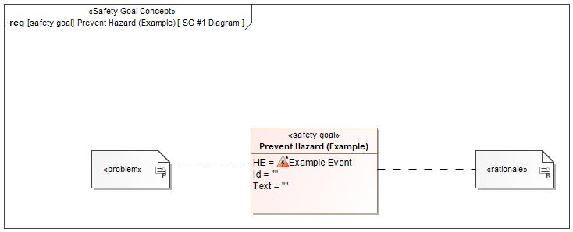

Figure 1: SG #1 Diagram – Prevent Hazard (Example)

*Note: The authoritative source for the Safety Goals is document “FFSD 02 Hazard Analysis* *and Risk Assessment”. The documentation of Safety Goals in this chapter (In the Argumentation for Safety Goal achievement) is for information purposes only.*

*The authoritative source for the Functional Safety Requirements is section 2.1.x.3: of this document. The documentation of Functional Safety Requirements in the following chapter (complete or summarised) is for information purposes only.*

#### Warning and Recovery Concept

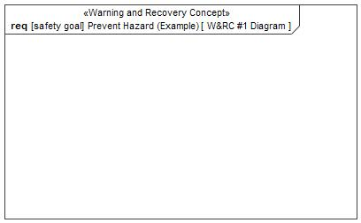

Figure 7: W&RC #1 Diagram – Prevent Hazard (Example)

#### FSRs for - Prevent Hazard (Example)

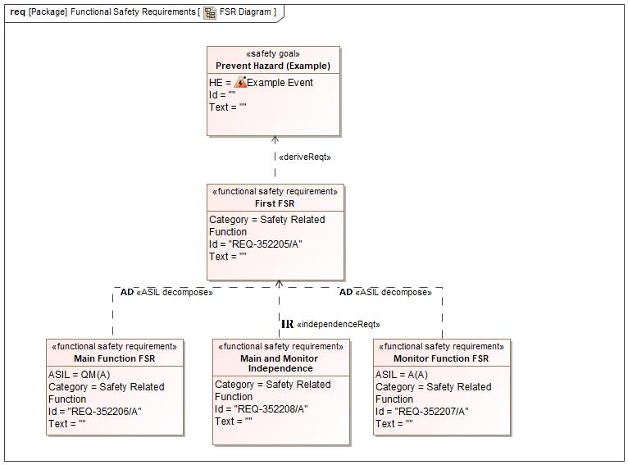

Figure 1. Prevent Hazard (Example)

REQ-352205/A First FSR

Related to:

* Safe States:
  + Safe State #1

|  |  |  |  |  |  |  |  |
| --- | --- | --- | --- | --- | --- | --- | --- |
| Requirement ID: REQ-352205/A | | | | | | | |
| **Purpose** |  | | | | | | |
| **V&V Acceptance Criteria** |  | | | | | | |
| **Notes** |  | | | | | | |
| **Source** |  | | | | | **Owner** |  |
| **Source Req.** | * 1332605268.jpg Prevent Hazard (Example) | | | | | **V&V Method** |  |
| **Type** | N/A | | **Priority** | | N/A | **Status** |  |
| **ASIL** |  | | **Category** | | Safety Related Function | **Fault Handling Time** | N/A |
| [Req. Template](http://wiki.ford.com/display/RequirementsEngineering/Requirements+Attributes) Version | | 6.0 | | End of Requirement | | | |

REQ-352206/A Main Function FSR

Related to:

* Safe States:
  + Safe State #1

|  |  |  |  |  |  |  |  |
| --- | --- | --- | --- | --- | --- | --- | --- |
| Requirement ID: REQ-352206/A | | | | | | | |
| **Purpose** |  | | | | | | |
| **V&V Acceptance Criteria** |  | | | | | | |
| **Notes** |  | | | | | | |
| **Source** |  | | | | | **Owner** |  |
| **Source Req.** | * 1332605268.jpg Prevent Hazard (Example) | | | | | **V&V Method** |  |
| **Type** | N/A | | **Priority** | | N/A | **Status** |  |
| **ASIL** | QM(A) | | **Category** | | Safety Related Function | **Fault Handling Time** | N/A |
| [Req. Template](http://wiki.ford.com/display/RequirementsEngineering/Requirements+Attributes) Version | | 6.0 | | End of Requirement | | | |

REQ-352207/A Monitor Function FSR

Related to:

* Safe States:
  + Safe State #1

|  |  |  |  |  |  |  |  |
| --- | --- | --- | --- | --- | --- | --- | --- |
| Requirement ID: REQ-352207/A | | | | | | | |
| **Purpose** |  | | | | | | |
| **V&V Acceptance Criteria** |  | | | | | | |
| **Notes** |  | | | | | | |
| **Source** |  | | | | | **Owner** |  |
| **Source Req.** | * 1332605268.jpg Prevent Hazard (Example) | | | | | **V&V Method** |  |
| **Type** | N/A | | **Priority** | | N/A | **Status** |  |
| **ASIL** | A(A) | | **Category** | | Safety Related Function | **Fault Handling Time** | N/A |
| [Req. Template](http://wiki.ford.com/display/RequirementsEngineering/Requirements+Attributes) Version | | 6.0 | | End of Requirement | | | |

REQ-352208/A Main and Monitor Independence

Related to:

* Safe States:
  + Safe State #1

|  |  |  |  |  |  |  |  |
| --- | --- | --- | --- | --- | --- | --- | --- |
| Requirement ID: REQ-352208/A | | | | | | | |
| **Purpose** |  | | | | | | |
| **V&V Acceptance Criteria** |  | | | | | | |
| **Notes** |  | | | | | | |
| **Source** |  | | | | | **Owner** |  |
| **Source Req.** | * 1332605268.jpg Prevent Hazard (Example) | | | | | **V&V Method** |  |
| **Type** | N/A | | **Priority** | | N/A | **Status** |  |
| **ASIL** |  | | **Category** | | Safety Related Function | **Fault Handling Time** | N/A |
| [Req. Template](http://wiki.ford.com/display/RequirementsEngineering/Requirements+Attributes) Version | | 6.0 | | End of Requirement | | | |

### Derivation of Functional Safety Requirements on Assumptions

**#Classification**: Functional Safety only

**#Hint:** Derive requirements from the Assumptions (refer to section “Safety Assumptions”

No Functional Safety Requirements tracing to Assumptions specified.

## ASIL Decomposition of Functional Safety Requirements

***#Classification:*** *Functional Safety Only*

***#Hint:*** *For ASIL D features additional measures like a requirements decomposition might be required. Fill out the following table for each ASIL D decomposition applied in the feature. The decomposition rationale is the reason why the decomposition was performed, whereas the rationale for each requirement expresses the reason and thought behind that particular requirement and should include how the requirement is able to independently fulfill the needs of the parent requirement.*

***#Link:***[*Functional Safety Sharepoint*](https://pd3.spt.ford.com/sites/GlobalFunctionalSafety/Pages/default.aspx) *- Functional Safety Concept*

### Decomposition of Functional Safety Requirement REQ-352205/A

| Initial Safety Requirement | REQ-352205/A First FSR | |
| --- | --- | --- |
| Decomposition Rationale |  | |
| Method for Decomposition | A -> A(A) + QM(A) | |
| Functional Safety Requirement 1 after Decomposition | F-S-Req-ID | REQ-352206/A |
| F-S-Req. Title | Main Function FSR |
| ASIL | QM(A) |
| Rationale |  |
| Satisfied by |  |
| Functional Safety Requirement 2 after Decomposition | F-S-Req-ID | REQ-352207/A |
| F-S-Req. Title | A(A) |
| ASIL | Monitor Function FSR |
| Rationale |  |
| Satisfied by |  |
| Functional Safety Requirement for Independence | F-S-Req.-ID | REQ-352208/A |
| F-S-Req. Title | Main and Monitor Independence |
| ASIL |  |
| Rationale |  |

# CyberSecurity

**#Classification**: Cybersecurity only – Otherwise remove substructure and state “not applicable”.

## Security Goals

**#Classification**: Cybersecurity only

**#Hint:** The list of Cybersecurity Goals are an output of the Threat Model. The CAL attribute is not used yet.

**#Link:** [Alignment with Cybersecurity](http://wiki.ford.com/display/RequirementsEngineering/Alignment+with+Cybersecurity) – RE Wiki

## Cybersecurity Requirements

**#Classification**: Cybersecurity only

**#Hint:** Cybersecurity requirements derived from the Cybersecurity Goals. Those requirements should be granular enough to be satisfied by a single Logical Function in the Functional Architecture.

**#Link:** [Alignment with Cybersecurity](http://wiki.ford.com/display/RequirementsEngineering/Alignment+with+Cybersecurity) – RE Wiki

### Usage of SyncP

###RS_SEC_00001### Usage of SyncP

End-to-end transmission of profile data and associated requests between the backend and ECG shall be secured using SyncP, as defined in the in **S13a SyncP Functional Specification**.

SyncP configuration shall follow the requirements defined in the RVS SPSS, including:

* Header definition
* Message Verification
* Message ID Handling

|  |  |  |  |  |  |  |
| --- | --- | --- | --- | --- | --- | --- |
| **Requirement ID: ###RS_SEC_00001###** | | | | | | |
| **Rationale** | | | | | | |
| As the backend is the source of profile data, the communication layer must also have a high level of trust to assure inappropriate disclosure of PII and unintended or incorrect application of customer data does not occur. ECG shall implement secure communication with the PPP FI that provides:   1. Confidentiality to protect PII in transit end-to-end from backend FI to ECG 2. Assurance that communication originates from a trusted source and is not modified in transit 3. Protection against replay attacks   SyncP is a Ford standard mechanism to achieve these goals for secure communication. | | | | | | |
| **Acceptance Criteria** | | | | | | **V&V Method** |
| * SyncP is used to secure all messages transporting profile data from the backend FI to SYNC | | | | | | DV |
| **Notes** | | | | | | |
|  | | | | | | |
| **Type** | | Security | | **Source** | <Put any source here, which is not a requirement reference> | |
| **Priority** | | High (Mandatory) | | **Source Req.** | <Put any parent requirement trace link here> | |
| **Status** | | Approved | | **Owner** | Csmyth5 | |
| **Change Log** | | | | | | |
| **Version** | **Date** | **Author** | **Change** | | | |
| 1.0 | 5/24/2021 | MMART795 | Initial version | | | |
|  |  |  |  | | | |

### Timestamp

###RS_SEC_00002### Timestamp

PPP profiles delivered to the vehicle shall include a timestamp generated by the backend system encoding and encrypting SyncP messages.

|  |  |  |  |  |  |  |
| --- | --- | --- | --- | --- | --- | --- |
| **Requirement ID: ###RS_SEC_00002###** | | | | | | |
| **Rationale** | | | | | | |
| As the backend is the source for PPP profile data, the communication layer must also have a high level of trust to accurate delivery of profile data. This includes mitigation against replay attacks. | | | | | | |
| **Acceptance Criteria** | | | | | | **V&V Method** |
| * Profile data delivered to the vehicle includes a timestamp | | | | | | DV |
| **Notes** | | | | | | |
| The standard backend SyncP encoding/encrypting system for peripheral modules is IVSS. | | | | | | |
| **Type** | | Security | | **Source** | <Put any source here, which is not a requirement reference> | |
| **Priority** | | High (Mandatory) | | **Source Req.** | <Put any parent requirement trace link here> | |
| **Status** | | Approved | | **Owner** | Csmyth5 | |
| **Change Log** | | | | | | |
| **Version** | **Date** | **Author** | **Change** | | | |
| 1.0 | 5/24/2021 | MMART795 | Initial version | | | |
|  |  |  |  | | | |

### Timestamp Persistence

###RS_SEC_00003### Timestamp Persistence

ECG shall keep a record of the most recent timestamp received for each user’s profile that persists through all resets, software updates, and power loss.

|  |  |  |  |  |  |  |
| --- | --- | --- | --- | --- | --- | --- |
| **Requirement ID: ###RS_SEC_00003###** | | | | | | |
| **Rationale** | | | | | | |
| As the backend is the source for PPP profile data, the communication layer must also have a high level of trust to accurate delivery of profile data. This includes mitigation against replay attacks, which must be resilient against attempts to reset the mechanism preventing such attacks. | | | | | | |
| **Acceptance Criteria** | | | | | | **V&V Method** |
| * ECG maintains a record of the most recent timestamp for each user’s profile * The record is not erased, lost or modified due to resets, software updates, or power loss | | | | | | DV |
| **Notes** | | | | | | |
|  | | | | | | |
| **Type** | | Security | | **Source** | <Put any source here, which is not a requirement reference> | |
| **Priority** | | High (Mandatory) | | **Source Req.** | <Put any parent requirement trace link here> | |
| **Status** | | Approved | | **Owner** | Csmyth5 | |
| **Change Log** | | | | | | |
| **Version** | **Date** | **Author** | **Change** | | | |
| 1.0 | 5/24/2021 | MMART795 | Initial version | | | |
|  |  |  |  | | | |

### Profile Replay Protection

###RS_SEC_00004### Profile Replay Protection

ECG shall only accept profiles containing a timestamp newer than the last received timestamp for that user. Old/replayed profile data shall not be applied to the vehicle.

|  |  |  |  |  |  |  |
| --- | --- | --- | --- | --- | --- | --- |
| **Requirement ID: ###RS_SEC_00004###** | | | | | | |
| **Rationale** | | | | | | |
| As the backend is the source for Rocket Setup profile data, the communication layer must also have a high level of trust to accurate delivery of profile data. This includes mitigation against replay attacks and attempts to reinstall old data. | | | | | | |
| **Acceptance Criteria** | | | | | | **V&V Method** |
| * ECG rejects and does not apply or install profile data associated with an old timestamp | | | | | | DV |
| **Notes** | | | | | | |
|  | | | | | | |
| **Type** | | Security | | **Source** | <Put any source here, which is not a requirement reference> | |
| **Priority** | | High (Mandatory) | | **Source Req.** | <Put any parent requirement trace link here> | |
| **Status** | | Approved | | **Owner** | Csmyth5 | |
| **Change Log** | | | | | | |
| **Version** | **Date** | **Author** | **Change** | | | |
| 1.0 | 5/24/2021 | MMART795 | Initial version | | | |
|  |  |  |  | | | |

### Input Validation

###RS_SEC_00005### Input Validation

ECG shall validate that all fields within the payload (profile data) adhere to a well-defined schema.

|  |  |  |  |  |  |  |
| --- | --- | --- | --- | --- | --- | --- |
| **Requirement ID: ###RS_SEC_00005###** | | | | | | |
| **Rationale** | | | | | | |
| Input validation is a common area of vulnerability in applications with poorly or loosely defined inputs and can lead to risk of buffer/stack overflow, command injection, SQL injection, etc. Creation and enforcement of a schema helps mitigate against these risks by defining acceptable bounds on input. | | | | | | |
| **Acceptance Criteria** | | | | | | **V&V Method** |
| * A schema for communication of profile data to ECG is defined * ECG verifies that input data adheres to the defined schema | | | | | | Design Review |
| **Notes** | | | | | | |
|  | | | | | | |
| **Type** | | Security | | **Source** | <Put any source here, which is not a requirement reference> | |
| **Priority** | | Medium (Highly Recommended) | | **Source Req.** | <Put any parent requirement trace link here> | |
| **Status** | | Approved | | **Owner** | Csmyth5 | |
| **Change Log** | | | | | | |
| **Version** | **Date** | **Author** | **Change** | | | |
| 1.0 | 5/24/2021 | MMART795 | Initial version | | | |
|  |  |  |  | | | |

### Application of Profile Data and Settings

###RS_SEC_00006### Application of Profile Data and Settings

The user shall be positively identified by the vehicle before it applies or updates profile data and associated user preferences.

|  |  |  |  |  |  |  |
| --- | --- | --- | --- | --- | --- | --- |
| **Requirement ID: ###RS_SEC_00006###** | | | | | | |
| **Rationale** | | | | | | |
| Ford must protect customer data (especially PII) from unauthorized disclosure. Access control protects other users for being able to view customer data without their consent. | | | | | | |
| **Acceptance Criteria** | | | | | | **V&V Method** |
| * Profile data and user settings are not applied until the user is positively identified by the vehicle | | | | | | DV |
| **Notes** | | | | | | |
|  | | | | | | |
| **Type** | | Security | | **Source** | <Put any source here, which is not a requirement reference> | |
| **Priority** | | Medium (Highly Recommended) | | **Source Req.** | <Put any parent requirement trace link here> | |
| **Status** | | Approved | | **Owner** | Csmyth5 | |
| **Change Log** | | | | | | |
| **Version** | **Date** | **Author** | **Change** | | | |
| 1.0 | 5/24/2021 | MMART795 | Initial version | | | |
|  |  |  |  | | | |

### Secure Authentication

###RS_SEC_00007### Secure Authentication

The user shall be positively identified via a secure authentication mechanism approved by Vehicle Cyber Security.

|  |  |  |  |  |  |  |
| --- | --- | --- | --- | --- | --- | --- |
| **Requirement ID: ###RS_SEC_00007###** | | | | | | |
| **Rationale** | | | | | | |
| A secure access control mechanism provides reasonable proof of a user’s identity. | | | | | | |
| **Acceptance Criteria** | | | | | | **V&V Method** |
| * Vehicle Cyber Security approves the mechanism used to positively identify the user | | | | | | Design Review |
| **Notes** | | | | | | |
| The authentication mechanism should meet at least the following goals:   * The user is uniquely identified * The user is required to prove their identity by providing something they know (for example, a PIN or Password) or something they have (for example, a registered device with a known cryptographic identity) * The user is authorized to access the requested profile * Cryptographic mechanisms involved in the authentication mechanism are properly configured and robust against attacks | | | | | | |
| **Type** | | Security | | **Source** | <Put any source here, which is not a requirement reference> | |
| **Priority** | | Medium (Highly Recommended) | | **Source Req.** | <Put any parent requirement trace link here> | |
| **Status** | | Approved | | **Owner** | Csmyth5 | |
| **Change Log** | | | | | | |
| **Version** | **Date** | **Author** | **Change** | | | |
| 1.0 | 5/24/2021 | MMART795 | Initial version | | | |
|  |  |  |  | | | |

### Retry Strategy for Profile Delivery

###RS_SEC_00008### Retry Strategy for Profile Delivery

The cloud and ECG shall implement a strategy to confirm and, if necessary, retry delivery of profile data to the vehicle.

|  |  |  |  |  |  |  |
| --- | --- | --- | --- | --- | --- | --- |
| **Requirement ID: ###RS_SEC_00008###** | | | | | | |
| **Rationale** | | | | | | |
| Failure of a single delivery attempt (especially transient failures) should not cause failure of the feature’s functionality. | | | | | | |
| **Acceptance Criteria** | | | | | | **V&V Method** |
| * A strategy to confirm delivery of profile data from the cloud to the vehicle is defined and implemented * A strategy to retry delivery of profile data to the vehicle in the event of a failure or loss of connectivity is defined and implemented * The implemented strategy enables the system to recover from at least one delivery failure | | | | | | Design Review & DV |
| **Notes** | | | | | | |
|  | | | | | | |
| **Type** | | Security | | **Source** | <Put any source here, which is not a requirement reference> | |
| **Priority** | | Medium (Highly Recommended) | | **Source Req.** | <Put any parent requirement trace link here> | |
| **Status** | | Approved | | **Owner** | Csmyth5 | |
| **Change Log** | | | | | | |
| **Version** | **Date** | **Author** | **Change** | | | |
| 1.0 | 5/24/2021 | MMART795 | Initial version | | | |
|  |  |  |  | | | |

### Retry Strategy for Application of Settings

###RS_SEC_00009### Retry Strategy for Application of Settings

ECG shall implement a strategy to confirm and, if necessary, retry application of user preferences to downstream modules.

|  |  |  |  |  |  |  |
| --- | --- | --- | --- | --- | --- | --- |
| **Requirement ID: ###RS_SEC_00009###** | | | | | | |
| **Rationale** | | | | | | |
| Failure of a single attempt to apply preferences (especially transient failures) should not cause failure of the feature’s functionality. | | | | | | |
| **Acceptance Criteria** | | | | | | **V&V Method** |
| * A strategy to confirm delivery of user preferences to downstream modules is defined and implemented * A strategy to retry delivery of user preferences to downstream modules in the event of a failure is defined and implemented * The implemented strategy enables the system to recover from at least one delivery failure | | | | | | Design Review & DV |
| **Notes** | | | | | | |
|  | | | | | | |
| **Type** | | Security | | **Source** | <Put any source here, which is not a requirement reference> | |
| **Priority** | | Medium (Highly Recommended) | | **Source Req.** | <Put any parent requirement trace link here> | |
| **Status** | | Approved | | **Owner** | Csmyth5 | |
| **Change Log** | | | | | | |
| **Version** | **Date** | **Author** | **Change** | | | |
| 1.0 | 5/24/2021 | MMART795 | Initial version | | | |
|  |  |  |  | | | |

### Module Swap

###RS_SEC_00010### Module Swap

Upon detecting a new VIN, ECG shall remove all in-vehicle profile data from its internal store. ECG shall maintain a log of observed VINs.

|  |  |  |  |  |  |  |
| --- | --- | --- | --- | --- | --- | --- |
| **Requirement ID: ###RS_SEC_00010###** | | | | | | |
| **Rationale** | | | | | | |
| Technicians may install previously used modules into a new vehicle during the repair process. Customer data should be removed during this process so that it is not disclosed to other customers without prior consent. | | | | | | |
| **Acceptance Criteria** | | | | | | **V&V Method** |
| * ECG removes all profile data upon observation of a new VIN | | | | | | DV |
| **Notes** | | | | | | |
|  | | | | | | |
| **Type** | | Security | | **Source** | <Put any source here, which is not a requirement reference> | |
| **Priority** | | High (Mandatory) | | **Source Req.** | <Put any parent requirement trace link here> | |
| **Status** | | Approved | | **Owner** | Csmyth5 | |
| **Change Log** | | | | | | |
| **Version** | **Date** | **Author** | **Change** | | | |
| 1.0 | 5/24/2021 | MMART795 | Initial Version | | | |

### Master Reset

###RS_SEC_00011### Master Reset

Master Reset, PPP de-enrollment, or feature disable, shall cause all profile data on ECG and Sync to be deleted, and return other module profile settings to factory default values.

|  |  |  |  |  |  |  |
| --- | --- | --- | --- | --- | --- | --- |
| **Requirement ID: ###RS_SEC_00011###** | | | | | | |
| **Rationale** | | | | | | |
| Master Reset is intended to reset SYNC and other modules back to a factory-like state. Accordingly, ECG must remove all unapplied customer profile data. | | | | | | |
| **Acceptance Criteria** | | | | | | **V&V Method** |
| * ECG and Sync delete all in-vehicle profile data upon when feature no longer active * Other modules with profile settings reset to factory defaults | | | | | | DV |
| **Notes** | | | | | | |
|  | | | | | | |
| **Type** | | Security | | **Source** | <Put any source here, which is not a requirement reference> | |
| **Priority** | | High (Mandatory) | | **Source Req.** | <Put any parent requirement trace link here> | |
| **Status** | | Approved | | **Owner** | Csmyth5 | |
| **Change Log** | | | | | | |
| **Version** | **Date** | **Author** | **Change** | | | |
| 2.0 | 5/24/2021 | MMART795 | Initial Version | | | |

### Cloud Encryption of Profile Data at Rest

###RS_SEC_00012### Cloud Encryption for Profile Data at Rest

Sensitive user information provided in scope of the PPP feature must be encrypted upon storage within the Ford hosting environment. This information includes data which is considered SPII/PII (Sensitive / Personally Identifiable Information) per current GIS guidelines.

|  |  |  |  |  |  |  |
| --- | --- | --- | --- | --- | --- | --- |
| **Requirement ID: ###RS_SEC_00012###** | | | | | | |
| **Rationale** | | | | | | |
| User specific information within the PPP scope must be protected to support defence in depth to ensure that the compromise of storage mechanisms does not expose customer data.  This requirement is in line with the Vehicle and Cloud Mobility Standard – refer to notes for proper reference. | | | | | | |
| **Acceptance Criteria** | | | | | | **V&V Method** |
| * Profile data in storage systems is shown to perform encryption prior to storage * Systems which must pull data to support RVS use cases share a unique decryption method that is specific to the consuming application | | | | | | DV |
| **Notes** | | | | | | |
| This requirement specifically supports encryption between user entry and storage in Foundational Services by way of VPMS pre-encrypting data prior to storage in Foundation Services.  Refer to reference 3 in Section 1.4 for further definition | | | | | | |
| **Type** | | Security | | **Source** | <Put any source here, which is not a requirement reference> | |
| **Priority** | | High (Mandatory) | | **Source Req.** | <Put any parent requirement trace link here> | |
| **Status** | | Approved | | **Owner** | Csmyth5 | |
| **Change Log** | | | | | | |
| **Version** | **Date** | **Author** | **Change** | | | |
| 1.0 | 5/24/2021 | MMART795 | Initial version | | | |

### In-Vehicle Encryption of Profile Data at Rest

###RS_SEC_00013### In-Vehicle Encryption for Profile Data at Rest

Profile data at rest shall be encrypted using a profile specific key on all modules that link profile data with a user identity.

Profile data requiring encryption includes SPII/PII (Sensitive / Personally Identifiable Information) per current GIS guidelines, as well as non-SPII/PII profile data.

Encrypted profile data shall be decrypted in memory during recall when the associated user authenticates on the HMI, per the approved positive ID process (RS_SEC_00007).

|  |  |  |  |  |  |  |
| --- | --- | --- | --- | --- | --- | --- |
| **Requirement ID: ###RS_SEC_00013###** | | | | | | |
| **Rationale** | | | | | | |
| With multiple user profiles supported on a vehicle, all data associated with a profile can be linked to a specific user’s identity. | | | | | | |
| **Acceptance Criteria** | | | | | | **V&V Method** |
| * Profile data encrypted at rest on user identity linking modules * Profile data encrypted using profile specific keys * Decrypted profile data in memory only after successful authentication of profile owner | | | | | | DV |
| **Notes** | | | | | | |
|  | | | | | | |
| **Type** | | Security | | **Source** | <Put any source here, which is not a requirement reference> | |
| **Priority** | | High (Mandatory) | | **Source Req.** | <Put any parent requirement trace link here> | |
| **Status** | | Approved | | **Owner** | Csmyth5 | |
| **Change Log** | | | | | | |
| **Version** | **Date** | **Author** | **Change** | | | |
| 1.0 | 5/24/2021 | MMART795 | Initial version | | | |

### Secure Account Linking

###RS_SEC_00014### Secure Account Linking

Profile authentication leveraging single-sign-on for a Ford user identity linked with a 3rd party identity shall follow Ford standards for account linking and federated login. Authentication process shall require approval by the Ford security team.

|  |  |  |  |  |  |  |
| --- | --- | --- | --- | --- | --- | --- |
| **Requirement ID: ###RS_SEC_00014###** | | | | | | |
| **Rationale** | | | | | | |
| Authentication based on a linked identity requires security, privacy, and legal consideration, following a process documented by Ford standards. | | | | | | |
| **Acceptance Criteria** | | | | | | **V&V Method** |
| * Single-sign-on complies with Ford standards * Single-sign-on process is approved by cyber security | | | | | | DV |
| **Notes** | | | | | | |
|  | | | | | | |
| **Type** | | Security | | **Source** | <Put any source here, which is not a requirement reference> | |
| **Priority** | | High (Mandatory) | | **Source Req.** | <Put any parent requirement trace link here> | |
| **Status** | | Approved | | **Owner** | Csmyth5 | |
| **Change Log** | | | | | | |
| **Version** | **Date** | **Author** | **Change** | | | |
| 1.0 | 5/24/2021 | MMART795 | Initial version | | | |

### Secure Recall

###RS_SEC_00015### Secure Recall

Profile recall signals shall be cryptographically verifiable by receiving modules to ensure the recalled profile corresponds to the authenticated profile owner.

|  |  |  |  |  |  |  |
| --- | --- | --- | --- | --- | --- | --- |
| **Requirement ID: ###RS_SEC_00015###** | | | | | | |
| **Rationale** | | | | | | |
| If CAN signals controlling profile recall cannot be cryptographically linked to profile authentication, there is no guarantee that the authenticated profile and the recalled profile are the same. This could allow an attacker to replay CAN signals to recall a valid user’s profile, regardless of authentication status. | | | | | | |
| **Acceptance Criteria** | | | | | | **V&V Method** |
| * Only authenticated profiles can be recalled | | | | | | DV |
| **Notes** | | | | | | |
|  | | | | | | |
| **Type** | | Security | | **Source** | <Put any source here, which is not a requirement reference> | |
| **Priority** | | High (Mandatory) | | **Source Req.** | <Put any parent requirement trace link here> | |
| **Status** | | Approved | | **Owner** | Csmyth5 | |
| **Change Log** | | | | | | |
| **Version** | **Date** | **Author** | **Change** | | | |
| 1.0 | 5/24/2021 | MMART795 | Initial version | | | |

### Security Logging

###RS_SEC_00016### Security Logging

All specified events shall be logged using the FNV2 Analytics Framework security logging API and include the triggering event data and security logging common attributes.

Events to be blocked and logged as High Priority security events include:

* Profile recall without corresponding profile owner authentication
* Profile update without corresponding profile owner authentication

|  |  |  |  |  |  |  |
| --- | --- | --- | --- | --- | --- | --- |
| **Requirement ID: ###RS_SEC_00016###** | | | | | | |
| **Rationale** | | | | | | |
| Proper logging ensures that auditing for forensic purposes is possible in the event that improper web engine activity is detected. | | | | | | |
| **Acceptance Criteria** | | | | | | **V&V Method** |
| * All listed events are logged on occurrence and include requested meta data * Logs are consumed by FNV2 Analytics Framework security logging API | | | | | | DV |
| **Notes** | | | | | | |
| FNV2 Analytics security logging API:  https://www.eesewiki.ford.com/display/analytics/Security+Logging+Common+Attributes | | | | | | |
| **Type** | | Security | | **Source** | <Put any source here, which is not a requirement reference> | |
| **Priority** | | High (Mandatory) | | **Source Req.** | <Put any parent requirement trace link here> | |
| **Status** | | Approved | | **Owner** | Csmyth5 | |
| **Change Log** | | | | | | |
| **Version** | **Date** | **Author** | **Change** | | | |
| 1.0 | 5/24/2021 | MMART795 | Initial version | | | |

# Architecture

## Functional Architecture

**#Classification:** Mandatory for Functional Safety – otherwise optional

**#Hint**: This section depicts the coarse Functional Architecture. This architectural step is needed to find the right functional partitioning for the function level. The function shown here are those, which are specified on function level. Either SysML activity diagrams or Data Flow Diagrams could be used to depict such a Functional Architecture. For bigger features, which are decomposed in a hierarchical manner down to atomic functions (and which do not follow the Functional Safety process), a function tree could be given here.

**#Links:**

* Functional Decomposition: [RE Wiki – Functional Decomposition](http://wiki.ford.com/display/RequirementsEngineering/Functional+Decomposition)
* SysML - Activity Diagrams or [RE Wiki - Data Flow Diagrams](http://wiki.ford.com/display/RequirementsEngineering/Data+Flow+Diagram?src=contextnavpagetreemodehttp://wiki.ford.com/display/RequirementsEngineering/Data+Flow+Diagram?src=contextnavpagetreemode)
* Data Flow Diagram: [RE Wiki – Data Flow Diagram](http://wiki.ford.com/display/RequirementsEngineering/Functional+Decomposition)

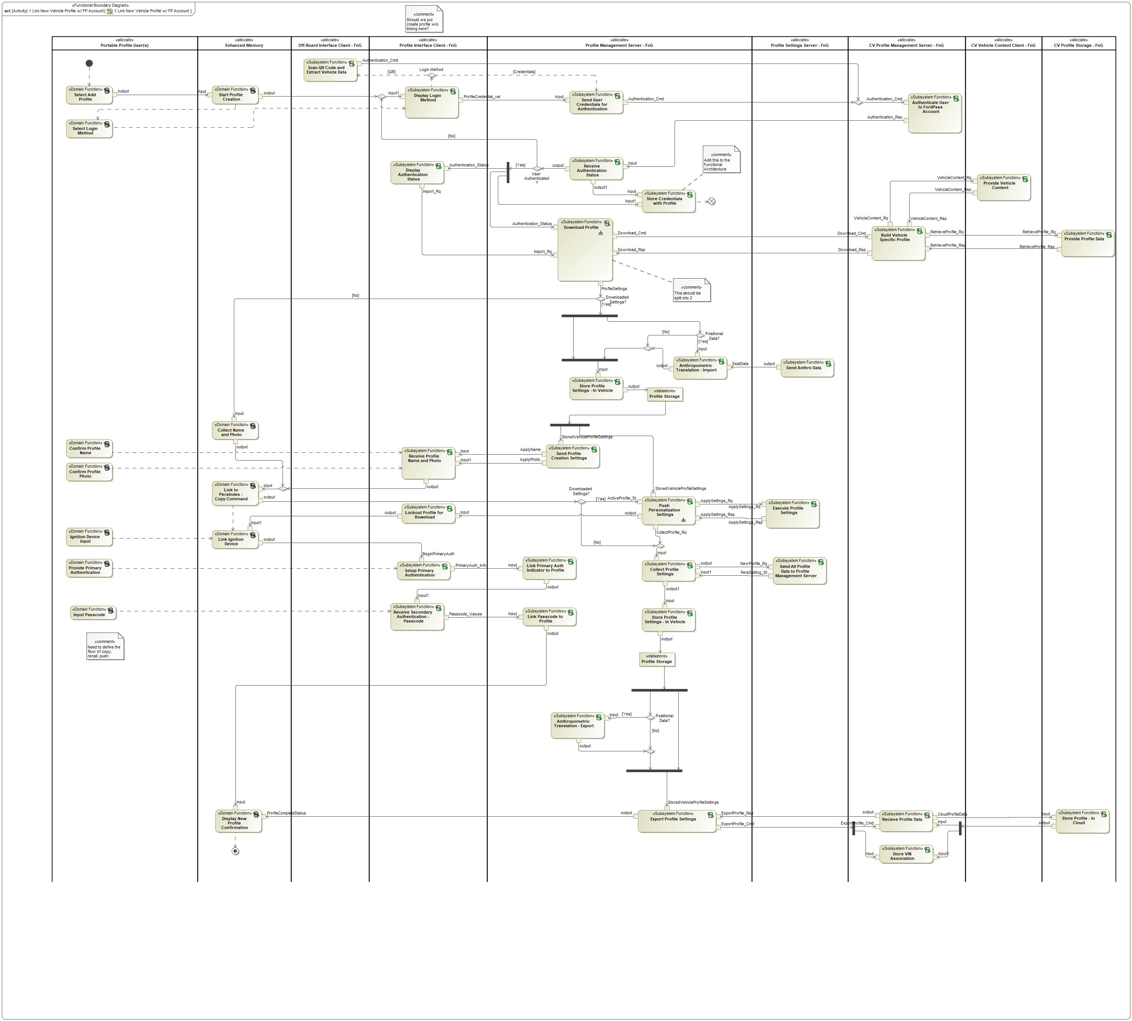

Figure 8: 1 Link New Vehicle Profile w/ FP Account

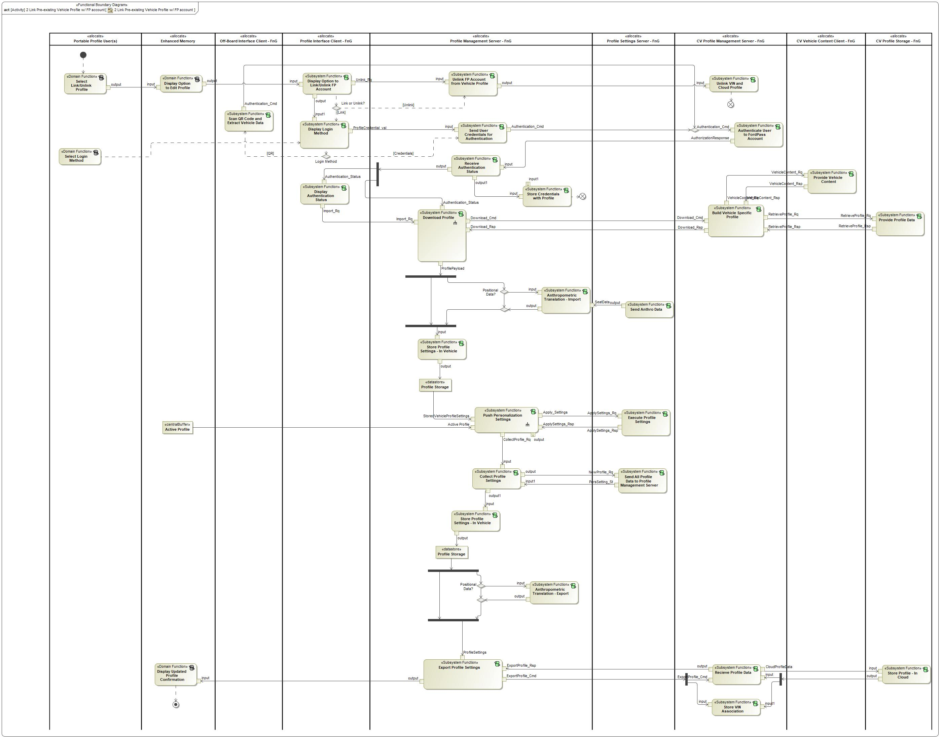

Figure 8: 2 Link Pre-existing Vehicle Profile w/ FP account

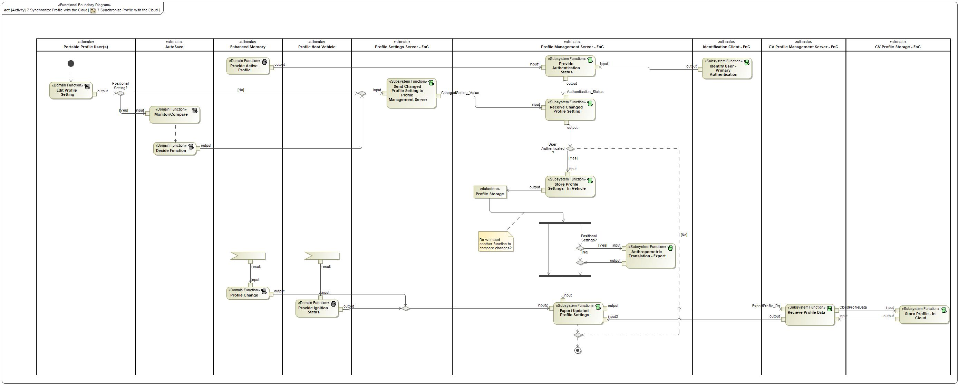

Figure 8: 7 Synchronize Profile with the Cloud

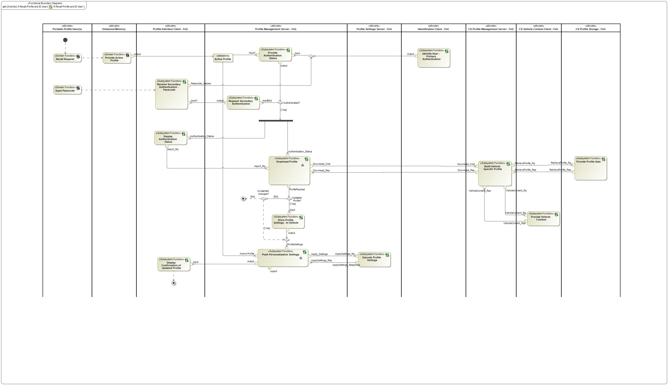

Figure 8: 9 Recall Profile and ID User

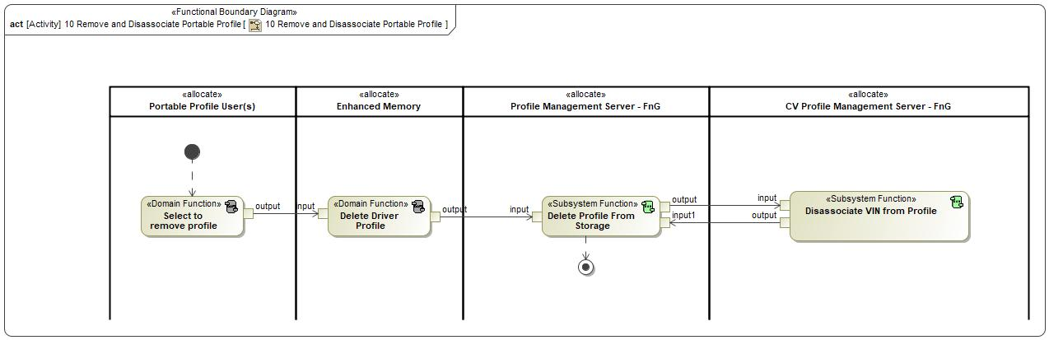

Figure 8: 10 Remove and Disassociate Portable Profile

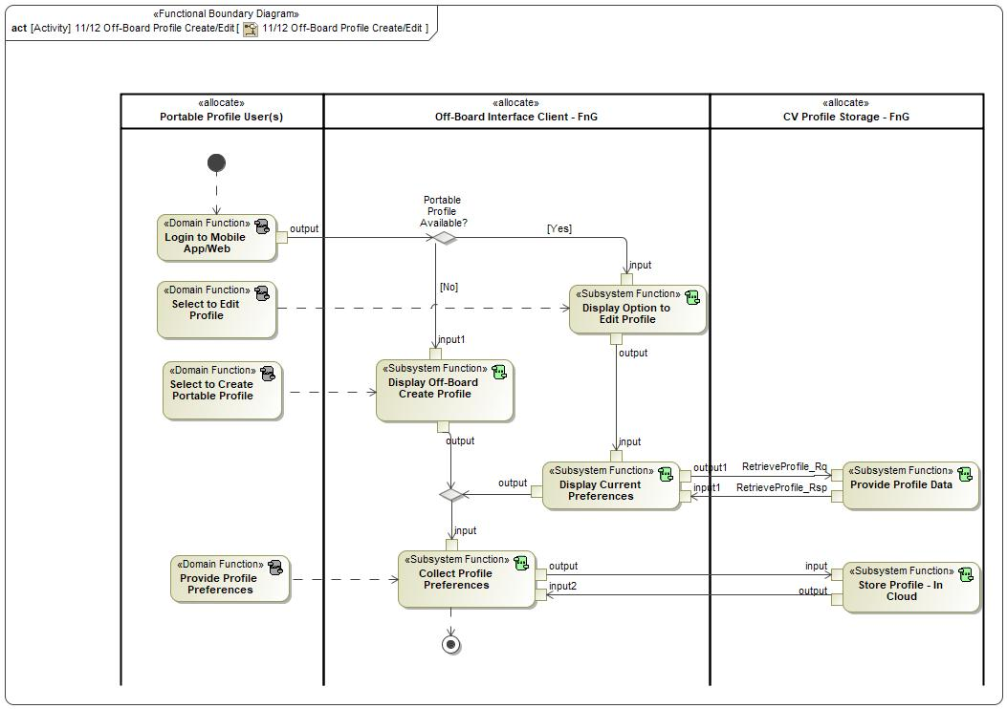

Figure 8: 11/12 Off-Board Profile Create/Edit

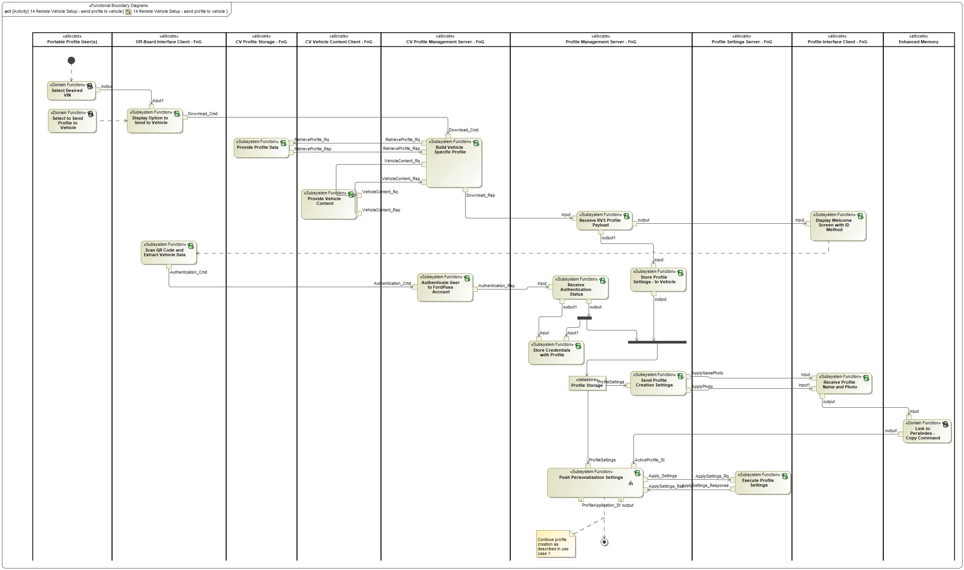

Figure 8: 14 Remote Vehicle Setup - send profile to vehicle

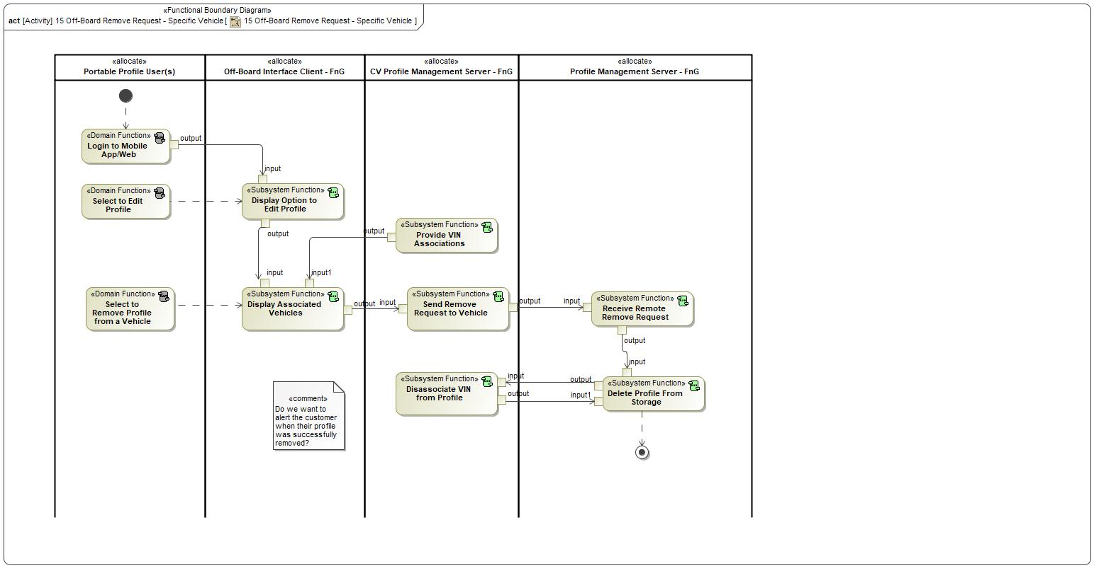

Figure 8: 15 Off-Board Remove Request - Specific Vehicle

### List of Functions

**#Hint:** The functions shown in the Functional Architecture should be listed and described in the table below

| **Function Name** | Description | Comments |
| --- | --- | --- |
| *(activity)* Recieve Profile Data | *(activity)* A cloud function that receives any profile data from the vehicle and passes it along to the cloud profile storage. |  |
| *(activity)* Send Anthro Data | *(activity)* This function sends data related to anthropometric translation from the applicable Profile Setting Server (DSM) to the Profile Management Server (ECG). |  |
| *(activity)* Link Passcode to Profile | *(activity)* A function allocated to the Profile Management Server that links a user configured passcode to their profile in the vehicle. |  |
| *(activity)* Send User Credentials for Authentication | *(activity)* This function passes user credentials from the vehicle to the cloud when a user initially logs into the vehicle HMI to import their portable profile. |  |
| *(activity)* Execute Profile Settings | *(activity)* This function applies profile settings sent from the profile management server and relays profile setting changes to the Profile Management Server. |  |
| *(activity)* Provide Primary Authentication | *(activity)* DOMAIN Function - Profile User |  |
| *(activity)* Display Authentication Status | *(activity)* The function is allocated to the Profile Interface Client which is inside the vehicle. This is an HMI function that will display the authentication status to a customer that is attempting to login to the vehicle. |  |
| *(activity)* Lockout Profile for Download | *(activity)* This function is allocated to the Profile Interface Client and provides an HMI graphic that locks out the HMI screen so that the customer cannot make any changes while the PPP feature is applying settings. |  |
| *(activity)* Select Add Profile | *(activity)* DOMAIN Function - Profile User |  |
| *(activity)* Collect Profile Settings | *(activity)* A function of the Profile Management Server to collect all in-vehicle profile settings from the Profile Setting Servers. The function interacts with the in-vehicle profile storage to save and store the profile settings. |  |
| *(activity)* Display New Profile Confirmation | *(activity)* DOMAIN Function - Enhanced Memory |  |
| *(activity)* Link Ignition Device | *(activity)* DOMAIN Function - Enhanced Memory |  |
| *(activity)* Store Credentials with Profile | *(activity)* When profile credentials are returned back to the vehicle and have a successful authentication status, this function stores and associates the credentials with the vehicle profile. |  |
| *(activity)* Receive Authentication Status | *(activity)* A function allocated to the Profile Management Server that receives the authentication status from the cloud and provides the status to requesting vehicle functions. |  |
| *(activity)* Confirm Profile Name | *(activity)* DOMAIN Function - Profile User |  |
| *(activity)* Setup Primary Authentication | *(activity)* This is an HMI function that allows the user to setup their primary authentication method for their profile. |  |
| *(activity)* Anthropometric Translation - Export | *(activity)* Translates seat profile data from a host vehicle into a normalized seat value. This function uses host vehicle seat data to perform calculation and provides a normalized value as an output. This occurs on each profile export. |  |
| *(activity)* Store Profile Settings - In Vehicle | *(activity)* In-vehicle storage of the profile settings that is allocated to the Profile Management Server. |  |
| *(activity)* Start Profile Creation | *(activity)* DOMAIN Function - Enhanced Memory |  |
| *(activity)* Provide Profile Data | *(activity)* This function stores profile data in the cloud and associates the data to a user profile. |  |
| *(activity)* Link Primary Auth Indicator to Profile | *(activity)* A function allocated to the Profile Management Server that links a primary authentication indicator (BT device, Face ID, NFC, etc.) to the user's vehicle profile to be user for profile authentication. |  |
| *(activity)* Confirm Profile Photo | *(activity)* DOMAIN Function - Profile User |  |
| *(activity)* Select Login Method | *(activity)* DOMAIN Function - Profile User |  |
| *(activity)* Authenticate User to FordPass Account | *(activity)* This function receives the user credentials and authenticates them with the backend system to ensure the credentials are associated to a valid FordPass account. |  |
| *(activity)* Receive Secondary Authentication - Passcode | *(activity)* This is an HMI function that receives the secondary authentication passcode from the user. This function is executed when primary authentication of a user is unavailable or fails. |  |
| *(activity)* Scan QR Code and Extract Vehicle Data | *(activity)* A function of the Off-Board Interface Client that uses the mobile device's camera to scan a QR code and extract relevant vehicle data to authenticate a user on a specific vehicle. |  |
| *(activity)* Ignition Device Input | *(activity)* DOMAIN Function - Profile User |  |
| *(activity)* Store Profile Settings - In Vehicle | *(activity)* In-vehicle storage of the profile settings that is allocated to the Profile Management Server. |  |
| *(activity)* Anthropometric Translation - Import | *(activity)* Translates seat profile data for the applicable vehicle. This function will take a normalized seat position and the host vehicle's seat data and calculate the new seat position as an output. This occurs on an initial profile import. |  |
| *(activity)* Link to PersIndex - Copy Command | *(activity)* DOMAIN Function |  |
| *(activity)* Input Passcode | *(activity)* DOMAIN Function - Profile User |  |
| *(activity)* Download Profile | *(activity)* This function requests and receives a profile payload for the authenticated user of the profile. |  |
| *(activity)* Display Login Method | *(activity)* This is an HMI function that is displayed to collect user credentials from the user. The credentials are used to authenticate a user in order to link their profile to their FordPass account and import their profile settings. |  |
| *(activity)* Push Personalization Settings | *(activity)* This function distributes profile settings from the Profile Management Server to the Profile Setting Servers |  |
| *(activity)* Collect Name and Photo | *(activity)* DOMAIN Function |  |
| *(activity)* Export Profile Settings | *(activity)* A function that will export profile settings from the vehicle to the cloud when a new vehicle profile is initially created. |  |
| *(activity)* Store VIN Association | *(activity)* This is a cloud function that stores all of the VINs that a portable profile is currently available in. |  |
| *(activity)* Store Profile - In Cloud | *(activity)* Cloud storage of the profile settings that is associated with the user's FordPass account. |  |
| *(activity)* Send All Profile Data to Profile Management Server | *(activity)* This function pushes profile data from the Profile Setting Servers to the Profile Management Server when there is a new profile created or when a change is made to a profile setting. |  |
| *(activity)* Receive Profile Name and Photo | *(activity)* A function of the Profile Interface Client in the vehicle that receives the imported Name and Photo during an initial profile import and profile creation. |  |
| *(activity)* Send Profile Creation Settings | *(activity)* Applies specific profile settings, such as name and photo, to the users profile while they are still in profile creation. |  |
| *(activity)* Build Vehicle Specific Profile | *(activity)* A cloud function that uses vehicle configuration data and the user's portable profile data to build a vehicle specific profile to be sent to the vehicle. |  |
| *(activity)* Provide Vehicle Content | *(activity)* This function provides personalized vehicle content for specific vehicles in order to help create a vehicle specific profile. |  |

Table 17: List of Functions on 1 Link New Vehicle Profile w/ FP Account

| **Function Name** | Description | Comments |
| --- | --- | --- |
| *(activity)* Download Profile | *(activity)* This function requests and receives a profile payload for the authenticated user of the profile. |  |
| *(activity)* Send All Profile Data to Profile Management Server | *(activity)* This function pushes profile data from the Profile Setting Servers to the Profile Management Server when there is a new profile created or when a change is made to a profile setting. |  |
| *(activity)* Display Authentication Status | *(activity)* The function is allocated to the Profile Interface Client which is inside the vehicle. This is an HMI function that will display the authentication status to a customer that is attempting to login to the vehicle. |  |
| *(activity)* Provide Profile Data | *(activity)* This function stores profile data in the cloud and associates the data to a user profile. |  |
| *(activity)* Scan QR Code and Extract Vehicle Data | *(activity)* A function of the Off-Board Interface Client that uses the mobile device's camera to scan a QR code and extract relevant vehicle data to authenticate a user on a specific vehicle. |  |
| *(activity)* Send User Credentials for Authentication | *(activity)* This function passes user credentials from the vehicle to the cloud when a user initially logs into the vehicle HMI to import their portable profile. |  |
| *(activity)* Anthropometric Translation - Import | *(activity)* Translates seat profile data for the applicable vehicle. This function will take a normalized seat position and the host vehicle's seat data and calculate the new seat position as an output. This occurs on an initial profile import. |  |
| *(activity)* Store Profile Settings - In Vehicle | *(activity)* In-vehicle storage of the profile settings that is allocated to the Profile Management Server. |  |
| *(activity)* Provide Vehicle Content | *(activity)* This function provides personalized vehicle content for specific vehicles in order to help create a vehicle specific profile. |  |
| *(activity)* Export Profile Settings | *(activity)* A function that will export profile settings from the vehicle to the cloud when a new vehicle profile is initially created. |  |
| *(activity)* Store Profile Settings - In Vehicle | *(activity)* In-vehicle storage of the profile settings that is allocated to the Profile Management Server. |  |
| *(activity)* Execute Profile Settings | *(activity)* This function applies profile settings sent from the profile management server and relays profile setting changes to the Profile Management Server. |  |
| *(activity)* Unlink VIN and Cloud Profile | *(activity)* A function of the cloud that unlinks the cloud profile from a specific VIN. This occurs when a customer unlinks their FordPass account from a vehicle profile or when the customer deletes their profile from a vehicle. |  |
| *(activity)* Store Credentials with Profile | *(activity)* When profile credentials are returned back to the vehicle and have a successful authentication status, this function stores and associates the credentials with the vehicle profile. |  |
| *(activity)* Receive Authentication Status | *(activity)* A function allocated to the Profile Management Server that receives the authentication status from the cloud and provides the status to requesting vehicle functions. |  |
| *(activity)* Store Profile - In Cloud | *(activity)* Cloud storage of the profile settings that is associated with the user's FordPass account. |  |
| *(activity)* Anthropometric Translation - Export | *(activity)* Translates seat profile data from a host vehicle into a normalized seat value. This function uses host vehicle seat data to perform calculation and provides a normalized value as an output. This occurs on each profile export. |  |
| *(activity)* Send Anthro Data | *(activity)* This function sends data related to anthropometric translation from the applicable Profile Setting Server (DSM) to the Profile Management Server (ECG). |  |
| *(activity)* Unlink FP Account from Vehicle Profile | *(activity)* A function of the Profile Management Server that unlinks the in-vehicle profile from the user's associated FordPass account when requested by the user. |  |
| *(activity)* Store VIN Association | *(activity)* This is a cloud function that stores all of the VINs that a portable profile is currently available in. |  |
| *(activity)* Display Option to Link/Unlink FP Account | *(activity)* HMI function that provides the capability for the user to link their FP account to any pre-existing vehicle profiles. |  |
| *(activity)* Display Login Method | *(activity)* This is an HMI function that is displayed to collect user credentials from the user. The credentials are used to authenticate a user in order to link their profile to their FordPass account and import their profile settings. |  |
| *(activity)* Display Option to Edit Profile | *(activity)* DOMAIN Function |  |
| *(activity)* Authenticate User to FordPass Account | *(activity)* This function receives the user credentials and authenticates them with the backend system to ensure the credentials are associated to a valid FordPass account. |  |
| *(activity)* Push Personalization Settings | *(activity)* This function distributes profile settings from the Profile Management Server to the Profile Setting Servers |  |
| *(activity)* Recieve Profile Data | *(activity)* A cloud function that receives any profile data from the vehicle and passes it along to the cloud profile storage. |  |
| *(activity)* Display Updated Profile Confirmation | *(activity)* DOMAIN Function |  |
| *(activity)* Select Login Method | *(activity)* DOMAIN Function - Profile User |  |
| *(activity)* Collect Profile Settings | *(activity)* A function of the Profile Management Server to collect all in-vehicle profile settings from the Profile Setting Servers. The function interacts with the in-vehicle profile storage to save and store the profile settings. |  |
| *(activity)* Select Link/Unlink Profile | *(activity)* DOMAIN Function - Profile User |  |
| *(activity)* Build Vehicle Specific Profile | *(activity)* A cloud function that uses vehicle configuration data and the user's portable profile data to build a vehicle specific profile to be sent to the vehicle. |  |

Table 17: List of Functions on 2 Link Pre-existing Vehicle Profile w/ FP account

| **Function Name** | Description | Comments |
| --- | --- | --- |
| *(activity)* Decide Function | *(activity)* DOMAIN Function |  |
| *(activity)* Anthropometric Translation - Export | *(activity)* Translates seat profile data from a host vehicle into a normalized seat value. This function uses host vehicle seat data to perform calculation and provides a normalized value as an output. This occurs on each profile export. |  |
| *(activity)* Provide Active Profile | *(activity)* DOMAIN Function - Enhanced Memory |  |
| *(activity)* Store Profile Settings - In Vehicle | *(activity)* In-vehicle storage of the profile settings that is allocated to the Profile Management Server. |  |
| *(activity)* Provide Authentication Status | *(activity)* Function of the Profile Management Server that provides the current authentication status of the active profile in the vehicle. Authentication status is based on the active profile and which user is identified in the vehicle. |  |
| *(activity)* Send Changed Profile Setting to Profile Management Server | *(activity)* A function of the Profile Setting Servers that send changed profile settings to the Profile Management Server when the customer makes an authenticated change. |  |
| *(activity)* Export Updated Profile Settings | *(activity)* A function that will export profile settings from the vehicle to the cloud when changes are made to the vehicle profile. |  |
| *(activity)* Profile Change | *(activity)* DOMAIN Function - Enhanced Memory |  |
| *(activity)* Edit Profile Setting | *(activity)* DOMAIN Function - Profile User |  |
| *(activity)* Store Profile - In Cloud | *(activity)* Cloud storage of the profile settings that is associated with the user's FordPass account. |  |
| *(activity)* Recieve Profile Data | *(activity)* A cloud function that receives any profile data from the vehicle and passes it along to the cloud profile storage. |  |
| *(activity)* Receive Changed Profile Setting | *(activity)* A function of the Profile Management Server that receives the values of a changed profile setting for an active and authenticated profile. This function does not accept changed settings if the profile is not authenticated. |  |
| *(activity)* Monitor/Compare | *(activity)* DOMAIN Function |  |
| *(activity)* Provide Ignition Status | *(activity)* DOMAIN Function - Host Vehicle |  |
| *(activity)* Identify User - Primary Authentication | *(activity)* This function identifies the user that has an active profile in the host vehicle. |  |

Table 17: List of Functions on 7 Synchronize Profile with the Cloud

| **Function Name** | Description | Comments |
| --- | --- | --- |
| *(activity)* Display Confirmation of Updated Profile | *(activity)* An HMI function that is used to communicate the status of an updated profile to the customer. |  |
| *(activity)* Store Profile Settings - In Vehicle | *(activity)* In-vehicle storage of the profile settings that is allocated to the Profile Management Server. |  |
| *(activity)* Input Passcode | *(activity)* DOMAIN Function - Profile User |  |
| *(activity)* Receive Secondary Authentication - Passcode | *(activity)* This is an HMI function that receives the secondary authentication passcode from the user. This function is executed when primary authentication of a user is unavailable or fails. |  |
| *(activity)* Push Personalization Settings | *(activity)* This function distributes profile settings from the Profile Management Server to the Profile Setting Servers |  |
| *(activity)* Identify User - Primary Authentication | *(activity)* This function identifies the user that has an active profile in the host vehicle. |  |
| *(activity)* Display Authentication Status | *(activity)* The function is allocated to the Profile Interface Client which is inside the vehicle. This is an HMI function that will display the authentication status to a customer that is attempting to login to the vehicle. |  |
| *(activity)* Provide Vehicle Content | *(activity)* This function provides personalized vehicle content for specific vehicles in order to help create a vehicle specific profile. |  |
| *(activity)* Recall Request | *(activity)* DOMAIN Function - Profile User |  |
| *(activity)* Provide Authentication Status | *(activity)* Function of the Profile Management Server that provides the current authentication status of the active profile in the vehicle. Authentication status is based on the active profile and which user is identified in the vehicle. |  |
| *(activity)* Provide Active Profile | *(activity)* DOMAIN Function - Enhanced Memory |  |
| *(activity)* Download Profile | *(activity)* This function requests and receives a profile payload for the authenticated user of the profile. |  |
| *(activity)* Provide Profile Data | *(activity)* This function stores profile data in the cloud and associates the data to a user profile. |  |
| *(activity)* Build Vehicle Specific Profile | *(activity)* A cloud function that uses vehicle configuration data and the user's portable profile data to build a vehicle specific profile to be sent to the vehicle. |  |
| *(activity)* Request Secondary Authentication | *(activity)* A function of the Profile Management Server that requests the Profile Interface Client to display the secondary authentication passcode screen to the user when the primary authentication failed to ID the user. |  |
| *(activity)* Execute Profile Settings | *(activity)* This function applies profile settings sent from the profile management server and relays profile setting changes to the Profile Management Server. |  |

Table 17: List of Functions on 9 Recall Profile and ID User

| **Function Name** | Description | Comments |
| --- | --- | --- |
| *(activity)* Delete Driver Profile | *(activity)* DOMAIN Function - Enhanced Memory |  |
| *(activity)* Delete Profile From Storage | *(activity)* A function of the Profile Management Server that deletes the local profile copy in the host vehicle when a delete request is received. |  |
| *(activity)* Select to remove profile | *(activity)* DOMAIN Function - Profile User |  |
| *(activity)* Disassociate VIN from Profile | *(activity)* Cloud function that arbitrates off-board requests to remove a profile from a specific VIN and sends that request down to the vehicle. |  |

Table 17: List of Functions on 10 Remove and Disassociate Portable Profile

| **Function Name** | Description | Comments |
| --- | --- | --- |
| *(activity)* Login to Mobile App/Web | *(activity)* DOMAIN Function |  |
| *(activity)* Display Current Preferences | *(activity)* An Off-Board Interface Client function that shows the customer their current preferences for their portable profile settings. The function collects these settings from the CV Profile Storage. |  |
| *(activity)* Display Off-Board Create Profile | *(activity)* This function provides the user an interface to create or edit a portable profile from outside a vehicle. |  |
| *(activity)* Store Profile - In Cloud | *(activity)* Cloud storage of the profile settings that is associated with the user's FordPass account. |  |
| *(activity)* Select to Create Portable Profile | *(activity)* DOMAIN Function - Profile User |  |
| *(activity)* Display Option to Edit Profile | *(activity)* Off-Board Interface Client function that provides the user the option to edit a pre-existing portable profile. |  |
| *(activity)* Collect Profile Preferences | *(activity)* A function of the Off-Board Interface Client that is used to receive input from the customer to collect profile preferences from outside of the vehicle. This function can be used in the RVS scenario of collecting preferences pre vehicle delivery or when a customer decides to create/edit their profile using the off-board interface. |  |
| *(activity)* Provide Profile Data | *(activity)* This function stores profile data in the cloud and associates the data to a user profile. |  |
| *(activity)* Provide Profile Preferences | *(activity)* DOMAIN Functions |  |
| *(activity)* Select to Edit Profile | *(activity)* DOMAIN Function |  |

Table 17: List of Functions on 11/12 Off-Board Profile Create/Edit

| **Function Name** | Description | Comments |
| --- | --- | --- |
| *(activity)* Receive Profile Name and Photo | *(activity)* A function of the Profile Interface Client in the vehicle that receives the imported Name and Photo during an initial profile import and profile creation. |  |
| *(activity)* Push Personalization Settings | *(activity)* This function distributes profile settings from the Profile Management Server to the Profile Setting Servers |  |
| *(activity)* Select Desired VIN | *(activity)* DOMAIN Function - Profile User |  |
| *(activity)* Select to Send Profile to Vehicle | *(activity)* DOMAIN Function - Profile User |  |
| *(activity)* Authenticate User to FordPass Account | *(activity)* This function receives the user credentials and authenticates them with the backend system to ensure the credentials are associated to a valid FordPass account. |  |
| *(activity)* Provide Vehicle Content | *(activity)* This function provides personalized vehicle content for specific vehicles in order to help create a vehicle specific profile. |  |
| *(activity)* Execute Profile Settings | *(activity)* This function applies profile settings sent from the profile management server and relays profile setting changes to the Profile Management Server. |  |
| *(activity)* Receive Authentication Status | *(activity)* A function allocated to the Profile Management Server that receives the authentication status from the cloud and provides the status to requesting vehicle functions. |  |
| *(activity)* Link to PersIndex - Copy Command | *(activity)* DOMAIN Function |  |
| *(activity)* Display Welcome Screen with ID Method | *(activity)* This function is used during the Remote Vehicle Setup (RVS) scenario and is allocated to the Profile Interface Client. This function displays a welcome screen to the customer and provides a method for the customer to provide positive ID. |  |
| *(activity)* Display Option to Send to Vehicle | *(activity)* This function provides the user interface that allows the user to push their portable profile to a specific vehicle. |  |
| *(activity)* Build Vehicle Specific Profile | *(activity)* A cloud function that uses vehicle configuration data and the user's portable profile data to build a vehicle specific profile to be sent to the vehicle. |  |
| *(activity)* Store Profile Settings - In Vehicle | *(activity)* In-vehicle storage of the profile settings that is allocated to the Profile Management Server. |  |
| *(activity)* Scan QR Code and Extract Vehicle Data | *(activity)* A function of the Off-Board Interface Client that uses the mobile device's camera to scan a QR code and extract relevant vehicle data to authenticate a user on a specific vehicle. |  |
| *(activity)* Provide Profile Data | *(activity)* This function stores profile data in the cloud and associates the data to a user profile. |  |
| *(activity)* Send Profile Creation Settings | *(activity)* Applies specific profile settings, such as name and photo, to the users profile while they are still in profile creation. |  |
| *(activity)* Store Credentials with Profile | *(activity)* When profile credentials are returned back to the vehicle and have a successful authentication status, this function stores and associates the credentials with the vehicle profile. |  |
| *(activity)* Receive RVS Profile Payload | *(activity)* A function that is similar to the "Download Profile" function that receives the Remote Vehicle Setup (RVS) payload and temporarily caches the profile until there is positive ID of the user. |  |

Table 17: List of Functions on 14 Remote Vehicle Setup - send profile to vehicle

| **Function Name** | Description | Comments |
| --- | --- | --- |
| *(activity)* Display Associated Vehicles | *(activity)* This function is allocated to the Off-Board Interface Client and displays the different vehicles that the user's portable profile is currently saved to. The user can select from the list of vehicles and request to remove their profile from that vehicle. |  |
| *(activity)* Select to Remove Profile from a Vehicle | *(activity)* DOMAIN Function - Profile User |  |
| *(activity)* Delete Profile From Storage | *(activity)* A function of the Profile Management Server that deletes the local profile copy in the host vehicle when a delete request is received. |  |
| *(activity)* Select to Edit Profile | *(activity)* DOMAIN Function |  |
| *(activity)* Disassociate VIN from Profile | *(activity)* Cloud function that arbitrates off-board requests to remove a profile from a specific VIN and sends that request down to the vehicle. |  |
| *(activity)* Receive Remote Remove Request | *(activity)* A function allocated to the Profile Management Server that can receive remote requests to remove a portable profile that is currently saved to the vehicle. |  |
| *(activity)* Send Remove Request to Vehicle | *(activity)* A function allocated to the cloud that relays remote remove requests from the Off-Board Interface Client to the Profile Management Server of a specific vehicle. |  |
| *(activity)* Display Option to Edit Profile | *(activity)* Off-Board Interface Client function that provides the user the option to edit a pre-existing portable profile. |  |
| *(activity)* Provide VIN Associations | *(activity)* This is a cloud function that provides the information of all of the VIN's that are associated to the user's portable profile. |  |
| *(activity)* Login to Mobile App/Web | *(activity)* DOMAIN Function |  |

Table 17: List of Functions on 15 Off-Board Remove Request - Specific Vehicle

## Logical Architecture

**#Classification:** Functional Safety Analysis only

**#Hint:** FS Analysis requires a description of the boundary of the feature and its elements. A simple block diagram or a SysML Internal Block Diagram could be used to depict the Logical Architecture

***#Link:*** [*Ford Functional Safety Sharepoint*](https://pd3.spt.ford.com/sites/GlobalFunctionalSafety/Pages/default.aspx)

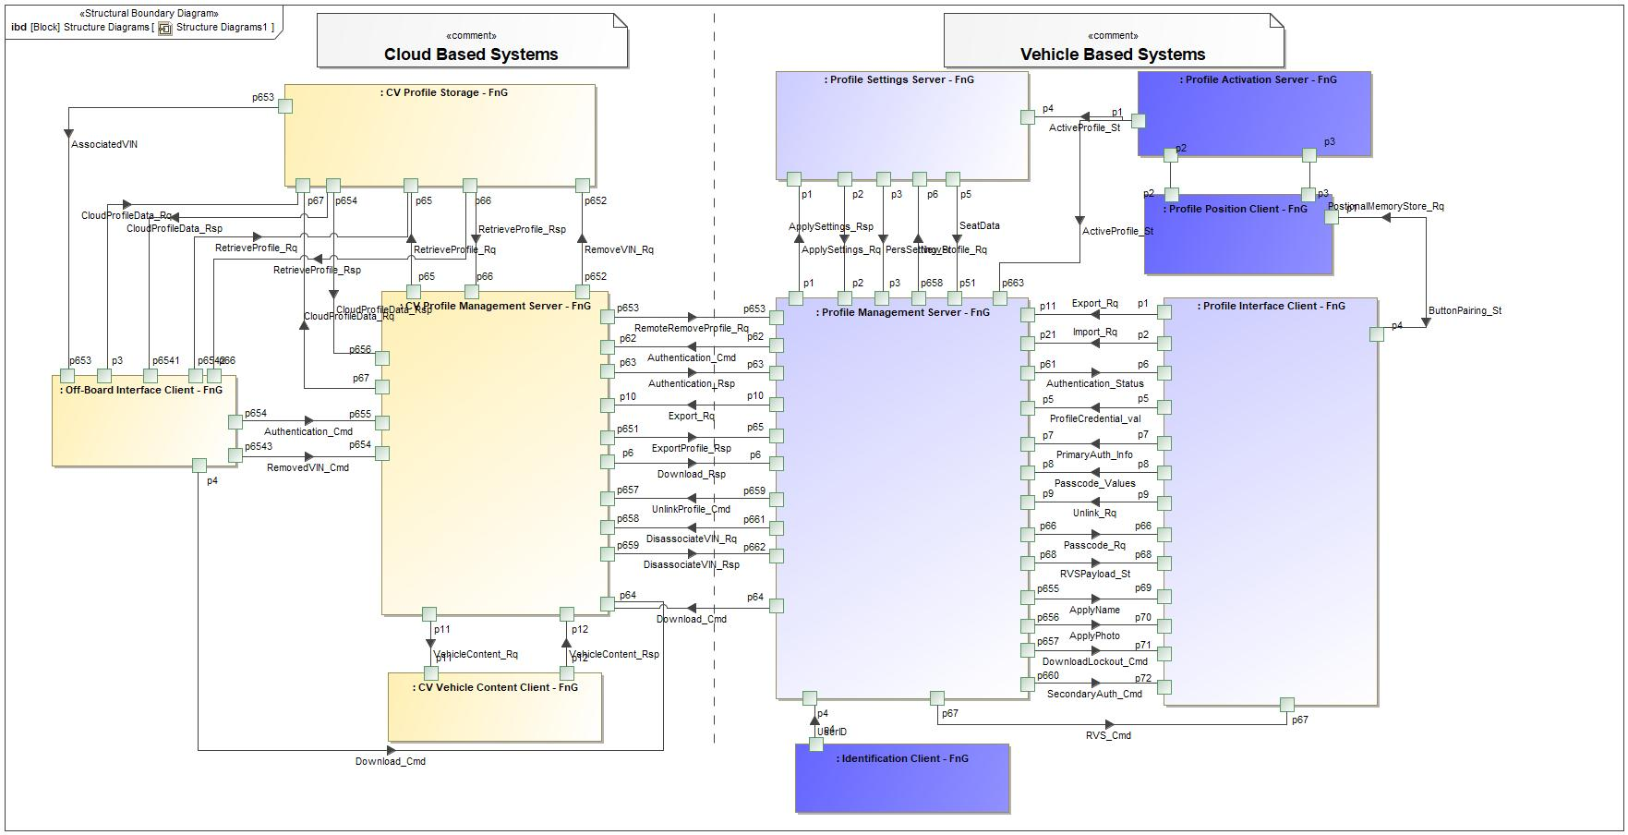

Figure 9: Structure Diagrams1

### Logical Elements

**#Hint:** Lists the elements of the Logical Architecture and the functions from the Functional Architecture, which are allocated to those elements.

|  |  |  |  |
| --- | --- | --- | --- |
| **Element Name** | **Description** | **Allocated Functions** | **Comments** |
| CV Profile Management Server - FnG | The CV Profile Management Server coordinates profile requests sent to and from vehicles. | * Authenticate User to FordPass Account * Build Vehicle Specific Profile * Disassociate VIN from Profile * Provide VIN Associations * Recieve Profile Data * Send Remove Request to Vehicle * Store VIN Association * Unlink VIN and Cloud Profile |  |
| CV Profile Storage - FnG | CV Profile Storage is the subsystem that stores a user's profile data in the cloud. | * Provide Profile Data * Store Profile - In Cloud * Store VIN Association |  |
| CV Vehicle Content Client - FnG | The CV Vehicle Content Client provides the list of available personalized settings on a specific vehicle. | * Provide Vehicle Content |  |
| Identification Client - FnG | Identification Client is the subsystem that identifies who is inside of the host vehicle. | * Authenticate User to FordPass Account * Identify User - Primary Authentication |  |
| Off-Board Interface Client - FnG | The Off-Board Interface Client is the subsystem that will provide user interface to the users outside of the host vehicle. (i.e. FordPass) | * Collect Profile Preferences * Display Associated Vehicles * Display Current Preferences * Display Off-Board Create Profile * Display Option to Edit Profile * Display Option to Send to Vehicle * Scan QR Code and Extract Vehicle Data |  |
| Profile Activation Server - FnG | The Profile Activation Server is an Enhanced Memory logical function group that determines the active profile in the vehicle. |  |  |
| Profile Interface Client - FnG | The Profile Interface Client is the subsystem that interfaces with the customer inside of the host vehicle. | * Display Authentication Status * Display Confirmation of Updated Profile * Display Login Method * Display Option to Link/Unlink FP Account * Display Welcome Screen with ID Method * Lockout Profile for Download * Receive Profile Name and Photo * Receive Secondary Authentication - Passcode * Setup Primary Authentication |  |
| Profile Management Server - FnG | The Profile Management Server is a subsystem in the host vehicle that stores current profile data and applies the data to the applicable Profile Settings Servers. | * Anthropometric Translation - Export * Anthropometric Translation - Import * Collect Profile Settings * Delete Profile From Storage * Download Profile * Export Profile Settings * Export Updated Profile Settings * Link Passcode to Profile * Link Primary Auth Indicator to Profile * Provide Authentication Status * Push Personalization Settings * Receive Authentication Status * Receive Changed Profile Setting * Receive Remote Remove Request * Receive RVS Profile Payload * Request Secondary Authentication * Send Profile Creation Settings * Send User Credentials for Authentication * Store Credentials with Profile * Store Profile Settings - In Vehicle * Unlink FP Account from Vehicle Profile |  |
| Profile Position Client - FnG | The Profile Position Client is an Enhanced Memory logical function group that handles positional saves and recalls. |  |  |
| Profile Settings Server - FnG | The Profile Settings Server manages the profile data by making the personalization settings available to the user. | * Execute Profile Settings * Send All Profile Data to Profile Management Server * Send Anthro Data * Send Changed Profile Setting to Profile Management Server |  |

Table 19: Logical Elements

### Logical Interfaces

**#Hint:** Describe the interactions of the feature with other features or elements.

|  |  |  |  |
| --- | --- | --- | --- |
| **Interface** | **Direction** | **Description** | **Value Range** |
| ActiveProfile_St | p1 (Profile Activation Server - FnG) To p4 (Profile Settings Server - FnG) | Indicates the active vehicle profile. |  |
| p1 (Profile Activation Server - FnG) To p663 (Profile Management Server - FnG) | Indicates the active vehicle profile. |  |
| ApplyName | p655 (Profile Management Server - FnG) To p69 (Profile Interface Client - FnG) | Applies downloaded profile name during in vehicle profile creation. |  |
| ApplyPhoto | p656 (Profile Management Server - FnG) To p70 (Profile Interface Client - FnG) | Applies downloaded profile photo during in vehicle profile creation. |  |
| ApplySettings_Rq | p1 (Profile Management Server - FnG) To p1 (Profile Settings Server - FnG) | Pushing settings from Profile Management Server to all Profile Setting Servers that contain personalized settings |  |
| ApplySettings_Rsp | p2 (Profile Settings Server - FnG) To p2 (Profile Management Server - FnG) | Success or Failure response that the Profile Settings Server provides to the Profile Management Server after personalization settings are applied. |  |
| AssociatedVIN | p653 (CV Profile Storage - FnG) To p653 (Off-Board Interface Client - FnG) | Signal provides all of the VINs that are associated to the user's portable profile to the Off-Board Interface Client. |  |
| Authentication_Cmd | p62 (Profile Management Server - FnG) To p62 (CV Profile Management Server - FnG) | Profile credentials sent to the cloud to be authenticated. |  |
| p654 (Off-Board Interface Client - FnG) To p655 (CV Profile Management Server - FnG) | Profile credentials sent to the cloud to be authenticated. |  |
| Authentication_Rsp | p63 (CV Profile Management Server - FnG) To p63 (Profile Management Server - FnG) | A success or failure response for the Authentication_Cmd. The response tells the vehicle if the provided credentials are authenticated or not. |  |
| Authentication_Status | p61 (Profile Management Server - FnG) To p6 (Profile Interface Client - FnG) | Internal vehicle status that broadcasts if a profile is authenticated or not. |  |
| ButtonPairing_St | p1 (Profile Position Client - FnG) To p4 (Profile Interface Client - FnG) | Status to indicate the memory seat button that is paired to a profile. |  |
| CloudProfileData_Rq | p3 (Off-Board Interface Client - FnG) To p67 (CV Profile Storage - FnG) | Profile data that is either sent from the Off-Board Interface Client or the vehicle to the CV Profile Storage. |  |
| p67 (CV Profile Management Server - FnG) To p67 (CV Profile Storage - FnG) | Profile data that is either sent from the Off-Board Interface Client or the vehicle to the CV Profile Storage. |  |
| CloudProfileData_Rsp | p654 (CV Profile Storage - FnG) To p656 (CV Profile Management Server - FnG) | A success/failure response when profile data is sent to the CV Profile Storage to be saved. |  |
| p654 (CV Profile Storage - FnG) To p6541 (Off-Board Interface Client - FnG) | A success/failure response when profile data is sent to the CV Profile Storage to be saved. |  |
| DisassociateVIN_Rq | p661 (Profile Management Server - FnG) To p658 (CV Profile Management Server - FnG) | A request from vehicle to cloud to disassociate a VIN from a user's cloud profile. |  |
| DisassociateVIN_Rsp | p659 (CV Profile Management Server - FnG) To p662 (Profile Management Server - FnG) | A response to the DisassociateVIN_Rq that indicates if the request was a success or failure. |  |
| DownloadLockout_Cmd | p657 (Profile Management Server - FnG) To p71 (Profile Interface Client - FnG) | A command sent to the Profile Interface Client when the Profile Management Server is actively applying profile data. |  |
| Download_Cmd | p4 (Off-Board Interface Client - FnG) To p64 (CV Profile Management Server - FnG) | Command sent from the vehicle to the cloud to download a portable profile. |  |
| p64 (Profile Management Server - FnG) To p64 (CV Profile Management Server - FnG) | Command sent from the vehicle to the cloud to download a portable profile. |  |
| Download_Rsp | p6 (CV Profile Management Server - FnG) To p6 (Profile Management Server - FnG) | A response to the Download_Cmd. The response imports profile data for the requesting profile. |  |
| ExportProfile_Rq | p10 (Profile Management Server - FnG) To p10 (CV Profile Management Server - FnG) | This signal will send user profile data from the vehicle to the cloud to be stored. |  |
| ExportProfile_Rsp | p65 (Profile Management Server - FnG) To p651 (CV Profile Management Server - FnG) | A response to the ExportProfile_Rq that indicates if the export was a success or failure. |  |
| p651 (CV Profile Management Server - FnG) To p65 (Profile Management Server - FnG) | A response to the ExportProfile_Rq that indicates if the export was a success or failure. |  |
| Export_Rq | p1 (Profile Interface Client - FnG) To p11 (Profile Management Server - FnG) | A request from the Profile Interface Client to the Profile Management Server based on the user's input. This signal determines if profile data should be exported to the cloud when a profile is linked to a FordPass account. |  |
| p10 (Profile Management Server - FnG) To p10 (CV Profile Management Server - FnG) | A request from the Profile Interface Client to the Profile Management Server based on the user's input. This signal determines if profile data should be exported to the cloud when a profile is linked to a FordPass account. |  |
| Import_Rq | p2 (Profile Interface Client - FnG) To p21 (Profile Management Server - FnG) | A request from the Profile Interface Client to the Profile Management Server based on the user's input. This signal determines if profile data should be imported into the vehicle when a profile is linked to a FordPass account. |  |
| NewProfile_Rq | p658 (Profile Management Server - FnG) To p6 (Profile Settings Server - FnG) | A request sent from Profile Management Server to the Profile Setting Servers to collect all profile data when a new profile is being created. |  |
| Passcode_Rq | p66 (Profile Management Server - FnG) To p66 (Profile Interface Client - FnG) | Signal is sent to the Profile Interface client when the primary authentication method failed to identify the user. |  |
| Passcode_Values | p8 (Profile Interface Client - FnG) To p8 (Profile Management Server - FnG) | User input passcode values that is sent from the Profile Interface Client to the Profile Management Server. Profile Management Server will use these values to authenticate a user to their profile. |  |
| PersSetting_St | p3 (Profile Settings Server - FnG) To p3 (Profile Management Server - FnG) | The current value of a personalization setting for the active portable profile. This data is sent to the Profile Management Server to update the user's portable profile. |  |
| PositiveID_St | p4 (Identification Client - FnG) To p4 (Profile Management Server - FnG) | The positive identification status of a user that is in the host vehicle. |  |
| PostionalMemoryStore_Rq | p4 (Profile Interface Client - FnG) To p1 (Profile Position Client - FnG) | Request from Profile Interface Client to store the positional memory to the requested memory slot. |  |
| PrimaryAuth_Info | p7 (Profile Interface Client - FnG) To p7 (Profile Management Server - FnG) | Information about the primary authentication method that is used by the Profile Management Server to authenticate a user in any future key cycle. |  |
| ProfileCredential_val | p5 (Profile Interface Client - FnG) To p5 (Profile Management Server - FnG) | Credential values that are collected by Profile Interface Client and sent to the Profile Management Server. |  |
| RemoteRemoveProfile_Rq | p653 (CV Profile Management Server - FnG) To p653 (Profile Management Server - FnG) | A request sent from the cloud to the vehicle to remotely remove a profile from a vehicle. |  |
| RemovedVIN_Cmd | p6543 (Off-Board Interface Client - FnG) To p654 (CV Profile Management Server - FnG) | A command from the Off-Board Interface Client (mobile app/web) that requests a profile to be removed from a specific VIN. |  |
| RemoveProfile_Cmd | p653 (CV Profile Management Server - FnG) To p653 (Profile Management Server - FnG) | This signal is a sent from the cloud to a specific vehicle that requests the removal of a user's portable profile from the specified vehicle. |  |
| RemoveVIN_Rq | p652 (CV Profile Management Server - FnG) To p652 (CV Profile Storage - FnG) | Request to remove a VIN association from a user's portable profile storage. |  |
| RetrieveProfile_Rq | p65 (CV Profile Management Server - FnG) To p65 (CV Profile Storage - FnG) | CV Profile Management Server requests to retrieve profile data from the CV Profile Storage. |  |
| p6542 (Off-Board Interface Client - FnG) To p65 (CV Profile Storage - FnG) | CV Profile Management Server requests to retrieve profile data from the CV Profile Storage. |  |
| RetrieveProfile_Rsp | p66 (CV Profile Storage - FnG) To p66 (CV Profile Management Server - FnG) | CV Profile Storage providing the requested profile data to the CV Profile Management Server |  |
| p66 (CV Profile Storage - FnG) To p66 (Off-Board Interface Client - FnG) | CV Profile Storage providing the requested profile data to the CV Profile Management Server |  |
| RVSPayload_St | p68 (Profile Management Server - FnG) To p68 (Profile Interface Client - FnG) | An internal vehicle flag to determine if an RVS profile has been delivered to the vehicle. |  |
| RVS_Cmd | p67 (Profile Management Server - FnG) To p67 (Profile Interface Client - FnG) | A command from Profile Management Server to Profile Interface Client to indicate a RVS payload has been received by the vehicle. |  |
| SeatData | p5 (Profile Settings Server - FnG) To p51 (Profile Management Server - FnG) | All of the information needed to perform anthropometric translation. |  |
| SecondaryAuth_Cmd | p660 (Profile Management Server - FnG) To p72 (Profile Interface Client - FnG) | A command to display the secondary authentication screen on the Profile Interface Client. |  |
| UnlinkProfile_Cmd | p659 (Profile Management Server - FnG) To p657 (CV Profile Management Server - FnG) | A command sent from the vehicle to the cloud to unlink a FordPass account from the requesting vehicle profile. |  |
| Unlink_Rq | p9 (Profile Interface Client - FnG) To p9 (Profile Management Server - FnG) | Request from the Profile Interface Client to the Profile Management Server to unlink a profile from its linked FordPass account. |  |
| UserID | p4 (Identification Client - FnG) To p4 (Profile Management Server - FnG) | User ID information sent by the Identification Client to the Profile Management Server that indicates who is identified in the vehicle. |  |
| VehicleContent_Rq | p11 (CV Profile Management Server - FnG) To p11 (CV Vehicle Content Client - FnG) | A request to gather the personalizable vehicle content for a specific VIN. |  |
| VehicleContent_Rsp | p12 (CV Vehicle Content Client - FnG) To p12 (CV Profile Management Server - FnG) | A response to VehicleContent_Rq that contains personalizable vehicle content for a specific VIN. |  |

Table 18: Feature Interactions

# Open Concerns

**#Hint:** The following list presents open concerns, which have to be discussed or clarified over the course of the on-going requirements engineering.

| ID | Concern Description | e-Tracker / Reference | Responsible | Status | Solution |
| --- | --- | --- | --- | --- | --- |
| 1 |  |  |  |  |  |

Table 20: Open Concerns *(Not supported by MagicDraw report generation)*

# Revision History

**#Hint:** A new version number is assigned to a document with a given revision each time it is checked in to Team Center (TCSE). After release of a revision, the document cannot be edited and no new versions can be created on that revision. When updating the document after that, a new revision has to be created and new versions on that revision will be created upon checking in.

|  |  |  |  |  |
| --- | --- | --- | --- | --- |
| Version | Rev. | Date | Description | Responsible |
| *1* | *1* | *3/1/2021* | * *Added Cloud Connectivity Data Analytics Requirements Section (5.4.3.1) to the template* * *Added Data elements table to Cloud Connectivity Data Analytics Requiremetns* | *Jbauer50* |
| *1* | *2* | *5/28/2021* | * *Added section 7 Cybersecurity to the feature document to comply with updated template* * *Added all cyber security requirements in section (16 requirements)* * *Added requirement to limit HMI to 3 profiles if positional settings do not support PPP* * *Added requirement to define configurations to enable/disable Profile Setting Servers from the portability interface.* | *Jbauer50* |

## Template Revisions

*#Important: Do not change this section*

|  |  |  |  |  |
| --- | --- | --- | --- | --- |
| Version | Rev. | Date | Description | Responsible |
| *0* | *6* | *2015-05-26* | * *Chapter “Feature Overview” and made a 2nd level heading.* * *Chapter “Feature Modeling” divided into 3 subchapter (“Scenarios”, “Use Cases”, “State Machines”) for different modeling methods* | *Jbaden1* |
| *0* | *7* | *2015-05-27* | * *Table of Content updated* * *Template Revision History chapter added* | *Jbaden1* |
| *0* | *8* | *2015-07-02* | * *Section “Unsettled Issues” added* | *Alevin7* |
| *0* | *9* | *2015-08-04* | * *Section “Feature Variants” added* * *Section “Feature Boundary Diagram” renamed to “Feature Context Diagram”* * *Document Properties adapted to match needs of VBA macros* | *Jbaden1, Awegman1* |
| *1* | *0* | *2015-09-11* | * *Section “Feature Variants” reworked* * *Feature Goals removed. Only “Safety Goals“ chapter remains.* * *Heading 2 formatting issues corrected.* * *Requirements / Use Cases Listing removed from traceability chapter.* * *Formatting of attribute table in Notation chapter corrected* * *Open Topics / Known Issues chapter moved to the end* | *Jbaden1* |
| *1* | *1* | *2015-11-16* | * *Table-Styles removed (for smooth VSEM import)* * *Some clean-up of sections “Purpose” and “Audience”* | *Awegman1, jbaden1* |
| *1* | *2* | *2016-02-26* | * *Minor corrections based on lessons learned from CC and PCL pilot (e.g. section market/regions) and discussion with Functional Safety Team (purpose of feature)* * *Footer corrected* * *Boundary diagram interface chapter renamed to influences.* | *Jbaden1* |
| *1* | *3* | *2016-02-26* | * *Minor corrections after review with Whitney Keith from Functional Safety team* | *Jbaden1* |
| *1* | *4* | *2016-03-10* | * *Some cleanup of meta-data in Word Properties* | *Jbaden1* |
| *1* | *5* | *2016-03-10* | * *Footer formatting corrected (Issue 19)* * *Results from review with Functional Safety Team incorporated (Issue 20).* | *jbaden1* |
| *1* | *6* | *2016-04-18* | * *Scenario Template added* | *Jbaden1* |
| *1* | *7* | *2016-04-18* | * *Chapter “Operation Modes and States” moved before “Use Case” section.* | *Jbaden1* |
| *1* | *8* | *2016-04-18* | * *Broken Wiki links repaired.* | *Jbaden1* |
| *2* | *0* | *2016-05-19* | * *Adapted to Specification_Macros.dotm V2.0* * *Requirements Templates chapter (ch. 1.7.1) no longer has an attribute table, but refers directly to the Wiki..* | *Jbaden1* |
| *2* | *1* | *2016-06-10* | * *Table for Context Diagram modified (lists external entities and Influence Description only)* | *Jbaden1* |
| *2* | *2* | *2016-07-08* | * *Template version added to footer* * *Several hints added to the various sections* * *Findings from Functional Safety Team incorporated.* * *RE_SafetyRequirement style added* | *Jbaden1* |
| *2* | *3* | *2016-09-21* | * *Update from Functional Safety Team incorporated (“Lessons Learned”, “System Behaviors for HARA”)* | *Jbaden1* |
| *2* | *4* | *2016-11-15* | * *Update from Functional Safety Team incorporated (“Lessons Learned”, “System Behaviors for HARA”)* * *Explanatory notes made more formal* | *Jbaden1* |
| *3* |  |  | *Skipped to synchronize with Specification_Macros.dotm* |  |
| *4* |  |
| *5* | *0* | *2017-01-13* | * *Meta data updated for specification macros, version 3.1* * *SW Unit chapter removed for the time being* * *Green boxes added for user hints* | *Jbaden1* |
| *5* | *1* | *2017-01-18* | * *Minor editorial changes* | *Jbaden1* |
| *6* | *0* | *2017-02-03* | * *CR48: Chapter 6 renamed from “Safety” to “Functional Safety”. New sub-chapter “Safety” introduced in Non-Functional Requirements section* | *Jbaden1* |
| *6* | *0* | *2017-04-28* | * *CR7: “RequirementsTraceability” chapter removed* | *Jbaden1* |
| *6* | *0* | *2017-11-15* | * *CR32/53: New Cover Sheet + Disclaimer replaces FAP-150 like ones.* * *CR75: Some rewording -> Terminology to Glossary, Notation -> Document Conventions* * *CR49: Rename “Assumptions & Constraints” to “Assumptions”* * *CR74: Safety Assumptions added to chapter 6.* * *CR58: Add function allocation column to Logical Architecture chapter* | *Jbaden1* |
| *6* | *0* | *2018-01-31* | * *CR63: Updated links to Functional Safety Sharepoint* | *Jbaden1* |
| *6* | *0* | *2018-07-24* | * *CR69: Add FSR to FeatureDoc* * *CR64: Add new section "Design Requirements" to Function Spec and Feature Spec* | *Jbaden1* |
| *6* | *0* | *2018-08-06* | * *CR53: some corrections for metada and formatting* | *Jbaden1* |
| *6* | *0* | *2018-09-28* | * *Broken links to RE Wiki repaired* | *Jbaden1* |
| *6* | *0* | *2018-10-31* | * *Cover sheet and footer more GIS like. Functional Safety team feedback incorporated:*   + *New subsections “Functional Safety Requirements, (Decomposed) FSRs and Parameters / Values*   + *Removal of “Logical Architecture”* | *Jbaden1* |
| *6* | *0* | *2018-12-12* | * *FSR template removed, now as a macro in the Specification_Macros.dotm* | *Jbaden1* |
| *N* |  | *2019-04-03* | * *Updated code for context diagrams, actors and use cases.* * *Updated code structure with all macros at the beginning.* * *Updated code to populate assumptions using element-assumption relationship or hazardous event.* | *snuesch* |
| *N* |  | *2019-04-18* | * *Added structural boundary diagram for FuSa based on TGB discussion.* * *Added operating modes to functional safety requirements.* | *snuesch* |
| *N* |  | *2019-04-25* | * *Improved export of actions and activities on functional boundary diagram.* | *snuesch* |
| *6* | *0b* | *2019-05-23* | * *Re-introduce “Logical Architecture” (for Functional Safety)* | *Jbaden1* |
| *N* |  | *2019-06-17* | * *Aligned “Architecture” section with RE template.* * *Made “Ford Documents” table more flexible.* * *Added template terms to glossary* | *snuesch* |
| *N* |  | *2019-06-25* | * *Improved use cases to handle Primary and Secondary actors.* * *Added Performance Requirements to Uncategorized.* | *snuesch* |
| *6* | *0b* | *2019-06-26* | * *Chapter “Logical Elements” in “Logical Architecture” section added (FuSa CR 15136240)* * *“References” and “Glossary” chapter moved from section “Feature Overview” to “Introduction”. References and Glossary should be available in the document as early as possible* | *Jbaden1* |
| *N* |  | *2019-07-25* | * *Added populated “Logical Elements” table and allocated functions.* * *Export documentation field of context diagram.* | *snuesch* |
| *N* |  | *2019-08-09* | * *Export documentation field of use case diagram.* * *Fixed bug in Feature Requirement Verification Method.* * *Simplified export of References without publisher.* | *snuesch* |
| *N* |  | *2019-08-21* | * *Improved glossary and acronym tables* | *snuesch* |
| *N* |  | *2019-08-28* | * *Fixed bug in populating title in header* | *snuesch* |
| *N* |  | *2019-09-16* | * *Updated bibliography export* | *snuesch* |
| *N* |  | *2019-09-27* | * *Updated export of Verification Method and Requirement Status for Feature Requirements and V&V Method for Functional Safety Requirements.* | *snuesch* |
| *O* |  | *2019-11-12* | * *Updated bibliography export to include URL.* * *Allow hardware element on context diagram.* * *labelTag variable can be used to filter revision history.* * *Added logical property element type to beplled in from structural boundary diagram.* | *snuesch* |

# Appendix

## Definitions

No terms specified.

## Abbreviations

No acronyms specified.

Document ends here.